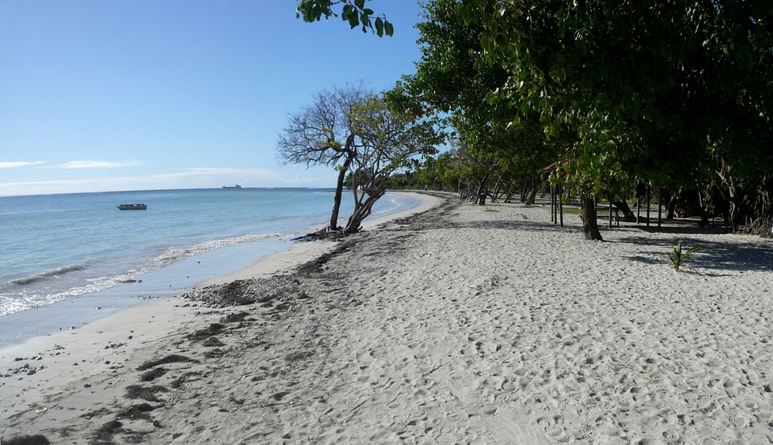
Blackline Master #1 Alternative Engage
Photo Credit: https://pixabay.com/en/caribbean-guadeloupe-beach-68107/

My 3 friends and I went on a trip to St. Lucia in the Caribbean. While we were walking along the beach, Gerry looked down at the sand, picked it up, and poured some in our hands. We looked closely and realized that it was made of tiny pieces of rock. We wondered, “If this sand is made of rocks, how did the sand move to get here?”

Gerry: “I think the sand moved here because the ocean dropped it here as it moved.”

Marianna: “I think the sand moved here because it came from the water running off of the mountain.”

Shelia: “I think the sand moved here because the wind blew it here from nearby islands.”

Me (Henry): “I think the sand was dropped here by glaciers that moved through the area long ago.”

Which of these people do you agree with and why? Explain how you believe the sand got there.

With your face partner, share which person you agreed with and explain how you think the sand got there.


Blackline Master #2 Student Lab Sheet
Student Name(s): ____________________________________________________________

Questions: How do the forces of wind, water, waves, and ice build-up and break down the surface of the Earth? What landforms are created as a result of the movement of sediment due to wind, water, waves, and ice?

Part 1: Demonstrate and observe how the forces of wind, water, waves, and ice move sediment.
Wind
Prediction: What do you think will happen when wind is applied to the sediment? _______
_____________________________________________________________________________________

Picture before wind applied | Distance sand traveled (cm) | Is the sand built up or torn down above the line? | Picture after wind applied | Is the sand built up or torn down below the line?

Water
Prediction: What do you think will happen when water is applied to the sediment? ______
_____________________________________________________________________________________

Picture before water is applied | Distance sand traveled (cm) | Is the sand built up or torn down above the line? | Picture after water is applied | Is the sand built up or torn down below the line?

Wave
Prediction: What do you think will happen when a wave is applied to the sediment? _____
_____________________________________________________________________________________

Picture before waves are applied | Distance sand traveled (cm) | Is the sand built up or torn down above the line? | Picture after waves are applied | Is the sand built up or torn down below the line?
Glacier
Prediction: What do you think will happen when a glacier is applied to the sediment? ____
Picture before glacier applied | Distance sand traveled in front of the ice cube (cm) | Is the sand built up or torn down above the line? | Picture after glacier applied | Is the sand built up or torn down below the line?
_____________________________________________________________________________________

Part 2: Analysis Questions

The movement of sediment by wind, water, waves, and glaciers is called erosion. When the sediment settles out of the wind, water, waves and glaciers and deposits it is called deposition. Use this terminology to help you answer the following questions.

1. At the wind station, what simulated erosion and what simulated deposition? Provide evidence to support your claim. _______________________________________________________
_____________________________________________________________________________________
_____________________________________________________________________________________

2. At the water station, what simulated erosion and what simulated deposition? Provide evidence to support your claim. _______________________________________________________
_____________________________________________________________________________________
_____________________________________________________________________________________

3. At the wave station, what simulated erosion and what simulated deposition? Provide evidence to support your claim. _______________________________________________________
_____________________________________________________________________________________
_____________________________________________________________________________________

4. At the glacier station, what simulated erosion and what simulated deposition? Provide evidence to support your claim. _______________________________________________________
_____________________________________________________________________________________
_____________________________________________________________________________________

Part 3: Extension Research and Application
1. What types of landforms can result from erosion and deposition caused by wind? Describe the process. _________________________________________________________________
_______________________________________________________________________________________________________________________________________________________________________________________________________________________________________________________________
_____________________________________________________________________________________

2. What types of landforms can result from erosion and deposition caused by water?
Describe the process. _________________________________________________________________
_______________________________________________________________________________________________________________________________________________________________________________________________________________________________________________________________

3. What types of landforms can result from erosion and deposition caused by waves?
Describe the process. _________________________________________________________________
_______________________________________________________________________________________________________________________________________________________________________________________________________________________________________________________________
_____________________________________________________________________________________

4. What type of landforms can result from erosion and deposition caused by glaciers? Describe the process. _________________________________________________________________
_______________________________________________________________________________________________________________________________________________________________________________________________________________________________________________________________
_____________________________________________________________________________________
Let’s Get Moving Exit Ticket
Blackline Master #3 Exit Ticket

1. When the water, ice, waves, and wind were applied to the sand it moved the sand down the stream table. Which process did the movement of sand simulate? (SC.6.E.6.1)
- Chemical Weathering
- Deposition
- Erosion
- Physical Weathering
2. As the sand moved down the stream table and settled at the bottom, what process does this simulate? (SC.6.E.6.1)
- Chemical Weathering
- Deposition
- Erosion
- Physical Weathering
3. The picture below depicts a river delta, where a river empties into a larger body of water. (SC.6.E.6.2)
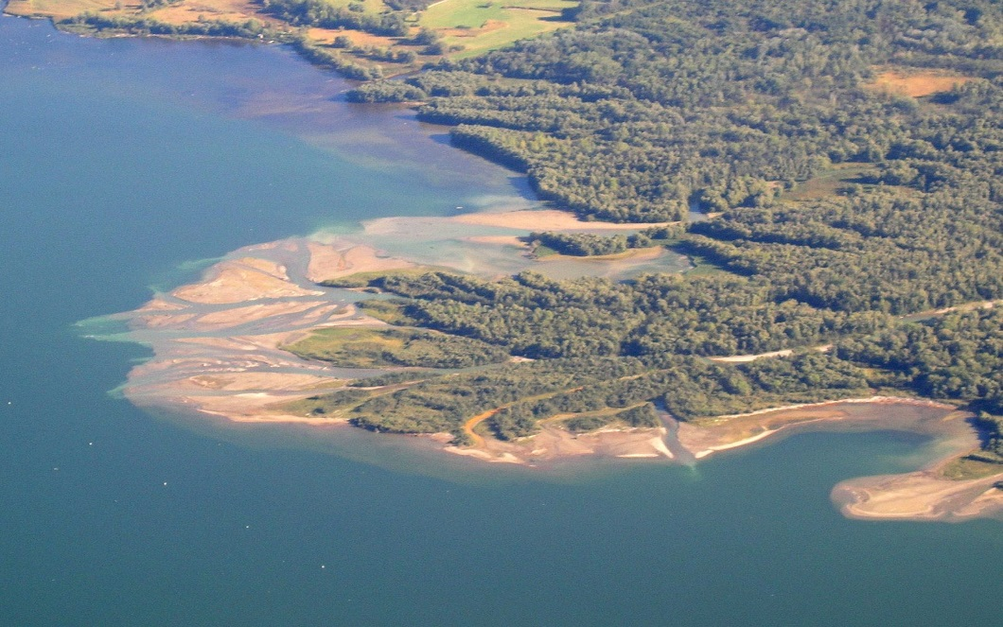
Photo Credit: https://commons.wikimedia.org/wiki/File:Chiemsee_Tiroler_Achen_Delta.JPG

What process causes this landform?
- Chemical Weathering
- Deposition
- Erosion
- Physical Weathering

4. The picture below represents four different landforms. (SC.6.E.6.2)
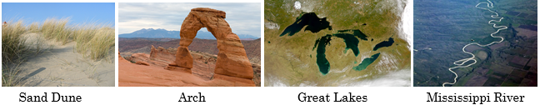
Photo Credits: https://commons.wikimedia.org/wiki/File:Helmgras_kijkduin_februari_2005.JPG, https://commons.wikimedia.org/wiki/File:Delicate_Arch_LaSalle.jpg, https://commons.wikimedia.org/wiki/File:Great_Lakes_from_space.jpg, http://listeningreading.blogspot.com/2011/05/legendary-mississippi-river-from-voa.html
All of the above landforms are caused by erosion except:
- arch
- Great Lakes
- Mississippi River
- sand dune

Blackline Master #4 Station Direction Cards

Station 1: Wind

Materials: straw, pan/tray, sand, ruler

Directions:
- Pour sand along the top of the tray (if it’s empty) filling it to the top and down to the pre-drawn line on the pan. Make sure sand is not compacted.
- Place straw directly over sand and gently blow 3 times (be careful not to get sand onto the table).
- Observe what happens to the sand.
- Record your observations in the table on your lab sheet to describe what happened when you blew the sand.
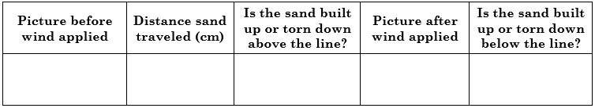
- Once observations are complete, fix the sand back into a loose pile.
- Once finished wait for teacher’s directions.

Station 2: Water

Materials: water, 100mL beaker, pan/tray, sand, ruler, sand disposal area

Directions:
- Pour sand along the top of the tray (if it’s empty) filling it to the top and down to the pre-drawn line on the pan. Make sure sand is not compacted.
- Pour 100 ml of water into your beaker and gently pour the water over the top of the sand.
- Observe what happens to the sand.
- Record your observations in the table on your lab sheet to describe what happened when you poured water into the sand.
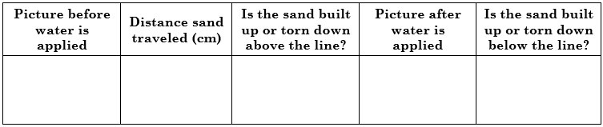
- Once observations are complete, clean up your area and place wet sand in predetermined area.
- Once finished wait for teacher’s directions.

Station 3: Waves
Materials: water, pan/tray, sand, ruler, sand disposal area

Directions:
- Pour sand along the top of the tray filling it to the top and down to the pre-drawn line on the pan. Make sure sand is not compacted.
- Fill the bottom of the pan with water up to the black line.
- Carefully rock the pan back in forth in a wave like motion
- Observe what happens to the sand.
- Record your observations in the table on your lab sheet to describe what happened to the sand when you rocked the water back and forth creating waves.
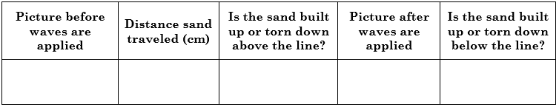
- Once observations are complete, clean up your area and dump the wet sand in predetermined spot.
- Once finished wait for the teacher’s directions.

Station 4: Glacier Station
Materials: ice, pan/tray, sand, ruler

Directions:
- Pour sand along the top of the tray filling it to the top and down to the pre-drawn line on the pan. Make sure sand is not compacted.
- Take an ice cube, place it in the sand, and then move it from the top of the pan down to the black line.
- Observe what happens to the sand.
- Record your observations in the table on your lab sheet to describe what happened when you moved the ice cube through the sand.
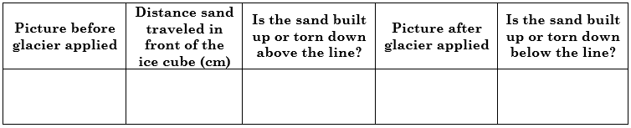
- Once observations are complete throw ice cube away and fix sand back into a loose pile.
- Once finished wait for the teacher’s directions.
Blackline Master #5 ANSWER KEYS
Student Name(s): ____________________________________________________________

Questions: How do the forces of wind, water, waves, and ice build-up and break down the surface of the Earth? What landforms are created as a result of the movement of sediment due to wind, water, waves, and ice?

Part 1: Demonstrate and observe how the forces of wind, water, waves, and ice move sediment.
Wind
Prediction: What do you think will happen when wind is applied to the sediment? Student responses will vary depending on their previous knowledge.

Picture before wind applied | Distance sand traveled (cm) | Is the sand built up or torn down above the line? | Picture after wind applied | Is the sand built up or torn down below the line?
should show a mound of sand, undisturbed | student responses will vary depending on the strength of their wind | sand is torn down above the line | should show that some of the sand has moved to the lower part of the tray and is missing from the mound | sand is built up below the line

Water
Prediction: What do you think will happen when water is applied to the sediment? Student responses will vary depending on their previous knowledge.

Picture before water is applied | Distance sand traveled (cm) | Is the sand built up or torn down above the line? | Picture after water is applied | Is the sand built up or torn down below the line?
should show a mound of sand, undisturbed | student responses will vary depending on how their water was distributed | sand is torn down above the line | should show that some of the sand has moved to the lower part of the tray and is missing from the mound | sand is built up below the line

Wave
Prediction: What do you think will happen when a wave is applied to the sediment? Student responses will vary depending on their previous knowledge.

Picture before waves are applied | Distance sand traveled (cm) | Is the sand built up or torn down above the line? | Picture after waves are applied | Is the sand built up or torn down below the line?
should show a mound of sand, undisturbed | student responses will vary depending on the strength of their waves | sand is torn down above the line | should show that some of the sand has moved to the lower part of the tray and is missing from the edge of the mound | sand is built up below the line
Glacier
Prediction: What do you think will happen when a glacier is applied to the sediment?
Picture before glacier applied | Distance sand traveled in front of the ice cube (cm) | Is the sand built up or torn down above the line? | Picture after glacier applied | Is the sand built up or torn down below the line?
should show a mound of sand, undisturbed | student responses will vary depending on the strength they apply on their ice cube | sand is torn down above the line | should show that some of the sand has moved to the lower part of the tray and is missing from the mound | sand is built up below the line
Student responses will vary depending on their previous knowledge.

Part 2: Analysis Questions

The movement of sediment by wind, water, waves, and glaciers is called erosion. When the sediment settles out of the wind, water, waves and glaciers and deposits it is called deposition. Use this terminology to help you answer the following questions.

1. At the wind station, what simulated erosion and what simulated deposition? Provide evidence to support your claim. Erosion was the picking up and moving of the sand by the wind and deposition was the new little piles of sand that were deposited in new places. Erosion is the movement of the sand. Deposition is the new placement of the sand.

2. At the water station, what simulated erosion and what simulated deposition? Provide evidence to support your claim. Erosion was the picking up and moving of the sand by the water and deposition was the new placement of sand that were deposited at the end of our little “rivers.” Erosion is the movement of the sand. Deposition is the new placement of the sand.

3. At the wave station, what simulated erosion and what simulated deposition? Provide evidence to support your claim. Erosion was the picking up and moving of the sand by the waves and deposition was the spreading out of sand in new places in the water. Erosion is the movement of the sand. Deposition is the new placement of the sand.

4. At the glacier station, what simulated erosion and what simulated deposition? Provide evidence to support your claim. Erosion was the picking up and moving of the sand by the ice cube (or the pushing of the sand in front of the ice) and deposition was the new little piles of sand that were deposited in new places or that fell off the ice cube as it melted. Erosion is the movement of the sand. Deposition is the new placement of the sand.

Part 3: Extension Research and Application
1. What types of landforms can result from erosion and deposition caused by wind? Describe the process. Responses may vary but could include that wind erosion can cause arcs to form. Deposition by wind can cause sand dunes. The wind picks up weathered rock from mountains and plateaus and moves it to new places; sometimes it hollows out a rock. the wind picks up sand from the beach and deposits it off shore in dunes.

2. What types of landforms can result from erosion and deposition caused by water?
Describe the process. Responses may vary but could include that water erosion can cause river beds to form as well as change the beach shoreline. It can also erode away the sides of mountains where water regularly runs through to form canyons. It can also erode away deposits underground to create caves and sinkholes. Deposition by water causes deltas, alluvial fans, sand bars, oxbow lakes, stalactites, and stalagmites.

3. What types of landforms can result from erosion and deposition caused by waves?
Describe the process. Responses may vary but could include that waves carry sand away from shorelines as well as depositing sediment on the shoreline. This creates beaches and sandbars.

4. What type of landforms can result from erosion and deposition caused by glaciers? Describe the process. Responses may vary but could include that glaciers can cause lakes, kettle lakes, and eskers to form from erosion. Glaciers leave behind moraines and outwash sediment from deposition.
Let’s Get Moving Exit Ticket
Blackline Master #3 Exit Ticket

1. When the water, ice, waves, and wind were applied to the sand it moved the sand down the stream table. Which process did the movement of sand simulate?
- Chemical Weathering
- Deposition
- Erosion
- Physical Weathering
2. As the sand moved down the stream table and settled at the bottom, what process does this simulate?
- Chemical Weathering
- Deposition
- Erosion
- Physical Weathering
3. The picture below depicts a river delta, where a river empties into a larger body of water.
Photo Credit: https://commons.wikimedia.org/wiki/File:Chiemsee_Tiroler_Achen_Delta.JPG

What process causes this landform?
- Chemical Weathering
- Deposition
- Erosion
- Physical Weathering

4. The picture below represents four different landforms.
Photo Credits: https://commons.wikimedia.org/wiki/File:Helmgras_kijkduin_februari_2005.JPG, https://commons.wikimedia.org/wiki/File:Delicate_Arch_LaSalle.jpg, https://commons.wikimedia.org/wiki/File:Great_Lakes_from_space.jpg, http://listeningreading.blogspot.com/2011/05/legendary-mississippi-river-from-voa.html
All of the above landforms are caused by erosion except:
- arch
- Great Lakes
- Mississippi River
- sand dune

