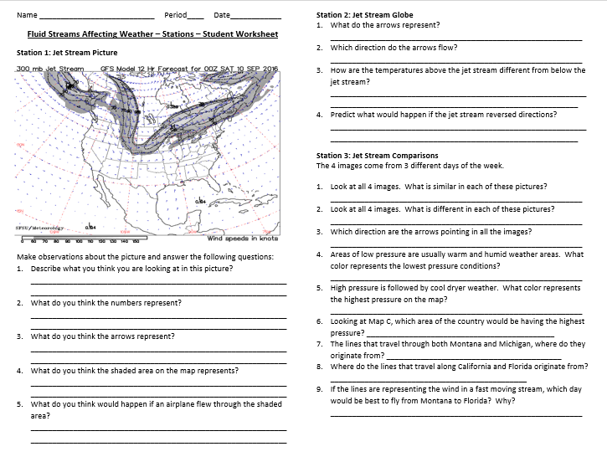
Blackline Master 1
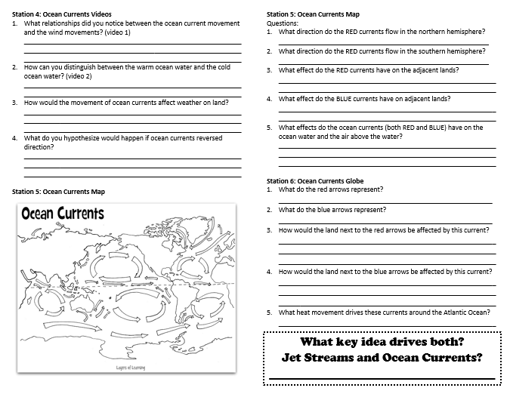
Blackline Master 1
Blackline Master 2
Fluid Streams Summative Assessment

- Bands of high-speed global winds found about 10 kilometers above Earth’s surface that influence weather patterns are called
- Jet streams.
- Polar easterlies.
- Prevailing westerlies.
- Trade winds.
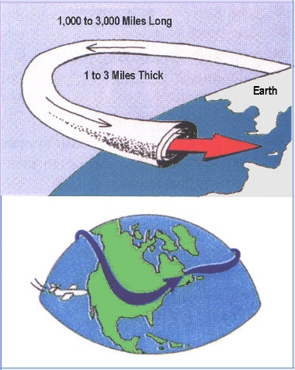
- Sharon is returning home to Miami, Florida from Seattle, Washington. Her flight to Seattle from Miami took 7 hours. The pilot has told Sharon the flight from Seattle to Miami will be about 5 hours. Why is Sharon’s flight home shorter than the flight to Seattle?
- Sharon’s plane is flying in the opposite direction as the Gulf Stream which pushes the air mass toward the east making her flight move faster.
- Sharon’s plane is flying in the opposite direction as the Jet Stream which pushes the air mass toward the east making her flight move faster.
- Sharon’s plane is flying in the same direction as the Gulf Stream which pushes the air mass toward the east making her flight move faster.
- Sharon’s plane is flying in the same direction as the Jet Stream which pushes the air mass toward the east making her flight move faster.

Use the following picture to answer question 3-4. The dark area is the ocean and the lighter areas of the map are the continents.
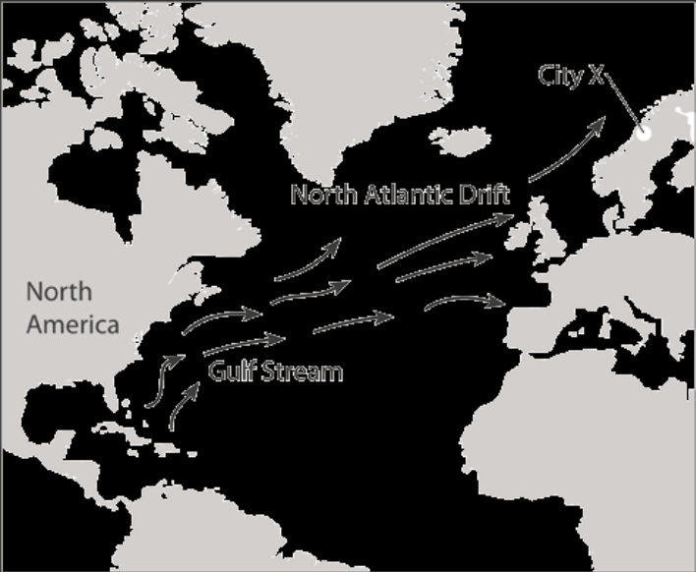
Image from: https://www.google.com/url?sa=i&rct=j&q=&esrc=s&source=images&cd=&cad=rja&uact=8&ved=0ahUKEwio6sqWpoXPAhXDLSYKHQ6NCxoQjB0IBg&url=https%3A%2F%2Fcommons.wikimedia.org%2Fwiki%2FFile%3AJet_Stream.jpg&psig=AFQjCNGBWRTfgKQGuQaxBsfUdUtevWIBxg&ust=1473612616205722
- The Gulf Stream is a warm current that joins with the North Atlantic Drift, another warm current, as it moves across the North Atlantic Ocean. Predict how these warm ocean currents affect the climate of City X, which is near the Arctic Circle.
- The climate of City X is always hot and dry.
- The currents result in a cold, severe climate in City X.
- The climate at City X is unaffected because it’s close to the Arctic Circle.
- City X has a warmer average temperature than a city at the same latitude in North America.

- Currents that start near the equator and moves towards the polar zones are
  - Cold water currents
  - Convection currents
  - Surface currents
  - Warm water currents

- Currents that start near the poles and moves towards the equator are
  - Cold water currents
  - Convection currents
  - Surface currents
  - Warm water currents

- There is a polar jet stream and a subtropical jet stream. The polar jet stream originates in the norther territories of Canada and can dip into the mid-western states of the United States. The weather in the United States often is influenced by the by the dips and peaks of the movement of the jet streams. If the polar jet stream drops down from Canada to Georgia what type of air mass is the polar jet stream bringing with it?
  - Cold dry air mass
  - Cold wet air mass
  - Warm dry air mass
  - Warm wet air mass
Fluid Streams Summative Assessment KEY
- a. Jet streams.
- d. Sharon’s plane is flying in the same direction as the Jet Stream which pushes the air mass toward the east making her flight move faster.
- d. City X has a warmer average temperature than a city at the same latitude in North America.
- d. Warm water currents
- a. Cold water currents
- a. Cold dry air mass
Blackline Master 3
Station 1: Jet Stream

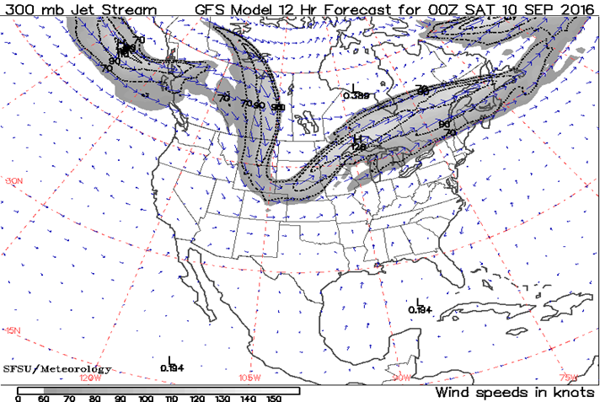Station 1: Jet Stream Picture

Station 1 – Student Questions
Make observations about the picture and answer the following questions:

1. Describe what you think you are looking at in this picture?
2. What do you think the numbers represent?
3. What do you think the arrows represent?
4. What do you think the shaded area on the map represents?
5. What do you think would happen if an airplane flew through the shaded area?

Station 2: Jet Stream Globe Activity

Station 2: Student Directions

Hold the red string on one end, and have a friend hold another side. Move your hand up and down to make bumps in the string, and see how it reacts. That’s the way the jet stream works, with constant bumps and dips.

Now pick up the blue string and wrap it around the globe so that the string goes directly though the United States. With the previous activity in mind create one wave that goes through the United States. Create four more waves all around the globe and connect the two ends of the string with tape.

Station 2: Student Questions

1. What do the arrows represent?
2. Which direction do the arrows flow?
3. How are the temperatures above the jet stream different from below the jet stream?
4. Predict what would happen if the jet stream reversed directions?
Station 3: Jet Stream Comparison Activity
Tuesday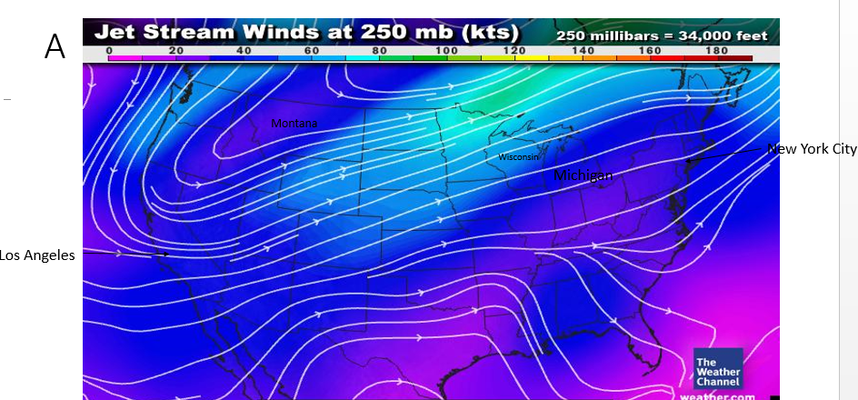
Friday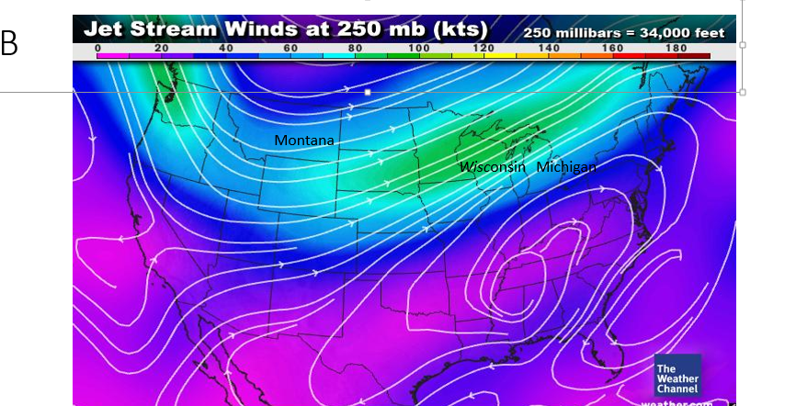
Sunday 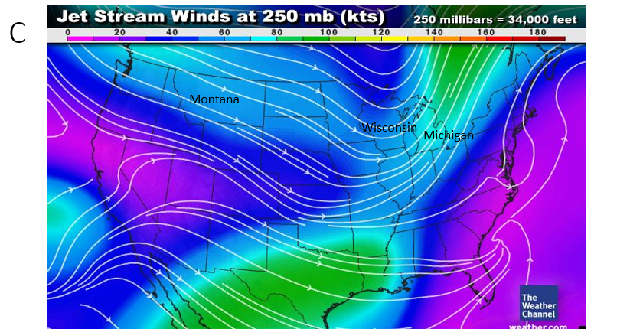
Station 3: Jet Stream Comparison Pictures

Station 3: Student Directions

In this station you will be looking at 3 screen shots from “The Weather Channel” website.
These 3 images come from 3 different days of the week. Notice the changes between the lines on the different days.

Station 3: Student Questions

1. Look at all 3 images. What is similar in each of these pictures?
2. Look at all 3 images. What is different in each of these pictures?
3. Which direction are the arrows pointing in all the images?
4. Areas of low pressure are usually warm and humid weather areas. What color represents the lowest pressure conditions?
5. High pressure is followed by cool dryer weather. What color represents the highest pressure on the map?
6. Looking at Map C, which area of the country would be having the highest pressure?
7. The lines that travel through both Montana and Michigan, where do they originate from?
8. Where do the lines that travel along California and Florida originate from?
9. If the lines are representing the wind in a fast moving stream, which day would be best to fly from Montana to Florida? Why?

Station 4: Ocean Currents & Global Winds Activity

Station 4: Student Directions
1. Watch the videos located on the NASA Aquarius Satellite website.
http://svs.gsfc.nasa.gov/cgi-bin/details.cgi?aid=3829

2. Make sure you are reading each of the captions underneath the videos before watching them; the captions give important information about each video.

3. After watching each of the 6 videos answer the following questions:

Station 4: Student Questions
- What relationships did you notice between the ocean current movement and the wind movements? (video 1)
- How can you distinguish between the warm ocean water and the cold ocean water? (video 2)
- Can you recognize any patterns that occur in global winds? (video 4)
- How would the movement of ocean currents affect weather on land? (video 1, 2, 5 and 6)
- What do you hypothesize would happen if ocean currents reversed direction?

Station 5: Coloring the Ocean Currents

Station 5: Student Directions
Coloring the Ocean Current. The map shows the global patterns of ocean currents.

1. Color the warm water currents that come from the equatorial regions RED.

2. Color the cold water currents from the polar regions BLUE.

Station 5: Student Questions
1. What direction do the RED currents flow in the northern hemisphere? (Where the USA is located)

2. What direction do the RED currents flow in the southern hemisphere?

3. What effect do the RED currents have on the adjacent lands?

4. What effect do the BLUE currents have on adjacent lands?

5. What effects would the ocean currents (both RED and BLUE) have on the ocean water and the air above the water?

Station 6: Ocean Currents Globe

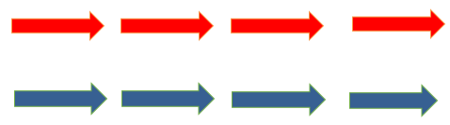
Station 6: Student Directions

Locate the Atlantic Ocean on the globe. Using your ocean current map from the previous station, tape the arrows, in the correct order onto the globe starting at the equator.

Station 6: Student Questions

1. What do the red arrows represent?

2. What do the blue arrows represent?

3. How would the land next to the red arrows be affected by this current?

4. How would the land next to the blue arrows be affected by this current?

5. What heat movement drives these currents around the Atlantic Ocean?

