Blackline Master 1

Directions

Scientists research organisms all across the world and learn all kinds of amazing facts about them. With so much information, it is necessary to have a system of classification to keep all their research organized.

  - Today you will be researching six organisms from the domain Eukarya, and collaborating with other scientists to share what you learned.
  - You were assigned five organisms on your research sheet. Search for them around the room and record the necessary data. (You will need a smart device and may work with a partner if you do not have one.)
  - You may choose any other organism you find for your sixth organism.
  - After you have filled-out your research sheet, work as a group of four
(A, B, C, & D) and collaborate to create a graphic organizer that shows all of your organisms classified into six kingdoms.

Field Notes
Domain and Kingdom:
- All organisms are divided into three groups called “Domains”.
- These Domains are divided into six smaller groups called “Kingdoms”.
- The Domain “Eukarya” contains all organisms with nuclei. (Eukaryotes)

Cellular Structure:
- Organisms made of ONE CELL are called UNICELLULAR.
- Organisms made of more than one cell are called MULTICELLULAR.
- If the cell of an organism has a nucleus, it is EUKARYOTIC.
- If the cell of an organism does NOT have a nucleus, it is PROKARYOTIC.

Diet:
- Organisms that can generate their own energy from the sun through photosynthesis are called AUTOTROPHS. (i.e.: Producers/Plants)
- Organisms that must acquire energy from an outside source are called HETEROTROPHS. (i.e.: Consumers/Carnivores/Herbivores)

Blackline Master 2
A
Research Sheet A

Organism | Diet | Cellular Structure | Notes
Jaguar | Heterotroph/Autotroph | Unicellular/Multicellular
Red-Eyed Tree Frog | Heterotroph/Autotroph | Unicellular/Multicellular
Sporozoan | Heterotroph/Autotroph | Unicellular/Multicellular
Aloe Vera | Heterotroph/Autotroph | Unicellular/Multicellular
Yeast | Heterotroph/Autotroph | Unicellular/Multicellular
(Your Choice) | Heterotroph/Autotroph | Unicellular/Multicellular

Organism | Diet | Cellular Structure | Notes
Perigold Black Truffle | Heterotroph/Autotroph | Unicellular/Multicellular
Anglerfish | Heterotroph/Autotroph | Unicellular/Multicellular
Bald Eagle | Heterotroph/Autotroph | Unicellular/Multicellular
Bell Pepper Plant | Heterotroph/Autotroph | Unicellular/Multicellular
Paramecium | Heterotroph/Autotroph | Unicellular/Multicellular
(Your Choice) | Heterotroph/Autotroph | Unicellular/Multicellular
Blackline Master 2
B
Research Sheet B

Blackline Master 2
C
Research Sheet C
Organism | Diet | Cellular Structure | Notes
Stingray | Heterotroph/Autotroph | Unicellular/Multicellular
Puffball | Heterotroph/Autotroph | Unicellular/Multicellular
Zooflagellate | Heterotroph/Autotroph | Unicellular/Multicellular
Green Iguana | Heterotroph/Autotroph | Unicellular/Multicellular
Basil | Heterotroph/Autotroph | Unicellular/Multicellular
(Your Choice) | Heterotroph/Autotroph | Unicellular/Multicellular

D

Blackline Master 2
Organism | Diet | Cellular Structure | Notes
Emperor Penguin | Heterotroph/Autotroph | Unicellular/Multicellular
Golden Algae | Heterotroph/Autotroph | Unicellular/Multicellular
Chanterelle | Heterotroph/Autotroph | Unicellular/Multicellular
Noble Fir Tree | Heterotroph/Autotroph | Unicellular/Multicellular
King Cobra | Heterotroph/Autotroph | Unicellular/Multicellular
(Your Choice) | Heterotroph/Autotroph | Unicellular/Multicellular
Research Sheet D
Blackline Master 3
Organism Research Cards

Aardvark  Anglerfish  Bald Eagle | Aloe Vera  Atlantic Puffin  Basil | American Alligator  Baboon  Bell Pepper Plant

Blackline Master 3
Organism Research Cards
Black Rhinoceros  Boa Constrictor  Chanterelle | Blue Jay  Cane Toad  Clownfish | Blue Whale  Cardinal  Dynamite Crepe Myrtle

Blackline Master 3
Organism Research Cards

Eastern Diamondback Rattlesnake  Golden Algae  Great White Shark | Emperor Penguin  Golden Eagle  Green Iguana | Galapagos Tortoise  Golden Poison Dart Frog  Iris

Blackline Master 3
Organism Research Cards

Jaguar  Leopard Seal  Mudpuppy | King Cobra  Mongoose  Musk-Ox | Komodo Dragon  Morning Glory  Naked Mole Rat

Blackline Master 3
Organism Research Cards

Noble Fir  Pansy  Perigold Black Truffle | Leopard  Paramecium  Puffball | Ostrich  Pink Dogwood Tree  Pufferfish

Blackline Master 3
Organism Research Cards

Pumpkin Vine  Ring-Tailed Lemur  Seahorse | Raven  Rosemary  Snow Leopard | Red-Eyed Tree Frog  Sandtiger Shark  Sporozoan

Blackline Master 3
Organism Research Cards

Spotted Salamander  Warty Newt  Yeast | Stingray  Web-footed Gecko  Zooflagellate | Sunflower  White-Tailed Deer  Teacher Example Tile
 |  | SAMPLE For Teacher Demonstration!

Blackline Master 4
Mystery Organism QR Codes

Mystery Organism #1 | Mystery Organism #2 | Mystery Organism #3
Mystery Organism #4 | Mystery Organism #5 | Mystery Organism #6
Mystery Organism #7 | Mystery Organism #8 | Mystery Organism #9
Mystery Organism #10 | Mystery Organism #11 | Which mystery organism will you choose?

Blackline Master 5
Dichotomous Key

1a | Organism has feet/legs | Go to 2
1b | Organism does not have feet/legs | Go to 3
2a | Organism has 4 or less legs | Go to 4
2b | Organism has more than 4 legs | Go to 5
3a | Organism is green and leafy | Kelp (Protist)
3b | Organism is not green and leafy | Go to 6
4a | Organism has 4 legs | Go to 7
4b | Organism has 2 legs | Blue Footed Boobie (Animal, Vertebrate, Bird)
5a | Organism has wings | Butterfly (Animal, Invertebrate, Insect)
5b | Organism does not have wings | Praying Mantis (Animal, Invertebrate, Insect)
6a | Organism is orange and dotted | Slime Mold (Fungus)
6b | Organism is not orange and dotted | Garter Snake (Animal, Vertebrate, Reptile)
7a | Organism has a visible tail | Go to 8
7b | Organism does not have a visible tail | Go to 9
8a | Organism is orange and spotted | Newt (Animal, Vertebrate, Amphibian)
8b | Organism is not orange and spotted | Red Panda (Animal, Vertebrate, Mammal)
9a | Organism has a hard outer shell | Tortoise (Animal, Vertebrate, Reptile)
9b | Organism does not have a hard outer shell | Go to 10
10a | Organism has antlers | Moose (Animal, Vertebrate, Mammal)
10b | Organism does not have antlers | Toad (Animal, Vertebrate, Amphibian)

Blackline Master 6
Dichotomous Key Reflection
- Use your dichotomous key to identify your mystery organism. What is your mystery organism? _________________________
- What are some of the characteristics of your mystery organism? ______________
______________________________________________________________________________________________________________________________________________________________________________________________________
- How is your mystery organisms similar to or different than one of the organisms that you’ve already researched?
Ways they’re similar | Ways they’re different

- Which of the organisms that you’ve already researched do you think is most closely related to your mystery organism? ______________________________________
- What evidence do you have that supports that these two organisms are the most closely related? _____________________________________________________
____________________________________________________________________________________________________________________________________
- The graphic organizer you used to classify and organize your organisms is considered a “model.” Why do you think this tool is considered a model? ______________________________________________________________________________________________________________________________________________________________________________________________________
- How is your model (graphic organizer) helpful in learning about the classification of organisms? ________________________________________________________
____________________________________________________________________________________________________________________________________
- A dichotomous key is also considered a “model.” Why do you think this tool is considered a model? ______________________________________________________________________________________________________________________________________________________________________________________________________
- How is your model (dichotomous key) helpful in learning about the classification of organisms? ________________________________________________________
____________________________________________________________________________________________________________________________________

Blackline Master 7

Classification Learning Check
1.) Organisms are classified together in Domains and Kingdoms based upon: (SC.6.L.15.1)
A.) Their name
B.) Random selection
C.) Similar Characteristics
D.) The Scientist who discovered them

2.) When classifying organisms, all of the following are important except: (SC.6.L.15.1)
A.) The organism’s age
B.) The organism’s diet
C.) The organism’s movement
D.) The organism’s cellular structure

3.) What combination of shared characteristics would all plants have in common? (SC.6.L.15.1)
A.) Autotrophic and unicellular
B.) Autotrophic and multicellular
C.) Heterotrophic and unicellular
D.) Heterotrophic and multicellular

4.) What combination of shared characteristics would all animals have in common? (SC.6.L.15.1)
A.) Autotrophic and multicellular
B.) Autotrophic and unicellular
C.) Heterotrophic and multicellular
D.) Heterotrophic and unicellular

5.) How are models useful to the study of classification? (SC.6.N.3.2)
A.) Models help you see objects that are too small.
B.) Models allow you to work with dangerous objects
C.) Models allow you to show mathematical relationships.
D.) Models let you see the relationships between organisms.

6.) Use the dichotomous key below to identify the mystery organism to the right.
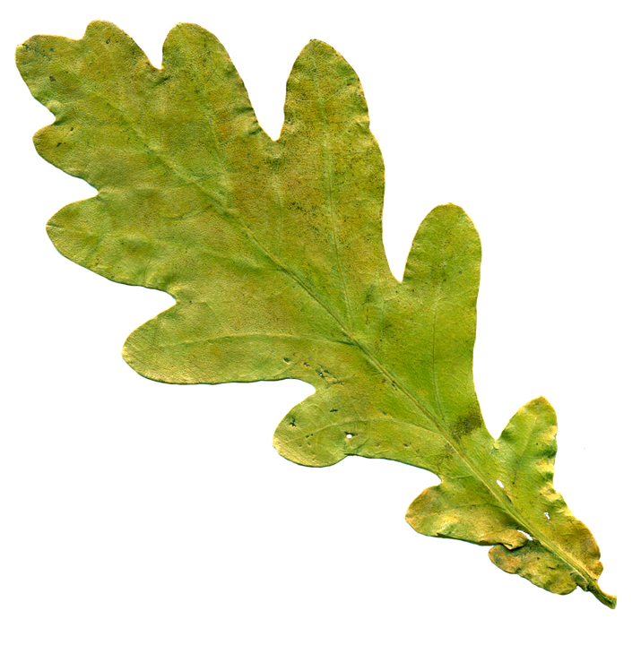
(SC.6.N.3.2)
1a | leaf has 3 or less lobes | Aspen
1b | leaf has more than 3 lobes | Go to 2
2a | Leaf has sharp, pointed edges | Maple
2b | Leaf has smooth, rounded edges | Go to 3
3a | Leaf is long and narrow | Oak
3b | Leaf is short and fat | Hawthorne

The identified leaf is:
A.) Aspen
B.) Hawthorne
C.) Maple
Photo Credit: https://pixabay.com/en/sheet-oak-leaf-yellowed-sheet-1029164/
D.) Oak

Blackline Master 8 – ANSWER KEYS

Dichotomous Key Reflection ANSWER KEY
- Use your dichotomous key to identify your mystery organism. What is your mystery organism? student responses will vary
- What are some of the characteristics of your mystery organism? student responses will vary
- How is your mystery organisms similar to or different than one of the organisms that you’ve already researched?
Ways they’re similar | Ways they’re different
student responses will vary | student responses will vary

- Which of the organisms that you’ve already researched do you think is most closely related to your mystery organism? student responses will vary
- What evidence do you have that supports that these two organisms are the most closely related? student responses will vary but should include that they have shared characteristics.
- The graphic organizer you used to classify and organize your organisms is considered a “model.” Why do you think this tool is considered a model? student responses will vary but should include that it is a model because it diagrams or shows how the different organisms are related.
- How is your model (graphic organizer) helpful in learning about the classification of organisms? student responses will vary but should include that it helps you organize the organisms so that you can group them according to shared characteristics and lets you see which organisms are more closely related.
- A dichotomous key is also considered a “model.” Why do you think this tool is considered a model? student responses will vary but should include that the dichotomous key models the process of organizing organisms according to similarities and differences in physical characteristics.
- How is your model (dichotomous key) helpful in learning about the classification of organisms? student responses will vary but should include that a dichotomous key allows you to classify and identify new organisms based on the characteristics of known organisms.

Classification Learning Check ANSWER KEY

1.) Organisms are classified together in Domains and Kingdoms based upon: (SC.6.L.15.1)
A.) Their name
B.) Random selection
C.) Similar Characteristics
D.) The Scientist who discovered them

2.) When classifying organisms, all of the following are important except: (SC.6.L.15.1)
A.) The organism’s age
B.) The organism’s diet
C.) The organism’s movement
D.) The organism’s cellular structure

3.) What combination of shared characteristics would all plants have in common? (SC.6.L.15.1)
A.) Autotrophic and unicellular
B.) Autotrophic and multicellular
C.) Heterotrophic and unicellular
D.) Heterotrophic and multicellular

4.) What combination of shared characteristics would all animals have in common? (SC.6.L.15.1)
A.) Autotrophic and multicellular
B.) Autotrophic and unicellular
C.) Heterotrophic and multicellular
D.) Heterotrophic and unicellular

5.) How are models useful to the study of classification? (SC.6.N.3.2)
A.) Models help you see objects that are too small.
B.) Models allow you to work with dangerous objects
C.) Models allow you to show mathematical relationships.
D.) Models show you the relationships between organisms.

6.) Use the dichotomous key below to identify the mystery organism to the right.
(SC.6.N.3.2)
1a | leaf has 3 or less lobes | Aspen
1b | leaf has more than 3 lobes | Go to 2
2a | Leaf has sharp, pointed edges | Maple
2b | Leaf has smooth, rounded edges | Go to 3
3a | Leaf is long and narrow | Oak
3b | Leaf is short and fat | Hawthorne

The identified leaf is:
A.) Aspen
B.) Maple
C.) Oak
D.) Hawthorne
Photo Credit: https://pixabay.com/en/sheet-oak-leaf-yellowed-sheet-1029164/

