***The Last Supper***

**Blackline Master #1**

**The Case:**

You are walking along the beach after dinner, sometime after 9:00pm in Daytona Beach, FL. You come across detectives at a crime scene of a young woman (Jane Doe). The detectives have asked you (a forensic pathologist on vacation) to assist in determining the cause of death and the individual(s) responsible. In order to identify the victim and the individual who committed the crime, you need to question all the individuals whom the victim came in contact with the day before. Near the victim there was a substantial amount of body fluids (vomit). In order to gain more information about the victims last know location, you need to analyze the body fluid (vomit) to identify at which establishment the victim had eaten. The detectives have found receipts in the victims’ purse from the following restaurants:

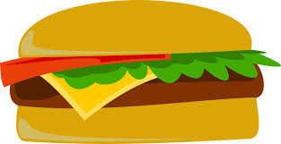***Burger Mania***

The victim loved to eat burgers with her friends at Burger Mania.

***What macromolecules would you expect to find in the stomach contents of the victim if the victim's final meal was eaten here?***

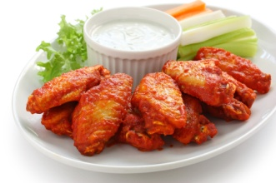***Wing House***

The victim would hang out here to watch sporting events while feasting on hot wings and celery.

***What macromolecules would you expect to find in the stomach contents of the victim if the victim's final meal was eaten here?***

***C:\Users\chapmanh\AppData\Local\Microsoft\Windows\Temporary Internet Files\Content.IE5\HZDMJR64\MC900112408[1].wmf***

***Olive Garden***

The victim loved to go here for a night of bread, olive oil, and pasta.

***What macromolecules would you expect to find in the stomach contents of the victim if the victim's final meal was eaten here?***

As a forensic pathologist, you have removed the contents of the victim’s stomach to analyze and determine where the victim had her last meal.

**Procedure:**

As you are completing each test make sure you are completing the TWO charts on your lab paper.

In order to analyze the contents of the body fluid (vomit) you need to utilize the following tests:

**BENEDICTS TEST (Glucose) – Beaker A:**

**GOGGLES MUST BE WORN FOR THE ENTIRE PERIOD.**

**GLOVES MUST BE WORN WHEN HANDLING CHEMICALS**

1) Add a spoon full of stomach contents to 50 ml beaker.

2) Add 10 drops of BENEDICTS SOLUTION to 50 ml beaker with contents.

3) Gently stir the contents of the beaker until you see a color change.

4) Place the 50 ml beaker in the hot water bath (250 ml beaker) for 10 minutes.

5) A negative test will result in a blue color. A positive test will result in an orange color. Record the color observed.

6) WASH THE BEAKER THOROUGHLY with the brush & soap.

**IODINE TEST (Starch) - Beaker B**

**Blackline Master #1**

**GOGGLES MUST BE WORN FOR THE ENTIRE PERIOD.**

**GLOVES MUST BE WORN WHEN HANDLING CHEMICALS**

1) Add a spoon full of stomach contents to beaker B.

2) Add 10 drops of IODINE SOLUTION to each beaker B.

3) Gently stir the contents of the beaker until you see a color change.

4) A negative test will result in a dark red color. A positive test will result in a black color. Record your observation.

5) WASH THE BEAKER THOROUGHLY with the brush & soap.

**BIURET TEST (Protein) - Beaker C**

**GOGGLES MUST BE WORN FOR THE ENTIRE PERIOD.**

**GLOVES MUST BE WORN WHEN HANDLING CHEMICALS**

1) Add a spoon full of stomach contents to test tube C

2) Add 10 drops of BIURET SOLUTION to each beaker C.

3) Gently stir the contents of the beaker until you see a color change.

4) A negative test will result in a blue color. A positive test will result in a violet/black color. Record the color observed.

5) WASH THE BEAKER THOROUGHLY with the brush & soap.

**LIPID TEST- Brown Paper Bag Square**

**GOGGLES MUST BE WORN FOR THE ENTIRE PERIOD.**

**GLOVES MUST BE WORN WHEN HANDLING CHEMICALS**

1) Add 3 drops of the stomach contents onto the brown paper bag square (3 inch by 3 inch).

2) Wait 3 minutes until the liquid has settled.

3) Wipe off excess vomit from brown paper bag.

4) Hold up the paper bag piece (3 inch by 3 inch) to the light and look at each spot. The foods that contain lipids will leave a greasy mark that turns the brown paper bag translucent.

5) Record your observations.

6) Dispose of the sample and brown paper bag.

***The Last Supper Results***

**Blackline Master #2**

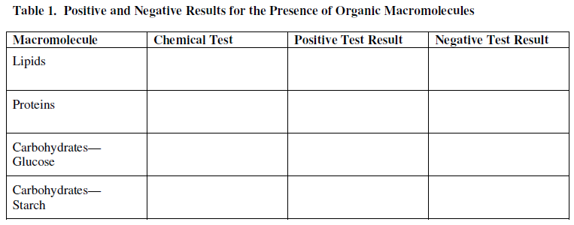

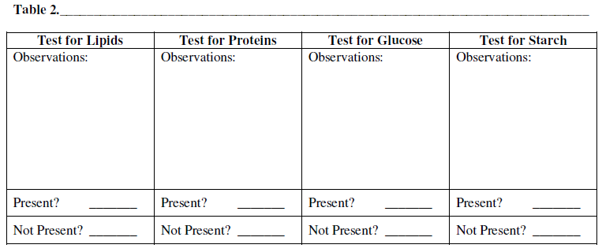

***KEY The Last Supper Results***

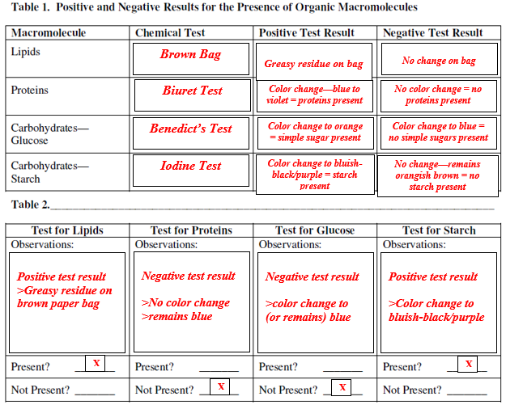

**Blackline Master #2**

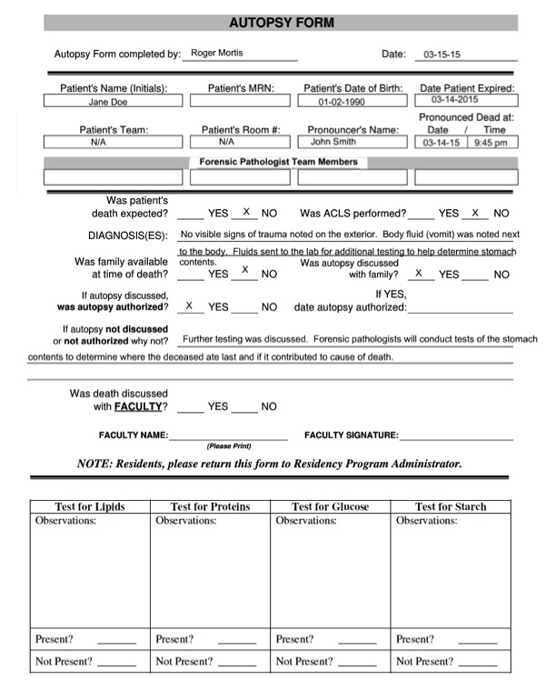

**Blackline Master #3**

**Blackline Master #3**

**Autopsy Report Answer Key**



***Possible answers may include: Brown bag is translucent or greasy***

X

X

X

X

***Possible answers may include: Solution will turn blueish***

**Possible answers may include:**

**Solution will turn orange**

***Possible answers may include:***

***Solution will turn Black***

**Blackline Master #4**

**Claim/Evidence/Justification Worksheet**

|  |  |
| --- | --- |
| **Guiding Question: Where did Jane Doe have her last supper?** | |
| **Claim:** *(make a statement where Jane Doe ate her last meal)* | |
| **Evidence** | **Justification** |
| *(****put*** *your data, graphs, text, etc. that helps to support your claim here)* | *(****explain how*** *your data, graphs, text, etc helps to support your claim here)* |

**Example Claim/Evidence/Justification Worksheet**

**Blackline Master #4**

|  |  |
| --- | --- |
| **Guiding Question: Where did Jane Doe have her last supper?** | |
| **Claim: *Jane Doe ate at Olive Garden before her death.*** | |
| **Evidence** | **Justification** |
| *(****put*** *your data, graphs, text, etc. that helps to support your claim here)*  *Students should write their final data table here and any information from the scenario that would be important to their case.* | *(****explain how*** *your data, graphs, text, etc helps to support your claim here)*  *Answers will vary, but should explain how the presence or absence of a certain macromolecule would support their claim.* |

|  |  |  |  |  |  |  |
| --- | --- | --- | --- | --- | --- | --- |
| **Macromolecule**  **Blackline Master #5** | **Elements Ratio** | **Suffixes** | **Function** | **Monomer** | **Examples (Food)** | **Structure** |
| Carbohydrates |  |  |  |  |  |  |
| Lipids |  |  |  |  |  |  |
| Protein |  |  |  |  |  |  |
| Nucleic Acids |  |  |  |  |  |  |

|  |  |  |  |  |  |  |
| --- | --- | --- | --- | --- | --- | --- |
| **Macromolecule** | **Elements Ratio** | **Suffixes** | **Function** | **Monomer** | **Examples (Food)** | **Structure** |
| Carbohydrates | 1:2:1 | **OSE** | **- Short term energy storage**  - **Structure (cell walls & exoskeletons)** | Monosaccharide | -**Glycogen**  **-Chitin**  **-Cellulose**  **-Glucose fructose galactose**  **-sucrose lactose maltose** | imgres |
| Lipids | No fixed ratio | Possible answers vary | **- Long term energy storage**  **- Insulates body**  **- Cushions body organs** | Triglyceride  (Glycerol + 3 fatty acids) | **Fats, Waxes, Oils, Steroids** | imgres |
| Protein | No fixed ratio | ASE | **-Transports O2**  **-Structural support**  **-Enzymes**  **-Receptors (cell membranes) - Defense** | Amino Acids (20) | * **Hemoglobin** * **Catalase** * **Antibodies** * **Keratin (hair, nails)** * **Actin/Myosin (muscles)** | imgres |
| Nucleic Acids | No fixed ratio | Possible answers vary | **- Instructions for making proteins - Genetic information passed from parent to offspring** | Nucleotide  (5-C sugar + phosphate + nitrogen  base) | DNA  RNA | images |

**Blackline Master #5**

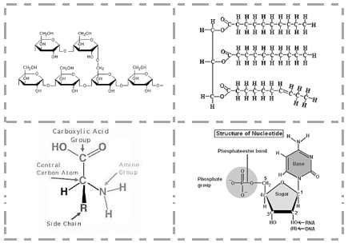**Macromolecules Structure Cut-Outs**

**Blackline Master #6**



**ould be given approximatelytudent)te with one another**

**Blackline Master #7**

**Fan N Pick Scenario Cards**

Animals like whales and seals have a thick layer of blubber, fatty tissue, under their skin. How would these animals be better adapted to colder environments where food sources are limited?

Describe a dinner a marathon runner would eat the night before running the Boston Marathon, and give reasons for your food choices.

What advice would you give someone who asked you “what foods should I eat to increase my nucleic acid intake?”

Proteins carry out several different functions in the body. What about protein’s structure allows it to be so versatile?

You are competing in a 50-day survival challenge and can choose only one type of food to bring. What food do you choose and why: lard, meat, or bread?

Where do we get most of the building blocks for our macromolecules?

**Fan N Pick Scenario Cards Answer Key**

**Blackline Master #7**

**1. Describe a dinner a marathon runner would eat the night before running the Boston Marathon, and give reasons for your food choices.** The dinner should include many forms of carbohydrates and some proteins (for examples pasta and meat) The carbohydrates provide and energy source and proteins help to build and repair muscles.

**2. Animals like whales and seals have a thick layer of blubber, fatty tissue, under their skin. How would these animals be better adapted to colder environments where food sources are limited?** Fat is long-term energy storage; the blubber can supply the animal with energy when they don't eat for a long period of time.

**3. What advice would you give someone who asked you “what foods should I eat to increase my nucleic acid intake?** All living things contain nucleic acids, so they can just eat more of any once living food source.

4. **Proteins carry out several different functions in the body. What about protein’s structure allows it to be so versatile?** The R group in the protein structure is interchangeable. A different R group is used based on the protein’s function.

**5. Where do we get most of the building blocks for our macromolecules?** We receive most of our building blocks from the food we eat.

**6.** **You are competing in a 50-day survival challenge and can choose only one type of food to bring. What food do you choose and why: lard, meat, or bread?** Lard; the lipid would supply you with the long term energy you would need to survive the 50-day challenge.

**Quiz Quiz Trade Cards**

**Blackline Master #8**

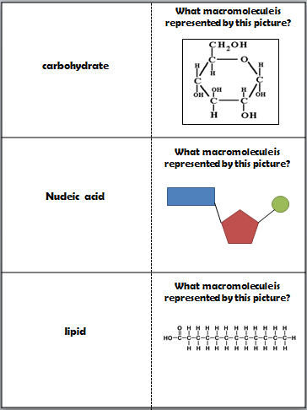

**Blackline Master #8**

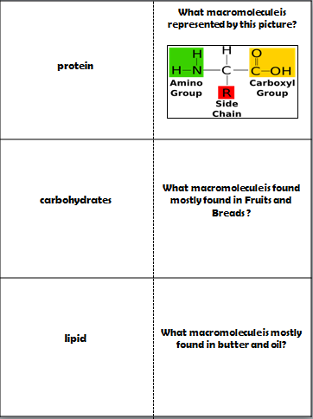

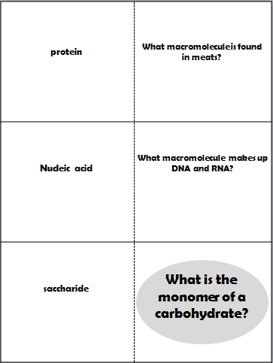

**Blackline Master #8**

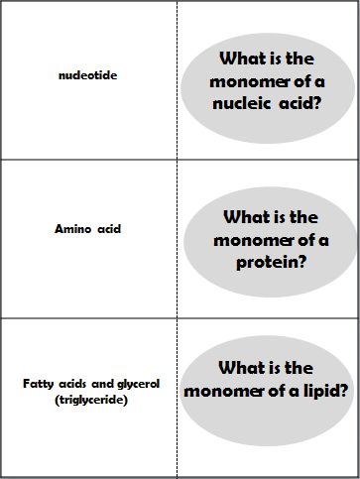

**Blackline Master #8**

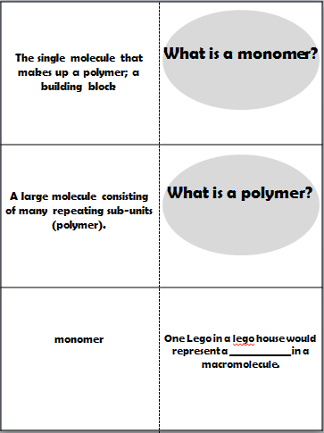

**Blackline Master #8**

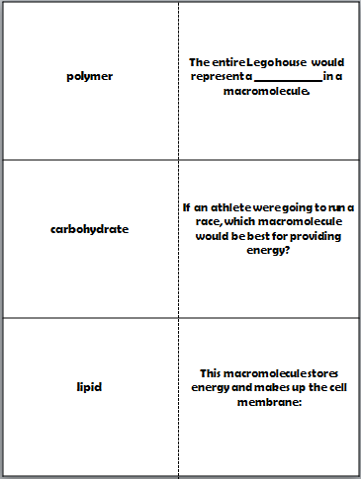

**Blackline Master #8**

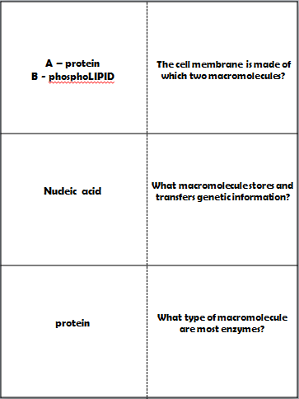

**Blackline Master #8**

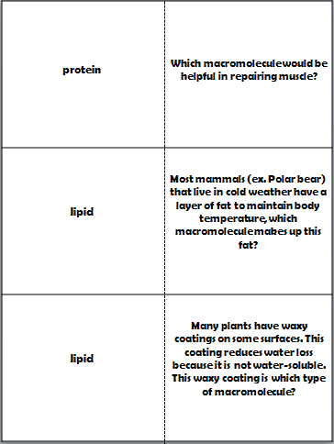

**Blackline Master #8**

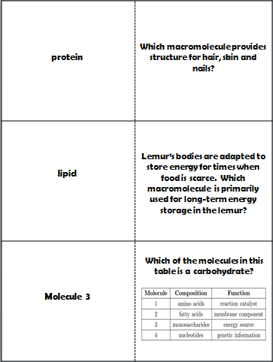

**Blackline Master #8**

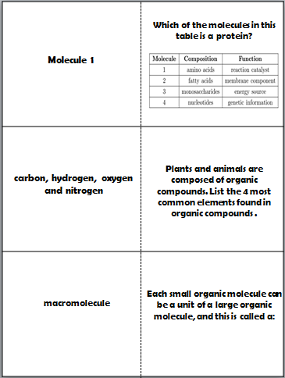

**Blackline Master #8**

**Macromolecule Check for Understanding**

**Blackline Master #9**

1. A biologist was given a sample of an unknown organic macromolecule and asked to determine the class of organic macromolecules to which it belonged. The chart shown below represents the results of the biologist’s analysis of the sample. Based on these results, to which class of organic macromolecules did this sample belong? *(SC.912.L.18.1)*

|  |  |
| --- | --- |
| **Element** | **Number of Atoms per molecule** |
| C | 6 |
| H | 12 |
| O | 6 |
| K | 0 |
| N | 0 |
| P | 0 |

a. lipid

b. protein

c. nucleic acid

d. carbohydrate

2. Proteins do all of the following things in the body, except which of the following? *(SC.912.L.18.1)*

a. digest food

b. carry genetic information

c. carry oxygen in the blood

d. speed up chemical reactions

3. Leon has a big football game this evening. What macromolecule should he load up on during dinner to ensure that he has enough energy for the big game? *(SC.912.L.18.1)*

a. carbohydrate

b. protein

c. nucleic acid

d. lipid

4. Storing energy is the primary function of two macromolecules. What macromolecule is represented by the structure below? *(SC.912.L.18.1)*

a. carbohydrate

b. protein

c. nucleic acid

d. lipid

5. If Jennifer wanted to grow her hair out without fear of it breaking or becoming damaged, what macromolecule should she increase in her daily diet? *(SC.912.L.18.1)*

a. protein

b. lipid

c. nucleic acid

d. carbohydrate

6. You are working with compound in a laboratory. You figure out the structure and see that it is made up of carbon, hydrogen, and oxygen in a ratio of two hydrogen atoms for each carbon atom. How could you best classify this compound? *(SC.912.N.1.1, SC.912.L.18.1)*

a. lipid

b. protein

c. carbohydrate

d. nucleic acid

**Macromolecule Check for Understanding**

**Blackline Master #9**

|  |  |
| --- | --- |
| **Element** | **Number of Atoms per molecule** |
| C | 6 |
| H | 12 |
| O | 6 |
| K | 0 |
| N | 0 |
| P | 0 |

1. A biologist was given a sample of an unknown organic macromolecule and asked to determine the class of organic macromolecules to which it belonged. The chart shown below represents the results of the biologist’s analysis of the sample. Based on these results, to which class of organic macromolecules did this sample belong? (SC.912.L.18.1)

a. lipid

b. protein

c. nucleic acid

d. carbohydrate

2. Proteins do all of the following things in the body, except which of the following? (SC.912.L.18.1)

a. digest food

b. carry genetic information

c. carry oxygen in the blood

d. speed up chemical reactions

3. Leon has a big football game this evening. What macromolecule should he load up on during dinner to ensure that he has enough energy for the big game? (SC.912.L.18.1)

a. carbohydrates

b. proteins

c. nucleic acids

d. lipids

4. Storing energy is the primary function of two macromolecules. What macromolecule is represented by the structure below? (SC.912.L.18.1)

a. carbohydrate

b. protein

c. nucleic acid

d. lipid

5. If Jennifer wanted to grow her hair out without fear of it breaking or becoming damaged, what macromolecule should she increase in her daily diet? (SC.912.L.18.1)

a. proteins

b. lipids

c. nucleic acids

d. carbohydrates

6. You are working with compound in a laboratory. You figure out the structure and see that it is made up of carbon, hydrogen, and oxygen in a ratio of two hydrogen atoms for each carbon atom. How could you best classify this compound? (SC.912.N.1.1; SC.912.L.18.1)

a. lipid

b.protein

c. carbohydrate

d. nucleic acid