Virtual Flower Dissection Lab
Blackline Master #1
Website: http://www.bbc.co.uk/schools/scienceclips/ages/9_10/life_cycles.shtml

1. Click full screen.
2. Take the flower apart and try to match the flower piece with the name. (drag the flower piece to its name).
3. When you are done matching. Click ok.

4. Now click each magnifying glass and record the functions of each of the plant pieces below.

a. Petals:

b. Sepals:

c. Nectaries:

d. Carpel:

e. Stamens:

f. Receptacle:

5. Click Label.
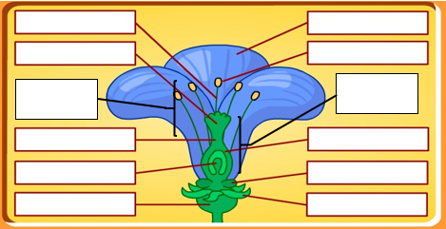
6. Drag each word to the correct blank. Label the flower below when you have finished (you will need it for the online quiz).

7. Click ok and then click quiz. Record your score here:
Flower Dissection Lab
Blackline Master #2

Purpose: How does each structure within a flower aid in sexual reproduction?

Background information: Flowers are the structures used by some plants to help with sexual reproduction. Flowers contain both female and male parts. Inside the ovule, a cell undergoes meiosis to form the egg. The male cells (pollen) are created by meiosis in the anther. Fertilization of the egg happens when pollen is delivered to the stigma of the pistil and travels down to the egg. The fertilization of the egg results in the formation of a seed. Usually when the seed begins to develop, the flower parts die.

Procedure: You will be dissecting a flower in order to identify specific structures responsible for sexual reproduction. You may need to use your virtual flower dissection activity to use as a reference to identify the flower structures.

Part I – Macro-observations (Data Table 1)
1. Examine your flower (with the hand lens). Locate the sepals and petals. Record the numbers, sizes, and colors.
2. Remove the sepals and petals from your flower by gently pulling them off the stem with your tweezers. Locate the stamens. Identify the filament and the anther.
3. Locate the pistil. The stigma at the top of the pistil is often sticky. The style is a long, narrow structure that leads from the stigma to the ovary.
4. Slice the ovary in half length-wise with a scalpel. Take your hand lens and exam each half. Notice the many, small, dot-like structures that fill the two halves. These are the ovules.

Flower Parts | Description of Function | Place Sample of Structure Here
Sepals
Petals

Flower Parts | Description of Function | Place Sample of Structure Here
Stamens
(make sure to label the filament and the anther portions)
Style
Stigma
Ovary
Ovules

Part II – Microscopic observations (Data Table 2)
1. Cut the anther in very small pieces with your scalpel.
2. Place one small, thin piece of the anther onto a microscope slide, add a drop of water, and place a cover slip on top of the specimen.
3. Examine the anther under low power, then medium, and then finally high power. Draw your observations under Data Table 2. The small, dot-like structures are the pollen grains.

Data Table 2

Drawing of anther under high power Total magnification:

Roots and Shoots Lab
Blackline Master #3
Carefully investigate the plant and record your observations, predictions, and research.
Structure |  | Observations | Predicted Function | Actual Function
Shoot | Stem
 | Leaf
 | Seed or Flower
Root | Tap Root
 | Lateral Root
 | Root Hair
 | Root Cap
Label the diagrams below based on your findings.
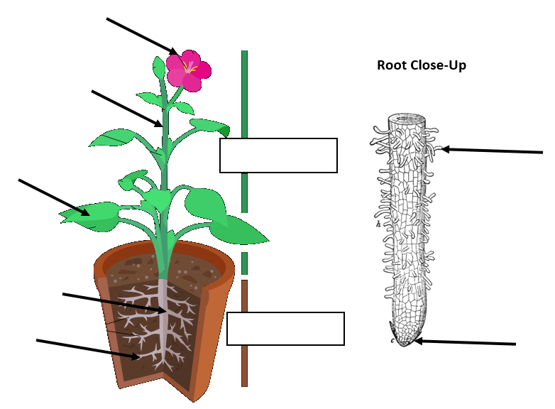

https://commons.wikimedia.org/wiki/File:Plant.svg

- Using the plant and/or the pictures, how might the function of the “tap root” be different than the function of the “root hairs?”

2. How does the structure and function of the SHOOT compare to that of the ROOT?
Similarities in Structure | Similarities in Function | Differences in Structure | Differences in Function
Vascular Tissues Lab
Blackline Master #4
Carefully investigate the plant and record your observations, predictions, and research.
Structure | Observations | Predicted Function | Actual Function
Ground Tissue
Dermal Tissue
Cambium
Xylem
Phloem
Pith
Label the diagrams below based on your findings.
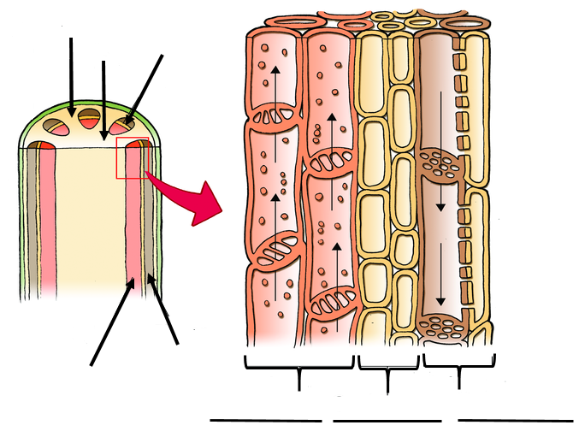
http://cnx.org/contents/9d8e911b-e813-4660-a63e-67f153dd9e2b@1/1.4.2-Plant-Tissues

Transpiration is the process by which moisture is carried through the plant from the roots to small pores on the underside of leaves where it then evaporates. The xylem and phloem are both essential to the process of transpiration. Explain their role in this process.

Explain how water is able to move UP the plant, against gravity, without anything to “pump” it up to those parts of the plant (think about the properties of water that you’ve learned about to help you explain).

Meristem tissue is found at the tips of the stems, tips of the roots, and tips of leaf buds. Based on their location on the plant, what do you predict is the function of meristem tissue? Explain your prediction.

Plant Physiology Assessment
Blackline Master #5

1. Petals are modified leaves that surround the reproductive parts of flowers. These modified leaves are typically colored and can produce a scent. Which of the following best explains how a petal structure is used in plant processes?
- attracts insects for pollination
- male part of the flower produces pollen here
- chloroplasts use light energy here to produce glucose
- location for male and female reproductive cells to unite in fertilization
2. Many terrestrial plant leaves have a waxy covering produced by the dermal tissues called the cuticle. If this waxy covering was overproduced so that the stomata became clogged, what would happen to the plant?
A. The plant would not be able to absorb water and oxygen from the air, and the plant would dry out, limiting most cell functions.

B. The plant would not be able to exchange oxygen and carbon dioxide, and the plant's ability to perform photosynthesis would be limited.

C. Glucose produced during photosynthesis would be prevented from reaching the rest of the plant, and energy production by cellular respiration would stop.

D. Sunlight would not be able to reach the plant's ground tissue cells through the thick dermal tissue, and the plant's ability to perform photosynthesis would be damaged.

3. If a plant's leaves developed so that its vascular tissue only contained xylem, how would this affect the rest of the plant's physiological processes?
A. Since most parts of the plant contain chloroplasts, the plant's cells would function as usual without a need for glucose from the leaves.

B. The carbon dioxide required for photosynthesis would not be absorbed and transported to the leaf cells, and photosynthesis would stop.

C. The glucose produced during photosynthesis in the leaf cells would not be able to reach the rest of the plant, and the cellular respiration in the plant's other cells would not function.

D. The plant's ground tissues would still be able to transport the water and nutrients from the roots to the rest of the plant, and so other processes like photosynthesis would continue as usual

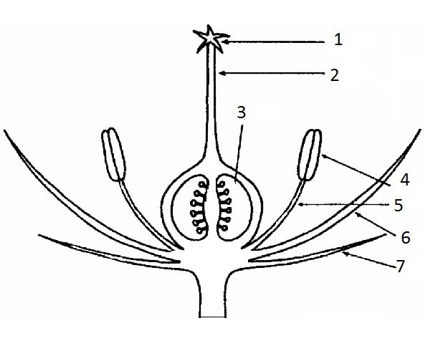
4. What numbers on the diagram include the structures of the female reproductive parts of a flower?
- 1 and 2
- 2 and 4
- 3 and 4
- 5 and 6
5. Meristem tissue is found at the tips of the stems, tips of the roots, and tips of leaf buds. Based on their location on the plant, what is the function of meristem tissue?
A. absorption of nutrients
B. growth
C. photosynthesis
D. reproduction

Blackline Master #6 ANSWER KEYS
Virtual Flower Dissection
Website: http://www.bbc.co.uk/schools/scienceclips/ages/9_10/life_cycles.shtml

1. Click full screen.
2. Take the flower apart and try to match the flower piece with the name. (drag the flower piece to its name).
3. When you are done matching. Click ok.

4. Now click each magnifying glass and record the functions of each of the plant pieces below.
a. Petals: attract insects, such as bees and butterflies

b. Sepals: protect the flower while it’s still a bud

c. Nectaries: makes nectar

d. Carpel: where seed is made

e. Stamens: male part of the flower that makes pollen

f. Receptacle: where petals adhere to

5. Click Label.
6. Drag each word to the correct blank. Label the flower below when you have finished (you will need it for the online quiz).
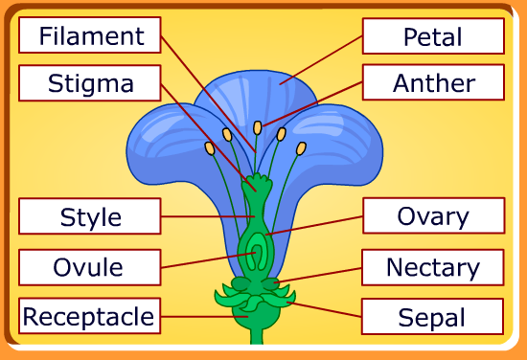
Flower Dissection

Purpose: How does each structure within a flower aid in sexual reproduction?

Background information: Flowers are the structures used by some plants to help with sexual reproduction. Flowers contain both female and male parts. Inside the ovule, a cell undergoes meiosis to form the egg. The male cells (pollen) are created by meiosis in the anther. Fertilization of the egg happens when pollen is delivered to the stigma of the pistil and travels down to the egg. The fertilization of the egg results in the formation of a seed. Usually when the seed begins to develop, the flower parts die.

Procedure: You will be dissecting a flower in order to identify specific structures responsible for sexual reproduction. You may need to use your virtual flower dissection activity and/or pg
687 in your whale book to use as a reference to identify the flower structures.

Part I – Macro-observations (Data Table 1)
1. Examine your flower (with the hand lens). Locate the sepals and petals. Record the numbers, sizes, and colors.
2. Remove the sepals and petals from your flower by gently pulling them off the stem with your tweezers. Locate the stamens. Identify the filament and the anther.
3. Locate the pistil. The stigma at the top of the pistil is often sticky. The style is a long, narrow structure that leads from the stigma to the ovary.
4. Slice the ovary in half length-wise with a scalpel. Take your hand lens and exam each half. Notice the many, small, dot-like structures that fill the two halves. These are the ovules.

Data Table 1
Flower Parts | Description of Function | Place Sample of Structure Here
Sepals | Protects developing flower bud before opening
Petals | Attracts insects and other  pollinators to plant

Stamens  (make sure to label the filament and the anther portions) | Anther – holds and makes pollen grains  Filament – holds pollen up to allow easier access by pollinators
Style | Pollen travels through this long tube to get to the ovary
Stigma | Sticky top of the style that allows for capture of pollen grains
Ovary | Style leads to the ovary. Holds the ovules (location of fertilization). Also, upon fertilization, turns into a fruit.
Ovules | Female gametes. Upon fertilization, these turn into seeds.

Part II – Microscopic observations (Data Table 2)
4. Place the anther from one of the stamens onto a microscope slide and add a drop of water.
5. Cut the anther in very small pieces with your scalpel.
6. Examine the anther under low power, then medium, and then finally high power. Draw your observations under Data Table 2. The small, dot-like structures are the pollen grains.

Drawing of anther under high power Total magnification:

Pollen grains look like small, yellow
circles under the microscope.

Roots and Shoots
Carefully investigate the plant and record your observations, predictions, and research.
Structure |  | Observations | Predicted Function | Actual Function
Shoot | Stem | answers will vary | answers will vary | They support the plant. They act like the plant's plumbing system, conducting water and nutrients from the roots and food in the form of glucose from the leaves to other plant parts.
 | Leaf | answers will vary | answers will vary | Leaves are designed to capture sunlight which the plant uses to make food
 | Seed or Flower | answers will vary | answers will vary | Reproductive parts of the plant
Root | Tap Root | answers will vary | answers will vary | The main anchor for the growing plant. absorbs nutrients and water
 | Lateral Root | answers will vary | answers will vary | Anchor the plant securely into the soil; absorbs nutrients and water
 | Root Hair | answers will vary | answers will vary | Roots act like straws absorbing water and minerals from the soil.
 | Root Cap | answers will vary | answers will vary | Allows for root growth; paves the way for lengthening of the plant
Label the diagrams below based on your findings.

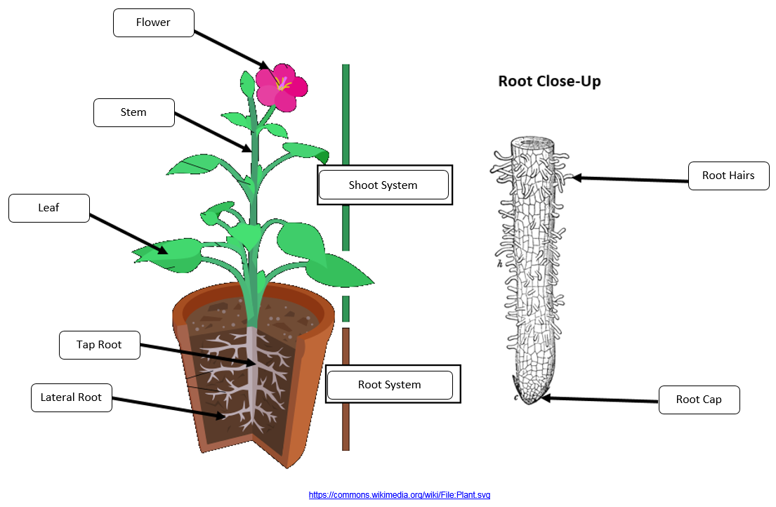
Using the plant and/or the pictures, how might the function of the “tap root” be different than the function of the “root hairs?”
Root hairs are more for water and nutrient absorption and provide little anchoring. The tap root is primarily for anchoring the plant.
How does the structure and function of the SHOOT compare to that of the ROOT?
Similarities in Structure | Similarities in Function | Differences in Structure | Differences in Function
answers will vary;  both long and cylindrical | answers will vary;  both transport water and nutrients to the plant | shoot has leaves and fruit/seeds, roots are typically white and hair-like | shoot is more photosynthetic’ root is primarily for water and nutrient absorption and anchoring
Vascular Tissues Lab
Carefully investigate the plant and record your observations, predictions, and research.
Structure | Observations | Predicted Function | Actual Function
Ground Tissue | answers will vary | answers will vary | photosynthesis, storage, regeneration, support, and protection.
Dermal Tissue | answers will vary | answers will vary | protect the plant from injury and water loss
Cambium | answers will vary | answers will vary | The cells in the cambium divide and multiply with the plant's secondary growth, which increases its girth size.
Xylem | answers will vary | answers will vary | transport water from roots to shoots and leaves, but it also transports some nutrients
Phloem | answers will vary | answers will vary | transports a water-based solution, rich in sugars made by photosynthesis
Pith | answers will vary | answers will vary | store and transport nutrients throughout the plant
Label the diagrams below based on your findings.
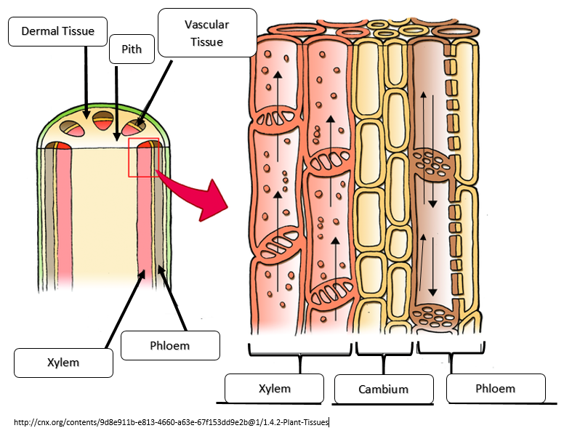
Transpiration is the process by which moisture is carried through the plant from the roots to small pores on the underside of leaves where it then evaporates. The xylem and phloem are both essential to the process of transpiration. Explain their role in this process. The xylem transports water from the roots to the leaves. The phloem transports sugar and nutrients to all the different parts of the plant.

Explain how water is able to move UP the plant, against gravity, without anything to “pump” it up to those parts of the plant (think about the properties of water that you’ve learned about to help you explain). When water evaporates out of the leaves through transpiration, it creates a negative pressure which draws water up through the plant through the xylem. Water is able to stick together to move up through the xylem by cohesion.

Meristem tissue is found at the tips of the stems, tips of the roots, and tips of leaf buds. Based on their location on the plant, what do you predict is the function of meristem tissue? Explain your prediction.
Because it is at the ends of all these parts, it is most likely to function in the growth of the plant. Plants grow from the ends of their parts.
Assessment
1. Petals are modified leaves that surround the reproductive parts of flowers. These modified leaves are typically colored and can produce a scent. Which of the following best explains how a petal structure is used in plant processes?
A. attracts insects for pollination
- male part of the flower produces pollen here
- chloroplasts use light energy here to produce glucose
- location for male and female reproductive cells to unite in fertilization
2. Many terrestrial plant leaves have a waxy covering produced by the dermal tissues called the cuticle. If this waxy covering was overproduced so that the stomata became clogged, what would happen to the plant?
A. The plant would not be able to absorb water and oxygen from the air, and the plant would dry out, limiting most cell functions.

B. The plant would not be able to exchange oxygen and carbon dioxide, and the plant's ability to perform photosynthesis would be limited.

C. Glucose produced during photosynthesis would be prevented from reaching the rest of the plant, and energy production by cellular respiration would stop.

D. Sunlight would not be able to reach the plant's ground tissue cells through the thick dermal tissue, and the plant's ability to perform photosynthesis would be damaged.

3. If a plant's leaves developed so that its vascular tissue only contained xylem, how would this affect the rest of the plant's physiological processes?
A. Since most parts of the plant contain chloroplasts, the plant's cells would function as usual without a need for glucose from the leaves.

B. The carbon dioxide required for photosynthesis would not be absorbed and transported to the leaf cells, and photosynthesis would stop.

C. The glucose produced during photosynthesis in the leaf cells would not be able to reach the rest of the plant, and the cellular respiration in the plant's other cells would not function.

D. The plant's ground tissues would still be able to transport the water and nutrients from the roots to the rest of the plant, and so other processes like photosynthesis would continue as usual

4. What numbers on the diagram include the structures of the female reproductive parts of a flower?
- 1 and 2
- 2 and 4
- 3 and 4
- 5 and 6
5. Meristem tissue is found at the tips of the stems, tips of the roots, and tips of leaf buds. Based on their location on the plant, what is the function of meristem tissue?
A. absorption of nutrients
B. growth
C. photosynthesis
D. reproduction

