**Blackline Master #1**

**Human Development Description Cards**

|  |  |
| --- | --- |
| * The embryo is 2 mm in length and has a mass of 100 mg. * The brain, spinal cord, and heart begin to develop. * The gastrointestinal tract begins to develop. | * The fetus is 7cm to 9 cm in length and has a mass of 28 g. * Fingers and toes are distinct. * Placenta is complete. * Fetal circulation is complete. * Organ systems are complete. |
| * The embryo is 4 mm in length and has a mass of 300 mg. * Arm and leg buds become visible. * The brain develops into five areas and some cranial nerves are visible. * The eyes and ear structures begin to form. * Tissue forms that develops into the vertebra and some other bones. * The heart continues to develop and now pumps in a regular rhythm. * Rudimentary blood moves through the main vessels. | * The fetus is 10 cm to 17 cm in length and has a mass of 55 g to 120 g. * The external genitalia are visible. * The newly formed kidneys begin to excrete urine. * The heartbeat is present. * Nasal septum and palate (in nose/mouth region) close. |
| * The embryo is 1.6 cm to 2.3 cm in length and has a mass of 1 g to 2 g. * The arms and legs have grown longer, and foot and hand areas can be distinguished. * The hands and feet have fingers and toes (digits), but may still be webbed. * The brain continues to form. * The lungs begin to form. | * The fetus is 25 cm in length and has a mass of 223 g. * A very soft, fine hair (lanugo) covers the entire body. * Fetal movements can be felt by the mother. The heartbeat can be heard with a stethoscope. |
| * The embryo is 3.1 cm to 4.1 cm in length and has a mass of 4 g to 7 g. * Nipples and hair follicles form. * Elbows and toes are visible. All essential organs have begun to form. * The eyelids are more developed. * External features of the ear begin to take their final shape. * Facial features continue to develop. * The intestines rotate. | * The fetus is 28 cm to 36 cm in length and has a mass of 680 g. * The skin appears wrinkled. * A waxy or cheese-like white substance that coats the skin (vernix caseosa) begins to develop. * Eyebrows and fingernails develop. |
| * The fetus is 35 cm to 38 cm in length and has a mass of 1200 g. * The skin has a distinct pink/red color. The membrane on the eyes begins to disappear. * The fetus has an excellent chance of survival on its own. * The eyes can open and close. | * The fetus is 38 cm to 43 cm in length and has a mass of 1500 to 2500 g. * The fetus is viable and could now survive on its own. * The fingerprints are formed. * Vigorous fetal movements occur. |
| * The fetus is 42 cm to 49 cm in length and has a mass of 1900 g to 2700 g. * Face and body have a loose wrinkled appearance, because of subcutaneous fat deposits. * The very soft, fine hair covering the body (lanugo) disappears. * The amniotic fluid begins to decrease. | * The fetus is 48 cm to 53 cm in length and has a mass of 3000 g. * The skin is smooth. * The eyes are uniformly slate (bluish) colored. * Bones of skull are ossified and nearly together at the sutures. |

**Blackline Master #2**

|  |  |
| --- | --- |
|  |  |
|  |  |
|  |  |

|  |  |
| --- | --- |
|  |  |
|  |  |
|  |  |

**Blackline Master #3**

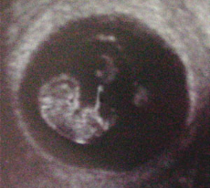**Case Study # 1**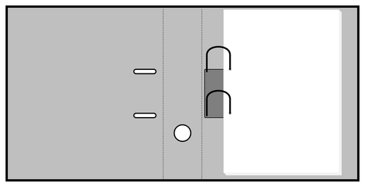

**Exam:** OB Ultrasound

**History:** A 29 year old female requests for size and date of pregnancy

**Findings:**

* Crown- to-Rump Measurement: 20mm to 30mm
* Length = 0.9 to 1.2 inch
* Weight = 2 g(0.07oz)
* Webbed hands and feet
* Cartilage and bones begin to form
* Upper lip and nose tip is being formed
* Tongue begins to develop and the larynx is developing
* Optic vessels visible but remain closed for several months
* Heartbeat detected

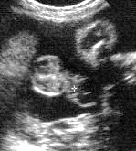**Case Study # 2**

**Exam:** OB Ultrasound

**History:** A 28 year old female requests for size and date of pregnancy

**Findings:**

* Crown –to-heel measurement: 46 cm
* Weight: 2400 grams
* Length: 18 inches
* Skull bones are pretty flexible and not completely joined
* Fat accumulations plumps up the arms and legs
* Eyes open when awake and close when sleeping
* Fingernails are completely formed
* Immune System is strengthening

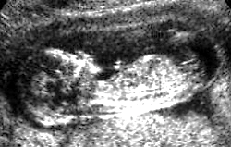**Case Study # 3**

**Exam:** OB Ultrasound

**History:** A 33 year old female requests for size and date of pregnancy

**Findings:**

* CRL Measurement: 74mm to 87 mm
* Length = 8cm
* Weight = 23g (0.8oz)
* Webbed hands and feet
* Bone replaces cartilage and ribs appear
* Nose and chin are well-defined
* Movements can be measured
* Child will begin to learn to suck its thumb
* Mouth can open/close
* External genitalia are almost defined

**Case Study # 4**

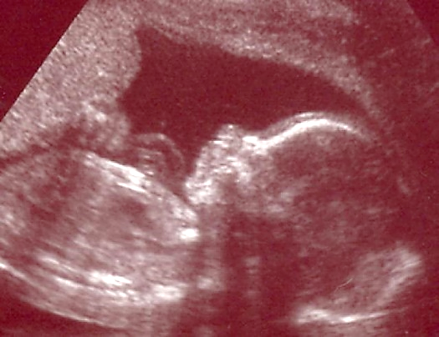

**Exam:** OB Ultrasound

**History:** A 25 year old female requests for size and date of pregnancy

**Findings:**

* Crown to heel measurement: 28cm
* Length = 11 inches
* Weight = 450 grams
* Fetus reacts to loud sounds
* Regular sleeping and waking rhythm
* Taste buds are forming on the tongue
* Eyebrows and eyelids are fully developed
* Fingernails cover the fingertips

**Case Study # 5**

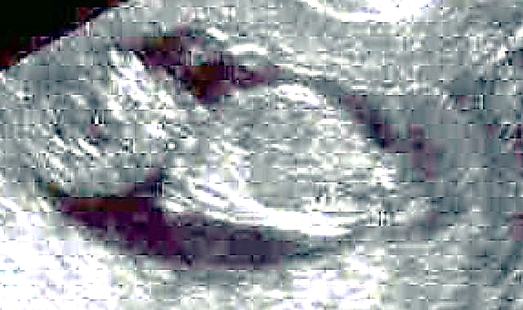

**Exam:** OB Ultrasound

**History:** A 31 year old female requests for size and date of pregnancy

**Findings:**

* Crown-to-rump: 1.5 inches (35mm)
* Weight = 0.18 ounce (5g)
* Taste buds are starting to develop
* Tooth buds are formed
* Baby can swallow and stick out tongue
* Sensitive to touch
* Cartilage now calcifying to become bone
* If a boy, testicles are starting to produce the testosterone hormone

**Case Study #6**

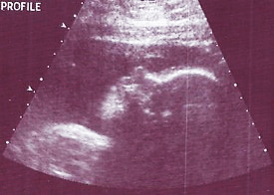

**Exam:** OB Ultrasound

**History:** A 34 year old female requests for size and date of pregnancy

**Findings:**

* Length: 37.5cm
* Weight = 1000 grams
* Brain waves show rapid eye movement (REM) sleep, which means the baby may be dreaming
* Feet are just over 2 inches (5.5cm) long
* Hair on the head is visible
* Milk teeth have developed under the gums
* Eyes are starting to move in their sockets
* Branches of lungs are quite developed
* Baby recognizes voices

**Blackline Master #4**

**Name_________________________________________Period_______Date_______________**

**Do You See What I See?**

**Student Lab Sheet**

**Instructions:** You are a doctor who has been assigned a special case study. You are trying to determine how far along a woman is in her pregnancy based on the ultrasound findings. For this activity your task is to learn all there is to know about the different stages of fetal development.

**1.) Matching -** Working with your group, match the picture of the embryo/fetus with the correct description card.

**2.) Reflecting -** Complete the table below to demonstrate your understanding of the different stages of pregnancy that you investigated.

**3.) Collaboration** - Next, compare your findings to another groups’ responses until you have completed all tables below. Finally, answer the questions about the trimesters of development that you investigated with your group.

**Trimesters of Development:**

|  |  |
| --- | --- |
| **Trimester : ________________** | **Descriptions** |
|  |  |
|  |  |
|  |  |
|  |  |
| **Trimester : ________________** | **Descriptions** |
|  |  |
|  |  |
|  |  |
|  |  |
| **Trimester : ________________** | **Descriptions** |
|  |  |
|  |  |
|  |  |
|  |  |

**Trimesters of Development Continued**

1. Human pregnancies are divided into trimesters. Approximately how many weeks are in each trimester? ______________________________________________________________________
2. During what trimester, or what week will the embryo become a fetus? _________________________________________________________________________________
3. During what trimester, or what week, will the embryo’s heart begin to beat? __________________________________________________________________________________
4. During what trimester, or what week will the fetus’ fingers and toes be fully formed? __________________________________________________________________________________
5. During what trimester, or what week will the fetus’ lungs be completely developed? __________________________________________________________________________________
6. Explain why the picture of the trimesters of development are considered a model. Explain some of the limitations of the model of the Trimesters of development.

______________________________________________________________________________________________________________________________________________________________________________________________________________________________________________________

**Blackline Master #5**

**Case Study Claim, Evidence, Justification**

* Working in your groups, you will become doctors to analyze a medical case study to determine which trimester your patient is in. Each case study will have a brief description of the patient and an ultrasound finding.
* You will state a claim as to which trimester you think your patient is in, provide evidence for your claim, and then provide justification for why your evidence supports your claim.
* Your group will present the case study and findings to the rest of the class.

|  |  |
| --- | --- |
| **Claim:** *(Write one or two sentences stating your claim)* | |
| **Evidence:** *(Use this column to record any evidence or analyzed data to support your claim.)* | **Justification:**  *(Use this column to defend your evidence using relevant scientific concepts.)* |

**Blackline Master #6**

**Human Development Quiz**

**1. All of the following will take place during the first trimester EXCEPT?** *(SC.912.L.16.13)*

A. lenses of the eye appear

B. heartbeat can be detected

C. wake and sleep cycles become regular

D. external sex organs show the sex of the fetus

**2. All of the following will take place during the second trimester EXCEPT?** *(SC.912.L.16.13)*

A. fetus makes urine

B. joints and bones begin to form

C. first movements are felt by mother

D. cerebral hemispheres begin to form

**Use the picture of the fetus below to answer questions 3 & 4.**

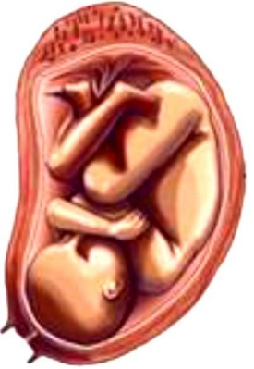

**3. During which trimester does the fetus grow to its largest size?** *(SC.912.L.16.13)*

A. first

B. second

C. third

D. fourth

**4. Why is it important for a fetus to reach at least 32 weeks before being born?** *(SC.912.L.16.13)*

A. To allow their kidneys to completely develop

B. To allow for their lungs to completely develop

C. To allow their bones and joints to completely develop

D. To allow their ovaries and testes to completely develop

**5. Models of the trimesters of development were used in this activity. Why are models important in science?** *(SC.912.N.3.5)*

A. Models can simplify, substitute, or stand-in for what you are actually studying.

B. Models can eliminate the danger when you have to work in dangerous conditions.

C. Models can show you an exact replica of what is happening or what you’re studying.

D. Models are the only tool that can help you communicate your ideas to other scientists.

**Blackline Master Answer Keys**

**Trimesters of Development:**

|  |  |
| --- | --- |
| **Trimester : ______1st______** | **Descriptions** |
|  | The embryo is 2 mm in length and has a mass of 100 mg.  The brain, spinal cord, and heart begin to develop.  The gastrointestinal tract begins to develop. |
|  | The embryo is 4 mm in length and has a mass of 300 mg. Arm and leg buds become visible. The brain develops into five areas and some cranial nerves are visible. The eyes and ear structures begin to form.  Tissue forms that develops into the vertebra and some other bones. The heart continues to develop and now pumps in a regular rhythm. Rudimentary blood moves through the main vessels. |
|  | The embryo is 1.6 cm to 2.3 cm in length and has a mass of 1 g to 2 g. The arms and legs have grown longer, and foot and hand areas can be distinguished.  The hands and feet have fingers and toes (digits), but may still be webbed.  The brain continues to form.  The lungs begin to form. |
|  | The embryo is 3.1 cm to 4.1 cm in length and has a mass of 4 g to 7 g.  Nipples and hair follicles form.  Elbows and toes are visible. All essential organs have begun to form.  The eyelids are more developed. External features of the ear begin to take their final shape.  Facial features continue to develop.  The intestines rotate. |

|  |  |
| --- | --- |
| **Trimester : ___2nd____** | **Descriptions** |
|  | The fetus is 7cm to 9 cm in length and has a mass of 28 g.  Fingers and toes are distinct.  Placenta is complete.  Fetal circulation is complete.  Organ systems are complete. |
|  | The fetus is 10 cm to 17 cm in length and has a mass of 55 g to 120 g. The external genitalia are visible. The newly formed kidneys begin to excrete urine. The heartbeat is present. Nasal septum and palate (in nose/mouth region) close. |
|  | The fetus is 25 cm in length and has a mass of 223 g.  A very soft, fine hair (lanugo) covers the entire body.  Fetal movements can be felt by the mother. The heartbeat can be heard with a stethoscope. |
|  | The fetus is 28 cm to 36 cm in length and has a mass of 680 g. The skin appears wrinkled. A waxy or cheese-like white substance that coats the skin (vernix caseosa) begins to develop. Eyebrows and fingernails develop. |
| **Trimester : ____3rd ____** | **Descriptions** |
|  | The fetus is 35 cm to 38 cm in length and has a mass of 1200 g. The skin has a distinct pink/red color. The membrane on the eyes begins to disappear.  The fetus has an excellent chance of survival on its own.  The eyes can open and close. |
|  | The fetus is 38 cm to 43 cm in length and has a mass of 1500 to 2500 g. The fetus is viable and could now survive on its own.  The fingerprints are formed.  Vigorous fetal movements occur. |
|  | The fetus is 42 cm to 49 cm in length and has a mass of 1900 g to 2700 g. Face and body have a loose wrinkled appearance, because of subcutaneous fat deposits. The very soft, fine hair covering the body (lanugo) disappears.  The amniotic fluid begins to decrease. |
|  | The fetus is 48 cm to 53 cm in length and has a mass of 3000 g.  The skin is smooth.  The eyes are uniformly slate (bluish) colored.  Bones of skull are ossified and nearly together at the sutures. |

**Case Study Answers:**

**Case Study # 1:** First Trimester- Week 9

**Case Study # 2:** Third Trimester- Week 34

**Case Study # 3:** Second Trimester- Week 13

**Case Study #4:** Second Trimester- Week 22

**Case Study #5:** First Trimester- Week 11

**Case Study #6:** Third Trimester – Week 28

**Quiz Answers:**

1. C 2. D 3. C 4. B 5. A