Blackline Master #1a

Ovary
Blackline Master #1b

Oviduct (fallopian tube) | Uterus
Cervix | Vagina
A muscular canal that joins the cervix (the lower part of uterus) to the outside of the body. It also is known as the birth canal. | A hollow, pear-shaped organ that is the home to a developing fetus. Also called the womb.
Blackline Master #1c

The lower part of the uterus which is strong and muscular. It has an opening to allow for the passage of menstrual blood, sperm, or a baby. | Small, oval-shaped glands that are located on either side of the uterus. These produce eggs and hormones.
Narrow tubes that are attached to the upper part of the uterus and serve as tunnels for the ova (egg cells) to travel from the ovaries to the uterus. This is normally where fertilization takes place.
Blackline Master #2a

Blackline Master #2b

Blackline Master #2c

seminal vesicle | prostate gland
epididymis | scrotum
vas deferens | urethra
penis | testicle
A muscular tube that passes upward alongside the testicles and transports sperm from the epididymis to the seminal vesicle. | A set of coiled tubes that connects to the vas deferens. This is where sperm are stored after they are produced.
A pouch-like structure that the epididymis and testicles hang in outside the pelvis. This acts as a climate-control system for the testes. | An oval body that is responsible for producing sperm and the male hormone, testosterone.
The channel that carries the semen and urine outside of the body through the penis. | Sac-like structures attached to the vas deferens that produce semen which lubricates and nourishes the sperm.
The male sex organ which is made of the shaft and the glans. | A gland at the base of the urethra which produces some parts of the semen.
Blackline Master #3a

Name_________________________________________Period_______Date______________

The Real Story of Where Babies Come From
Instructions: You are a scientist who is studying the sexual reproduction system and trying to understand how an individual is formed. For this activity your task is to learn about the different reproductive organs/structures and then develop a story explaining how an embryo is formed. This activity is divided up into four parts: matching, reflecting, collaborating, and creating.

1.) Matching - Working with your group, match the picture of the reproductive organ/structure with the correct name and description card.

2.) Reflecting - Complete the diagram and table below for the reproductive system that you investigated. Answer the questions about the system that you investigated.

Female Reproductive System:
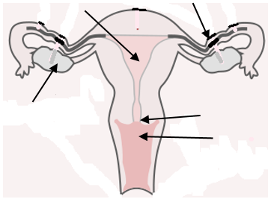
Organ/Structure | Main Function
Blackline Master #3b
Female Reproductive System Continued
a.) The female reproductive cell is the egg. Where do you think the eggs come from? Predict what their journey might be like once ovulation has occurred. Tell about the journey of the egg and the parts of the female reproductive system that they encounter along the way. ________________________________________________________________________________________________________________________________________________________________________________________________________________________________________________________________________________________________________________

b.) Explain why the picture of the female reproductive system is considered a model. Explain some of the limitations of the model of the female reproductive system. ____________________________________________________________________________
____________________________________________________________________________________________________________________________________________________________________________________________________________________________________

Male Reproductive System:
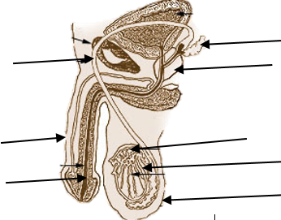
Organ/Structure | Main Function

Blackline Master #3c
Male Reproductive System Continued
a.) The male reproductive cell is the sperm. Where do you think the sperm come from? Predict what their journey might be like from the time they are formed to the time they exit the body. Tell about the journey of the sperm and the parts of the male reproductive system that they encounter along the way. ________________________________________________________________________________________________________________________________________________________________________________________________________________________________________________________________________________________________________________

b.) Explain why the picture of the male reproductive system is considered a model. Explain some of the limitations of the model of the male reproductive system. ________________________________________________________________________________________________________________________________________________________________________________________________________________________________________________________________________________________________________________

3.) Collaborating - Working in your same groups, join a different group (with the opposite reproductive system) and explain your findings. Also, be sure to record the other groups' findings in the appropriate table (above).

4.) Creating - Working in your new groups, create a story of your combined observations on the male and female reproductive systems and explain how these systems work together to create an individual. You may create a digital story, skit, picture book or something of your choosing to tell your story. Be sure to refer to the grading rubric for clarifications on expectations. At the end, all groups will share their stories with the entire class.

Grading Rubric
Category | 4 | 3 | 2 | 1
Title | Title is creative, sparks interest and is related to the story and topic | Title is related to the story and topic | Title is present, but does not appear to be related to the story and topic | No title
Creativity | The story contains many creative details and/or descriptions that contribute to the reader's enjoyment. The author has really used his imagination | The story contains a few creative details and/or descriptions that contribute to the reader's enjoyment. The author has used his imagination | The story contains a few creative details and/or descriptions, but they distract from the story. The author has tried to use his imagination | There is little evidence of creativity in the story. The author does not seem to have used much imagination
Focus on assigned topic | The entire story is related to the assigned topic and allows the audience to understand much more about the topic | Most of the story is related to the assigned topic. The story wanders off at one point, but the audience can still learn something about the topic | Some of the story is related to the assigned topic, but a audience does not learn much about the topic | No attempt has been made to relate the story to the assigned topic
Accuracy of facts | All facts presented in the story are accurate | Almost all facts presented in the story are accurate | Most facts presented in the story are accurate (at least 70%) | There are several factual errors in the story
Spelling and Punctuation | There are no spelling or punctuation. | There is one spelling or punctuation error | There are 2-3 spelling and punctuation errors | There are more than 3 spelling and punctuation errors
Blackline Master #4
Reproductive System & Fertilization Quiz

1. Sperm are created through meiosis in an area of the testes called the seminiferous tubules. Which of the following accurately describes the path that sperm take to exit the body? (SC.912.L.16.13)
A. through the epididymis to the urethra to the vas deferens
B. through the epididymis to the vas deferens to the urethra
C. through the vas deferens to the epididymis to the urethra
D. through the vas deferens to the urethra to the epididymis

2. Eggs are created through meiosis in an area of the ovary called a follicle. Which of the following accurately describes the path that an egg would take to exit the body? (SC.912.L.16.13)
A. through the fallopian tube to the vagina to the uterus
B. through the fallopian tube to the uterus to the vagina
C. through the uterus to the vagina to the fallopian tube
D. through the uterus to the fallopian tube to the vagina

Use the diagrams of the male and female reproductive systems below to answer questions 3 & 4.
3. In the MALE reproductive system, which structure is the arrow pointing to? (SC.912.L.16.13)
A. epididymis
B. prostate gland
C. scrotum
D. testicle

4. In the FEMALE reproductive system, which structure is the arrow pointing to? (SC.912.L.16.13)
A. cervix
B. ovary
C. uterus
D. vagina

5. Models of the male & female reproductive systems, as well as a model of fertilization were used in this activity. Why are models important in science? (SC.912.N.3.5)
A. Models are the only tool that can help you communicate your ideas to other scientists.
B. Models can decrease the danger when you have to work in dangerous conditions.
C. Models can simplify or substitute for what you are actually studying.
D. Models can show you an exact replica of what is happening or what you are studying.
Blackline Master Answer Keys
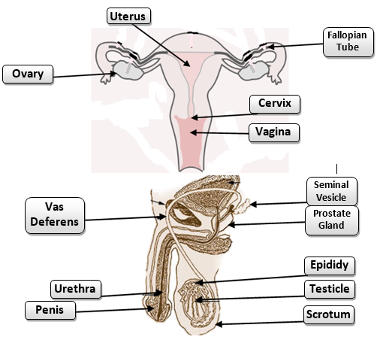
Female Reproductive System-
Cervix: the lower part of the uterus which is strong and muscular. It has an opening to the allow for the passage of menstrual blood, sperm, or a baby; Oviduct (fallopian tube): narrow tubes that attached to the upper part of the uterus and serve as tunnels for the ova (egg cells) to travel from the ovaries to the uterus. This is normally where fertilization takes place; Ovary: small, oval-shaped glands that are located on either side of the uterus. These produce eggs and hormones; Uterus: A hollow, pear-shaped organ that is the home to a developing fetus. Also called the womb; Vagina: a muscular canal that joins the cervix (the lower part of the uterus) to the outside of the body. It is also known as the birth canal.
Male Reproductive System- Epididymis: A set of coiled tubes that connects to the vas deferens. This is where sperm are stored after they are produced; Penis: the male sex organ which is made of the shaft and the glans; Prostate gland: a gland at the base of the urethra which produces some parts of the semen; Scrotum: A pouch-like structure that the epididymis and testicles hang in outside the pelvis. This acts as a climate control system for the testes; Seminal Vesicle : sac-like structures attached to the vas deferens that produce semen which lubricates and nourishes the sperm; Testicle : an oval body that is responsible for producing sperm and the male hormone, testosterone; Urethra : the channel that carries the semen and urine outside of the body through the penis; Vas deferens : A muscular tube that passes upward alongside the testicles and transports sperm from the epididymis to the seminal vesicle.

Quiz Answers:
1. B 2. B 3. A 4. A 5. C

