Blackline Master #1 Organism Mixer Cards

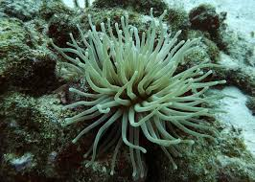  Photo Credit: https://pixabay.com/en/anemone-sea-life-scuba-diving-white-329559/ | Photo Credit: http://commons.wikimedia.org/wiki/File:718smiley.png  SEA ANEMONE
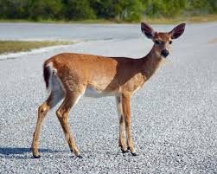  Photo Credit: https://commons.wikimedia.org/wiki/File:Key_Deer_on_Deer_Key.jpg | 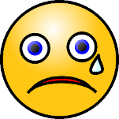  Photo Credit: https://pixabay.com/en/emoticon-cry-sad-tear-expression-25519/  DEER
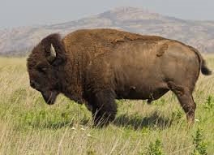  Photo Credit: https://commons.wikimedia.org/wiki/File:Bison_bison_Wichita_Mountain_Oklahoma.jpg | Photo Credit: https://pixabay.com/en/emoticon-smile-symbol-expression-25513/  BISON
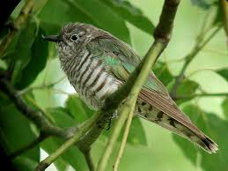  Photo Credit: https://commons.wikimedia.org/wiki/File:Shining_Bronze-Cuckoo_Dayboro.JPG | Photo Credit: http://commons.wikimedia.org/wiki/File:718smiley.png  CUCKOO
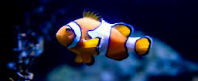  Photo Credit: https://commons.wikimedia.org/wiki/File:Clownfish_in_blue_water.jpg | Photo Credit: http://commons.wikimedia.org/wiki/File:718smiley.png  CLOWNFISH
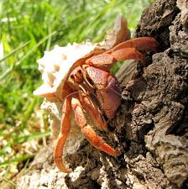  Photo Credit: https://en.wikipedia.org/wiki/Caribbean_hermit_crab | Photo Credit: http://commons.wikimedia.org/wiki/File:718smiley.png  HERMIT CRAB
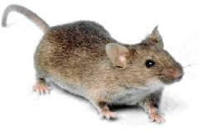  Photo Credit: http://dora.missouri.edu/mouse/ | Photo Credit: https://pixabay.com/en/emoticon-cry-sad-tear-expression-25519/  MOUSE
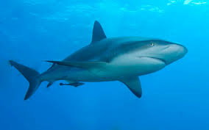  Photo Credit: http://www.sharksider.com/category/blog/ | Photo Credit: https://pixabay.com/en/emoticon-smile-symbol-expression-25513/  SHARK
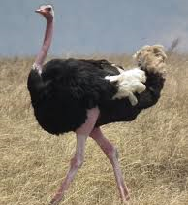  Photo Credit: http://globe-views.com/dreams/ostrich.htm | Photo Credit: http://commons.wikimedia.org/wiki/File:718smiley.png  OSTRICH
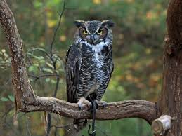  Photo Credit: https://commons.wikimedia.org/wiki/File:Great-horned_Owl_RWD_at_CRC2.jpg | Photo Credit: https://pixabay.com/en/angry-smiley-face-expression-312241/  OWL
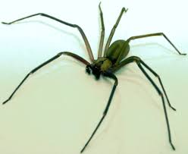  Photo Credit: https://commons.wikimedia.org/wiki/File:Brown-recluse-2-edit.jpg | Photo Credit: https://pixabay.com/en/angry-smiley-face-expression-312241/  SPIDER
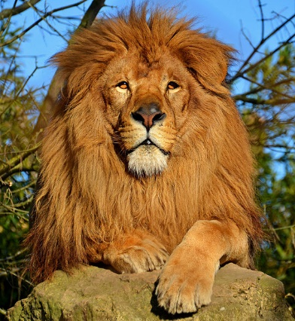  Photo Credit: https://commons.wikimedia.org/wiki/File:Lion_d'Afrique.jpg | Photo Credit: https://pixabay.com/en/angry-smiley-face-expression-312241/  LION
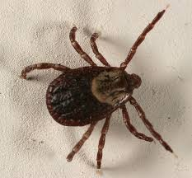  Photo Credit: https://commons.wikimedia.org/wiki/File:Dog_tick_5148.jpg | Photo Credit: http://commons.wikimedia.org/wiki/File:718smiley.png  TICK
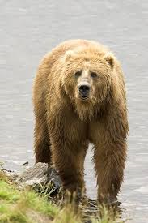  Photo Credit: https://commons.wikimedia.org/wiki/File:Grizzly_bear_brown_bear.jpg | Photo Credit: https://pixabay.com/en/angry-smiley-face-expression-312241/  BEAR
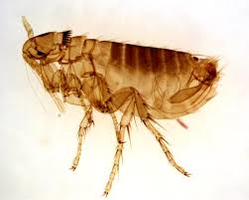  Photo Credit: http://www.orkin.com/other/fleas/what-do-fleas-look-like/ | Photo Credit: http://commons.wikimedia.org/wiki/File:718smiley.png  FLEA
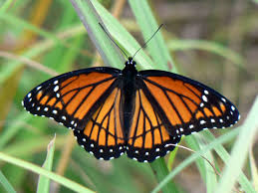  Photo Credit: https://commons.wikimedia.org/wiki/File:Limenitis_archippus_Cramer.jpg | Photo Credit: http://commons.wikimedia.org/wiki/File:Sert_-_dead_smile.svg  BUTTERFLY
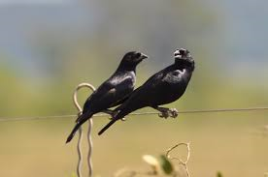  Photo Credit: https://en.wikipedia.org/wiki/Screaming_cowbird | Photo Credit: http://commons.wikimedia.org/wiki/File:718smiley.png  COWBIRD
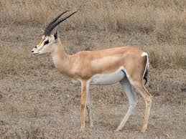  Photo Credit: https://commons.wikimedia.org/wiki/File:Grant%27s_Gazelle_taxobox.jpg | Photo Credit: http://commons.wikimedia.org/wiki/File:718smiley.png  GAZELLE
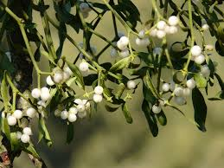  Photo Credit: https://pixabay.com/en/photos/mistletoe/ | Photo Credit: http://commons.wikimedia.org/wiki/File:718smiley.png  MISTLETOE
Photo Credit: https://en.wikipedia.org/wiki/Ornate_shrew | Photo Credit: http://commons.wikimedia.org/wiki/File:Sert_-_dead_smile.svg  SHREW
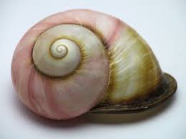  Photo Credit: https://commons.wikimedia.org/wiki/File:Snail_shell_Resolute_Track_Casuarina_forest,_around_25_mm_long2.JPGClo | Photo Credit: https://pixabay.com/en/emoticon-smile-symbol-expression-25513/  SNAIL SHELL
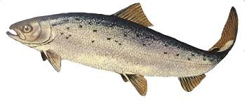  Photo Credit: https://en.wikipedia.org/wiki/Juvenile_fish | Photo Credit: http://commons.wikimedia.org/wiki/File:Sert_-_dead_smile.svg  SALMON
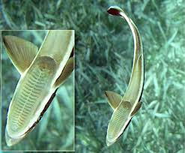  Photo Credit: https://en.wikipedia.org/wiki/Remora | Photo Credit: http://commons.wikimedia.org/wiki/File:718smiley.png  REMORA
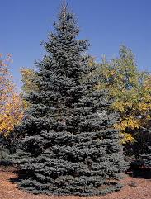  Photo Credit: https://commons.wikimedia.org/wiki/File:Picea_pungens_tree.jpg | Photo Credit: https://pixabay.com/en/emoticon-cry-sad-tear-expression-25519/  SPRUCE TREE
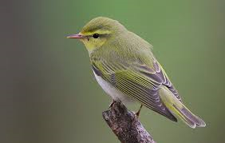  Photo Credit: https://en.wikipedia.org/wiki/Warbler | Photo Credit: https://pixabay.com/en/emoticon-cry-sad-tear-expression-25519/  WARBLER
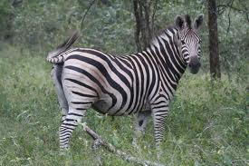  Photo Credit: https://commons.wikimedia.org/wiki/File:Common_zebra.jpg | Photo Credit: http://commons.wikimedia.org/wiki/File:Sert_-_dead_smile.svg  ZEBRA

Blackline Master #2 Organism Cutouts and Definition Sheet

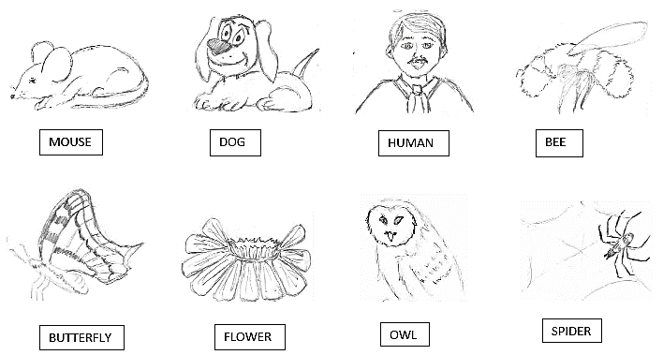

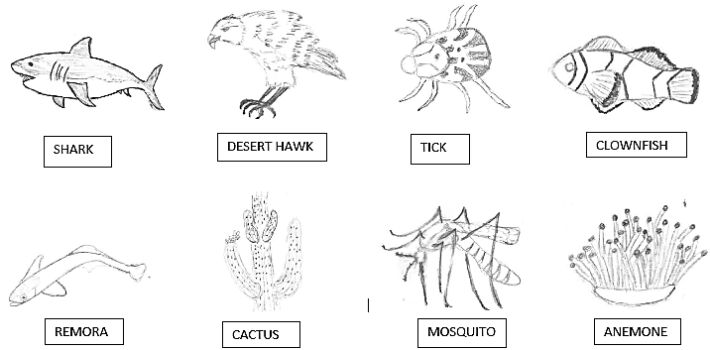
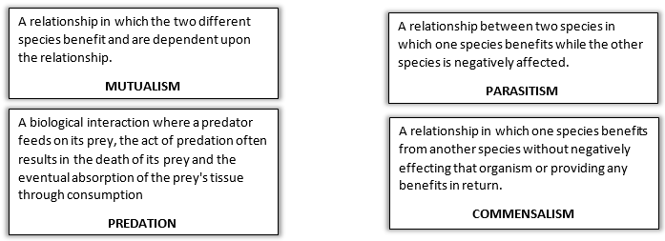
Blackline Master #3

Student Name: _____________________________ Period:_____________
Frenemies, Bros and Killers: A Lesson in Relationships of Living Things
Student Activity Sheet
Instructions: Open up your envelope and choose the matching organisms that have a relationship with the organisms pictured, that are represented by the emoticons featured for each. Glue the organisms and the definitions into the corresponding boxes.

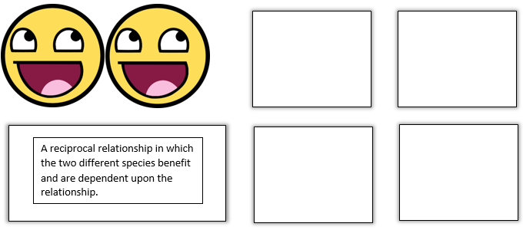
Sentences explaining the organism’s relationship in your own words (hint: use the definition as help): _______________________________________________________________________
______________________________________________________________________________

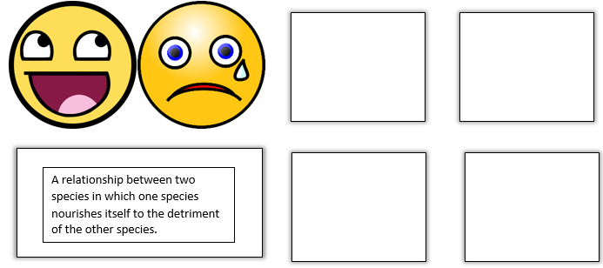
Sentences explaining the organism’s relationship in your own words (hint: use the definition as help): _______________________________________________________________________
____________________________________________________________________________
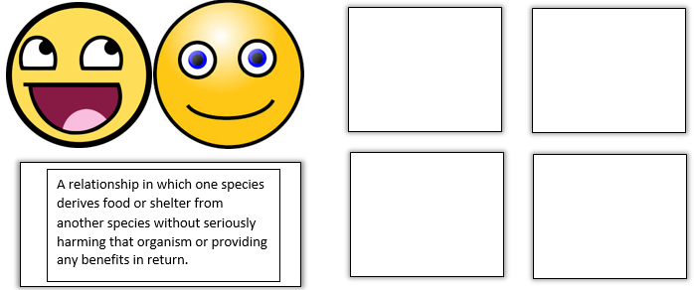

Sentences explaining the organism’s relationship in your own words (hint: use the definition as help): _______________________________________________________________________
____________________________________________________________________________
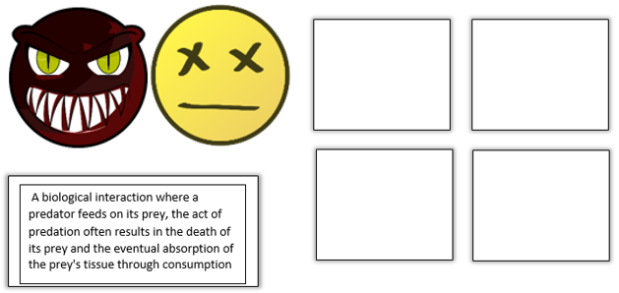

Sentences explaining the organism’s relationship in your own words (hint: use the definition as help): _______________________________________________________________________
____________________________________________________________________________

Blackline Master #4

Name:____________________________ Date:_______________________ Period:______________

Check for Understanding: A Lesson in Relationships of Living Things (Symbiosis)

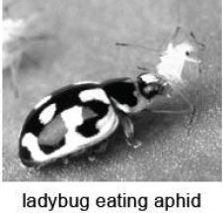
1. Ladybugs crawl up to aphids and eat them. Which interaction is being displayed between the population of ladybugs and the population of aphids? SC.7.L.17.2

A. predation
B. parasitism
C. mutualism
D. commensalism

2. Jane went for a walk on the farm. First, she saw a mosquito land on her arm and bite her. Second, she
saw a hawk capture a mouse. Last, she noticed a bird riding on the back of a cow and eating the bugs
off it. What is the order of the relationships Jane saw at the farm? SC.7.L.17.2
A. competition, predation, parasitism
B. parasitism, competition, mutualism
C. parasitism, predation, mutualism
D. predation, competition, parasitism

3. Cleaner fish feed on parasites in a shark's mouth and gills. This benefits the cleaner fish because they get a meal. This benefits the shark because it gets rid of parasites. Which of the following best describes the relationship between the cleaner fish and the shark? SC.7.L.17.2
A. Competition
B. Mutualism
C. Commensalism
D. Parasitism

4. A (+) means benefit, a (-) means harmed, (0) means unaffected, (X) means dead, draw the correct symbol that represents the relationship and give an example of organisms that interact. SC.7.L.17.2

A. Mutualism + and Example:____________________________________________

B. Commensalism + and Example:_________________________________________

C. Parasitism + and Example:_____________________________________________

D. Predation + and Example:_____________________________________________

Blackline Master #5: Answer Keys

Frenemies, Bros and Killers: A Lesson in Relationships of Living Things
Student Activity Sheet – ANSWER KEY

Instructions: Open up your envelope and choose the matching organisms that have a relationship with the organisms pictured, that are represented by the emoticons featured for each. Glue the organisms and the definitions into the corresponding boxes.

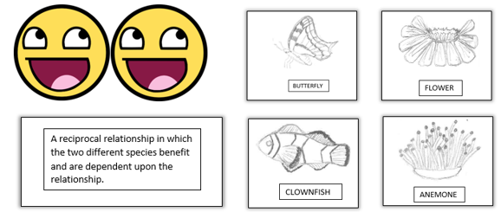
***Butterfly could also be the bee***
Sentences explaining the organism’s relationship in your own words (hint: use the definition as help): student responses will vary but their definition should be in their own words and be related to the definition of MUTUALISM.

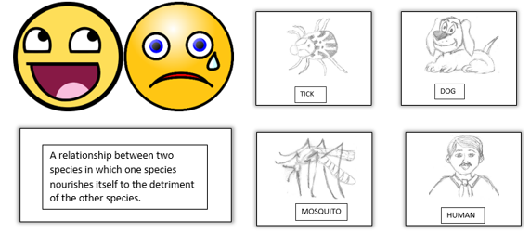
Sentences explaining the organism’s relationship in your own words (hint: use the definition as help): student responses will vary but their definition should be in their own words and be related to the definition of PARASITISM.

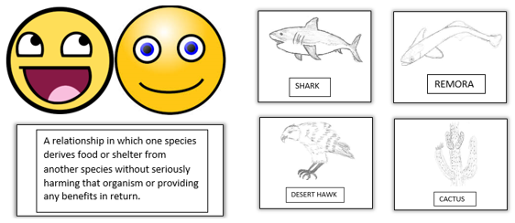
Sentences explaining the organism’s relationship in your own words (hint: use the definition as help): student responses will vary but their definition should be in their own words and be related to the definition of COMMENSALISM.

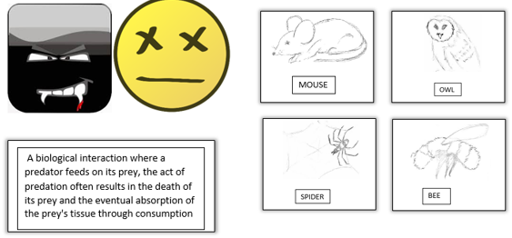
***Bee could also be the butterfly***
Sentences explaining the organism’s relationship in your own words (hint: use the definition as help): student responses will vary but their definition should be in their own words and be related to the definition of PREDATION.
Possible Student Responses to Organism Mixer Activity
CLOWNFISH  Photo Credit: https://commons.wikimedia.org/wiki/File:Clownfish_in_blue_water.jpg | SEA ANEMONE  Photo Credit: https://pixabay.com/en/anemone-sea-life-scuba-diving-white-329559/
Mutualism
TICK  Photo Credit: https://commons.wikimedia.org/wiki/File:Dog_tick_5148.jpg | DEER  Photo Credit: https://commons.wikimedia.org/wiki/File:Key_Deer_on_Deer_Key.jpg
Parasitism
COWBIRD  Photo Credit: https://en.wikipedia.org/wiki/Screaming_cowbird | BISON  Photo Credit: https://commons.wikimedia.org/wiki/File:Bison_bison_Wichita_Mountain_Oklahoma.jpg
Commensalism
WARBLER  Photo Credit: https://en.wikipedia.org/wiki/Warbler | CUCKOO  Photo Credit: https://commons.wikimedia.org/wiki/File:Shining_Bronze-Cuckoo_Dayboro.JPG
Parasitism
SNAIL SHELL  Photo Credit: https://commons.wikimedia.org/wiki/File:Snail_shell_Resolute_Track_Casuarina_forest,_around_25_mm_long2.JPGClo | HERMIT CRAB  Photo Credit: https://en.wikipedia.org/wiki/Caribbean_hermit_crab
Commensalism
OWL  Photo Credit: https://commons.wikimedia.org/wiki/File:Great-horned_Owl_RWD_at_CRC2.jpg | SHREW  Photo Credit: https://en.wikipedia.org/wiki/Ornate_shrew
Predation
REMORA  Photo Credit: https://en.wikipedia.org/wiki/Remora | SHARK  Photo Credit: http://www.sharksider.com/category/blog/
Commensalism
GAZELLE  Photo Credit: https://commons.wikimedia.org/wiki/File:Grant%27s_Gazelle_taxobox.jpg | OSTRICH  Photo Credit: http://globe-views.com/dreams/ostrich.htm
Mutualism

BUTTERFLY  Photo Credit: https://commons.wikimedia.org/wiki/File:Limenitis_archippus_Cramer.jpg | SPIDER  Photo Credit: https://commons.wikimedia.org/wiki/File:Brown-recluse-2-edit.jpg
Predation
ZEBRA  Photo Credit: https://commons.wikimedia.org/wiki/File:Common_zebra.jpg | 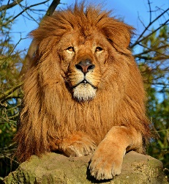  LION  Photo Credit: https://commons.wikimedia.org/wiki/File:Lion_d'Afrique.jpg
Predation
SALMON  Photo Credit: https://en.wikipedia.org/wiki/Juvenile_fish | BEAR  Photo Credit: https://commons.wikimedia.org/wiki/File:Grizzly_bear_brown_bear.jpg
Predation
MOUSE  Photo Credit: http://dora.missouri.edu/mouse/ | FLEA  Photo Credit: http://www.orkin.com/other/fleas/what-do-fleas-look-like/
Parasitism

MISTLETOE  Photo Credit: https://pixabay.com/en/photos/mistletoe/ | SPRUCE TREE  Photo Credit: https://commons.wikimedia.org/wiki/File:Picea_pungens_tree.jpg
Parasitism

Check for Understanding: A Lesson in Relationships of Living Things (Symbiosis) –
ANSWER KEY

1. Ladybugs crawl up to aphids and eat them. Which interaction is being displayed between the population of ladybugs and the population of aphids? SC.7.L.17.2

A. predation
B. parasitism
C. mutualism
D. commensalism

2. Jane went for a walk on the farm. First, she saw a mosquito land on her arm and bite her. Second, she
saw a hawk capture a mouse. Last, she noticed a bird riding on the back of a cow and eating the bugs
off it. What is the order of the relationships Jane saw at the farm? SC.7.L.17.2
A. competition, predation, parasitism
B. parasitism, competition, mutualism
C. parasitism, predation, mutualism
D. predation, competition, parasitism

3. Cleaner fish feed on parasites in a shark's mouth and gills. This benefits the cleaner fish because they get a meal. This benefits the shark because it gets rid of parasites. Which of the following best describes the relationship between the cleaner fish and the shark? SC.7.L.17.2
A. Competition
B. Mutualism
C. Commensalism
D. Parasitism

4. A (+) means benefit, a (—) means harmed, (0) means unaffected, (X) means dead, draw the correct symbol that represents the relationship and give an example of organisms that interact. SC.7.L.17.2

A. Mutualism + and + Example: bee/butterfly and flower, clownfish and sea anemone

B. Commensalism + and 0 Example: shark and remora, desert hawk and cactus

C. Parasitism + and - Example: mosquito and human, mistletoe and spruce tree

D. Predation + and X Example: lion and zebra, spider and butterfly/bee

