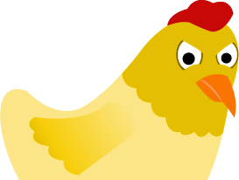
CHICKEN COLLISION
Student worksheet

Name __________________________________ Period______ Date______________
INSTRUCTIONS: Complete all of the tasks on the worksheet after you finish playing Chicken Collision or, if you prefer, you can complete the tasks while you are playing the game. Please read the directions for each task carefully and use evidence from the game for your responses.
TASK 1 Based on your practice in the Sandbox Mode of Chicken Collision, draw conclusions about the effect of balanced and unbalanced forces on the motion of an object.
Fill in the table:
Type of Force | The motion that results is…
When forces are balanced
When forces are unbalanced

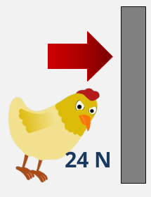
Gertie
Explain what would happen if you applied a force of 20 N to the left on the door in the image?
____________________________________________________________________________________________________________________________________________________________________________________________________________________________________________________________
TASK 2 Use what you learned from Level 1 and Level 2 in the Chicken Collision game to fill in the blank spaces on the table below.
Chicken  ID | Initial Direction | Final Direction | Net Force  (N) | Balanced  Or Unbalanced  Forces? | Explanation
 |  |  | 25
 |  |  |  |  | There was no movement.
 |  |  | 10

TASK 3 After playing the challenge level of Chicken Collision, answer the question below.
Nugget
Kevin

