Name ___________________________________________ Date: ___________________
Blackline Master #1

Use the magnets to explore and answer the following questions:
How can the magnets be used to show forces?
(What can the magnets do?)

What are some limitations that might prevent magnets from interacting?
(What can’t the magnets do?)

What are some of the characteristics of the magnets?

What sort of forces are exhibited by the magnets?

Are these contact or non-contact forces? Explain how you know.

How far do these forces extend; how large is the magnetic field (the range of the force)? Use your ruler to measure how far the force extends.

How strong is the magnetic field (the magnitude of the force)? What is the thickest object that the magnetic field can extend through? Use your ruler to measure how far the force extends.

Based on your observations and experiments, draw a picture that shows how you think the magnetic field might look.
Blackline Master #1

Test  Write a description of what you did and/or draw a picture. | Results  Describe what happened during your “test.” | Explanation  What does this tell you about magnets?

Blackline Master #1 ANSWER KEY

Name ___________________________________________ Date: ___________________

Use the magnets to explore and answer the following questions:
How can the magnets be used to show force? (What can the magnets do?)
Possible student answers include:
The magnets can push, pull, jump, attract, repel, race across the table, attract through my hand, etc. Answers will vary.

What are some limitations that might prevent magnets from interacting? (What can’t the magnets do?)
Possible student answers include:
The magnets can’t stick to some objects (objects not containing iron, nickel, and/or cobalt). Answers will vary.

What are some of the characteristics of the magnets?
Possible student answers include:
The magnets are shiny, have a pull force, have a push force, are very strong, etc. Answers will vary.

What sort of forces are exhibited by the magnets?
Possible student answers include:
The magnets have a push force and a pull force.

Are these contact or non-contact forces? Explain how you know.
Possible student answers include:
The forces exerted by magnets are non-contact forces. I know this because the magnets do not have to touch when they exert their push and pull forces.

How far do these forces extend; how large is the magnetic field (the range of the force)? Use your ruler to measure how far the force extends.
Possible student answers include:
Answers will depend on the strength of your magnets.

How strong is the magnetic field (the magnitude of the force)? What is the thickest object that the magnetic field can extend through? Use your ruler to measure how far the force extends.
Possible student answers include:
Answers will depend on the strength of your magnets.

Based on your observations and experiments, draw a picture that shows how you think the magnetic field might look.
Answers will vary depending on your students’ experiments with the magnets.
Blackline Master #1 ANSWER KEY

Test  Write a description of what you did and/or draw a picture. | Results  Describe what happened during your “test.” | Explanation  What does this tell you about magnets?
Descriptions, pictures, and explanations will vary depending on the students’ experiments.
Example: We put one magnet on the table and we moved the other magnet slowly toward it until we saw the first magnet move. | Example: The first magnet didn’t move until the second magnet got to within 5cm of it. | Example: This tells us that the pull force for the magnet extends about 5cm from the magnet.

Blackline Master #2

Name ____________________________________________________________________________________________ Date: ___________________

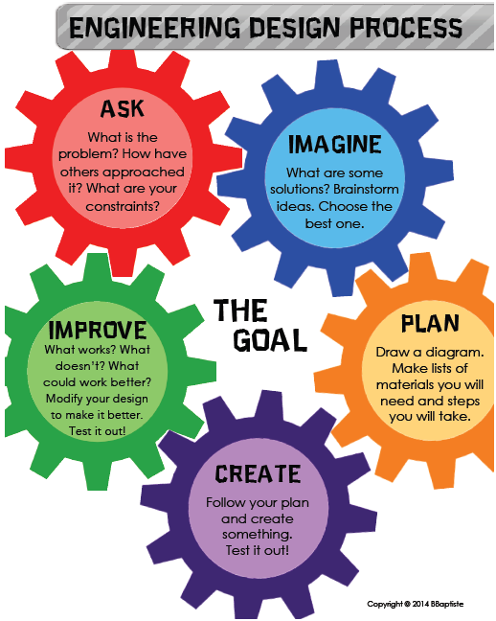
ASK: You have been hired by an engineering company to create a model of maglev (magnetic levitation) train that they plan to build. Your goal is to show how magnetic forces can be used to make objects, such as trains, levitate. Design and build a levitation device using the magnets, the putty, and the pencil.

IMAGINE: Brainstorm your group’s ideas here!

PLAN: Draw your design in the space provided on the back. Make sure you label the parts and the measurements of your device.

CREATE & TEST: Once you’ve designed your levitation device, use your diagram to build your device and test it out. Use the space on the back in RESULTS to write notes about what happened during your test.

IMPROVE: What worked? What didn’t work? How would you like to modify your design? Write your improvements and feedback in the table on the back! Once you’ve tested your design, seen other group’s designs, and gotten feedback from your fellow engineers, use any leftover space to draw your revised design and make note of the ideas & suggestions that you used from other groups.

Blackline Master #2

Design | Diagram  Draw a rough sketch of your device and label your measurements. | Results  Describe what happened during your “test.” | Improve  What worked? Why did this work? What didn’t work? Why didn’t this work? What could make your design better?
1
2
3
4

Blackline Master #2 ANSWER KEY

Name ____________________________________________________________________________________________ Date: ___________________

ASK: You have been hired by an engineering company to create a model of maglev (magnetic levitation) train that they plan to build. Your goal is to show how magnetic forces can be used to make objects, such as trains, levitate. Design and build a levitation device using the magnets, the putty, and the pencil.

IMAGINE: Brainstorm your group’s ideas here!
Answers will vary by group. Some possible brainstorming ideas may include:
We will need to use the magnet’s PUSH force to make it levitate.
We will need to find the push and pull sides of all the magnets.

PLAN: Draw your design in the space provided on the back. Make sure you label the parts and the measurements of your device.

CREATE & TEST: Once you’ve designed your levitation device, use your diagram to build your device and test it out. Use the space on the back in RESULTS to write notes about what happened during your test.

IMPROVE: What worked? What didn’t work? How would you like to modify your design? Write your improvements and feedback in the table on the back! Once you’ve tested your design, seen other group’s designs, and gotten feedback from your fellow engineers, use any leftover space to draw your revised design and make note of the ideas & suggestions that you used from other groups.

Blackline Master #2

Design | Diagram  Draw a rough sketch of your device and label your measurements. | Results  Describe what happened during your “test.” | Improve  What worked? Why did this work? What didn’t work? Why didn’t this work? What could make your design better?
1 | Diagrams and sketches will vary between groups. | Students will report what happened when they tried their first model. | Students will report what they will fix and what will stay the same based on trial of their first model.
2
3
4

Blackline Master #3
Name ___________________________________________ Date: ___________________

Magnets & Inquiry Quiz
(SC.6.P.13.1)
- Two magnets are laid end to end, but they won't stay together. This is because
A. opposite poles were placed together. C. they are different kinds of magnets.
B. like poles were placed together. D. they have different kinds of fields.
(SC.6.P.13.1)
- One similarity between magnetism and gravity is
A. magnetism and gravity are both contact forces.
B. magnetism and gravity are both short range forces.
C. magnetism and gravity are both non-contact forces.
D. magnetism and gravity both exhibit a push and a pull force.

(SC.6.P.13.1)
- Each of the following are examples of non-contact forces EXCEPT:
  - An apple falling off a tree
  - A paper clip sliding towards a magnet
  - The moon orbiting the Earth
  - A hand pushing an object
(SC.6.N.1.1)
- Charlie wants to build a magnetic levitation train for his younger brother. Charlie has drawn a diagram of his train and has built the train. What should Charlie do next with his design?
  - Test the device, get feedback from other people, and revise the design if needed.
  - Show his design to other people and get feedback before selling his design.
  - Publish his design in a magazine as is and wait for investors.
  - Test the device and sell it to the local veterinarian.
(SC.6.N.1.4)
- Four groups of students conducted the same experiment on how far the magnetic field extends on their new set of magnets. They keep one magnet stationary and bring another magnet closer and closer until it is either repelled or attracted to the stationary magnet. Once the attraction/repulsion occurs, they measure the distance at which it occurred. When the four groups got together they compiled the following data:

Group | Distance between Magnets
 | Trial 1 | Trial 2 | Trial 3 | Trial 4 | Trial 5 | Average Distance
1 | 5 cm | 4 cm | 6 cm | 8 cm | 5 cm | 5.6 cm
2 | 5 cm | 3 cm | 7 cm | 5 cm | 9 cm | 7 cm
3 | 1 cm | 3 cm | 2 cm | 1 cm | 2 cm | 1.8 cm
4 | 4cm | 3cm | 5cm | 6cm | 7cm | 5 cm

Based on the groups’ results, what feedback would you give these groups? Feedback can include questions you would ask and suggestions you would give.

Blackline Master #3 ANSWER KEY
Name ___________________________________________ Date: ___________________

Magnets & Inquiry Quiz
(SC.6.P.13.1)
- Two magnets are laid end to end, but they won't stay together. This is because
A. opposite poles were placed together. C. they are different kinds of magnets.
B. like poles were placed together. D. they have different kinds of fields.
(SC.6.P.13.1)
- One similarity between magnetism and gravity is
A. magnetism and gravity are both contact forces.
B. magnetism and gravity are both short range forces.
C. magnetism and gravity are both non-contact forces.
D. magnetism and gravity both exhibit a push and a pull force.

(SC.6.P.13.1)
- Each of the following are examples of non-contact forces EXCEPT:
- An apple falling off a tree
- A paper clip sliding towards a magnet
- The moon orbiting the Earth
- A hand pushing an object
(SC.6.N.1.1)
- Charlie wants to build a magnetic levitation train for his younger brother. Charlie has drawn a diagram of his train and has built the train. What should Charlie do next with his design?
  - Test the device, get feedback from other people, and revise the design if needed.
  - Show his design to other people and get feedback before selling his design.
  - Publish his design in a magazine as is and wait for investors.
  - Test the device and sell it to the local veterinarian.
(SC.6.N.1.4)
- Four groups of students conducted the same experiment on how far the magnetic field extends on their new set of magnets. They keep one magnet stationary and bring another magnet closer and closer until it is either repelled or attracted to the stationary magnet. Once the attraction/repulsion occurs, they measure the distance at which it occurred. When the four groups got together they compiled the following data:

Group | Distance between Magnets
 | Trial 1 | Trial 2 | Trial 3 | Trial 4 | Trial 5 | Average Distance
1 | 5 cm | 4 cm | 6 cm | 8 cm | 5 cm | 5.6 cm
2 | 5 cm | 3 cm | 7 cm | 5 cm | 9 cm | 7 cm
3 | 1 cm | 3 cm | 2 cm | 1 cm | 2 cm | 1.8 cm
4 | 4cm | 3cm | 5cm | 6cm | 7cm | 5 cm

Based on the groups’ results, what feedback would you give these groups? Feedback can include questions you would ask and suggestions you would give.
Possible Student Responses: Group 2 should check their data to be sure it’s accurate and check their procedure to make sure they didn’t do something incorrectly as their data is drastically different than the other three groups’. I would ask group 2 what happened that every other day, their plant shrunk. Did they measure it the same every day?

