Modeling Each State of Matter
Blackline Master #1

Part 1 Sound Waves-Small Groups

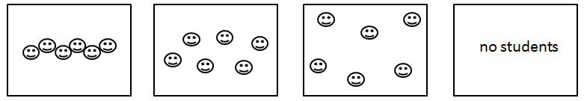

Solid Liquid Gas Vacuum

Part 2 Light Waves-Whole Class

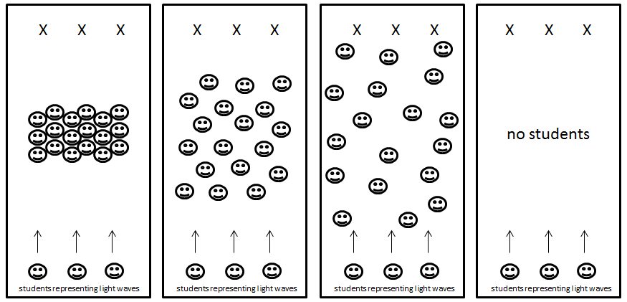

Solid Liquid Gas Vacuum

Battle of the Waves
Blackline Master #2

Purpose: How does the speed of sound and electromagnetic waves change through different mediums?

Materials
- Stopwatch
- Paper
- Pencil

Prediction
____________________________________________________________________________________

____________________________________________________________________________________

___________________________________________________________________________________.

Part 1: Speed of Sound Waves

Procedures
- Students will form groups of a minimum of 5-6 people.
- Discuss and brainstorm with your group how to model the particles in a solid, liquid, gas, or vacuum. You will each be a particle in these three states of matter.
- Use the stopwatch to simulate a sound wave traveling through the medium by passing it from one particle (person) to another.
- Your goal is to TIME how long it takes for the sound to travel through each state of matter.
- Collect and record your data within Data Table #1.

Data Table #1

State of Matter | Trial 1 | Trial 2 | Trial 3 | Average
Solid
Liquid
Gas
Vacuum (space)

Part 2: Speed of Electromagnetic/Light Waves
Blackline Master #2

Procedures

- Students will still collaborate with their previous group from Part 1.
- As a class, brainstorm how to model the particles in a solid, liquid, gas, or vacuum in a large group setting. You will each be a particle in these three states of matter.
- One person from each group will act as the light wave.
- Use the stopwatch to simulate a light wave traveling through the medium by timing how long it takes for the light wave person to get from one side of the particles to the other.
- Your goal is to TIME how long it takes for the light to travel through each state of matter.
- Collect and record your data within Data Table #2.

Data Table #2

State of Matter | Trial 1 | Trial 2 | Trial 3 | Average
Solid
Liquid
Gas
Vacuum (space)

Blackline Master #2
Graph

Directions: Graph your averages from Data Table 1 and Data Table 2. REMEMBER to follow all graphing rules by including titles and units.

Blackline Master #2
Conclusion:

- Was your prediction from the video correct? Explain.

____________________________________________________________________________________

____________________________________________________________________________________

___________________________________________________________________________________.

- Compare and contrast the data results from both graphs.

____________________________________________________________________________________

____________________________________________________________________________________

___________________________________________________________________________________.

- Which medium does sound travel the fastest in? Which medium does sound travel the slowest in? Explain and cite evidence.

____________________________________________________________________________________

____________________________________________________________________________________

___________________________________________________________________________________.

- Which medium does light travel the fastest in? Which medium does light travel the slowest in? Explain and cite evidence.
____________________________________________________________________________________

____________________________________________________________________________________

___________________________________________________________________________________.

- Explain any sources of error that may have occurred during your data acquisition.
____________________________________________________________________________________

____________________________________________________________________________________

____________________________________________________________________________________

___________________________________________________________________________________.

Blackline Master #2
Identifying Wave X:
Directions: Students collected data on Wave X as it traveled through a variety of materials. Analyze the data table below.

Materials | Speed of Wave X
Wood | 3960 m/s
Water | 1486 m/s
Air 40˚C | 355 m/s
Aluminum | 6320 m/s
Copper | 4600 m/s
Air 20˚C | 343 m/s
Glass | 6320 m/s
Vacuum

Using your knowledge from the Battle of the Waves experiment and information from the data table above, determine if the wave the students observed is a sound or light wave. Cite data from the table above when you explain and justify your answer.

Wave X is a _________________ wave.
Justification and explanation:
________________________________________________________________________________
________________________________________________________________________________
________________________________________________________________________________
________________________________________________________________________________

Fill in the missing value in the table with the speed of Wave X in a vacuum. Explain your answer.
________________________________________________________________________________
________________________________________________________________________________
________________________________________________________________________________.

Blackline Master #3
Name ____________________________________________________ Date _________________

Battle of the Waves Assessment

____ 1. Light travels fastest in which type of medium?
A. Vacuum (space) B. Gas
C. Liquid D. Solid

____ 2. Sound travels fastest in what type of medium?
A. Vacuum (space) B. Gas
C. Liquid D. Solid

____ 3. A medium is NOT required for sound to travel.
A. True C. False

Explain your answer: _________________________________________________________________

___________________________________________________________________________________
___________________________________________________________________________________.

4. Read the statements below and determine if each one is a characteristic of sound waves, light waves, or both. On the line, put either an S for sound waves, L for light waves, or B for both.

______These types of waves travel the slowest in solids.
______These types of waves travel the slowest in gases.
______These types of waves can travel in a vacuum (space).
______These types of waves do not require a medium to travel.

______These types of waves can travel through water.
______These types of waves require particles to vibrate.

5. During a thunderstorm, lightning and thunder actually occur at the same time. Using what you have learned, explain why we observe the sound of thunder after we observe the flash the lightning.
____________________________________________________________________________________
____________________________________________________________________________________
___________________________________________________________________________________.

Blackline Master #4 – ANSWER KEY
Conclusion:

- Was your prediction from the video correct? Explain.

Student answers will vary.

- Compare and contrast the data results from both graphs.

Student responses will vary but should include that the speed of sound and light are opposite
through the different mediums.
- Which medium does sound travel the fastest in? Which medium does sound travel the slowest in? Explain and cite evidence.

Sound travels the fastest in solids and the slowest in gasses. The closer the particles are, the quicker
they can vibrate, and the faster the wave will travel. Sound waves also cannot travel through a vacuum
because they require a medium to travel.

- Which medium does light travel the fastest in? Which medium does light travel the slowest in? Explain and cite evidence.
Light travels the fastest in a vacuum and the slowest in solids. Light waves travel faster when there are
less particles in its path.

- Explain any sources of error that may have occurred during your data acquisition.
Student responses will vary but might include that when modelling the light wave, the student
representing the wave might be moving at different rates for each trial. Another source of error might be
the delayed reaction time in stopping the timer.

Blackline Master #4 – ANSWER KEY
Identifying Wave X:
Directions: Students collected data on Wave X as it traveled through a variety of materials. Analyze the data table below.

Materials | Speed of Wave X
Wood | 3960 m/s
Water | 1486 m/s
Air 40˚C | 355 m/s
Aluminum | 6320 m/s
Copper | 4600 m/s
Air 20˚C | 343 m/s
Glass | 6320 m/s
Vacuum | 0 m/s

Using your knowledge from the Battle of the Waves experiment and information from the data table above, determine if the wave the students observed is a sound or light wave. Cite data from the table above when you explain and justify your answer.

Wave X is a sound wave.
Justification and explanation:
Student answers should incorporate the following:
- In the data table above, the speed of the wave is the slowest when traveling through the materials Air 20˚C at 343 m/s and Air 40˚C at 355 m/s which are both gases. The wave is the fastest within the wood at 3960 m/s, copper at 4600 m/s, glass at 6230 m/s, and aluminum at 6320 m/s, all of which are solids.
- Based on the Battle of the Waves experiment, we know that light waves do not require a medium to travel and travel the fastest when fewer particles are in the way. Sound waves require medium and travel when particles vibrate and move. The closer the molecules in that particular medium are to each other, the faster the sound wave will travel

Fill in the missing value in the table with the speed of Wave X in a vacuum. Explain your answer.
Student answers should incorporate the following:
- Sound waves require medium and travel when particles vibrate and move. The closer the molecules in that particular medium are to each other, the faster the sound wave will travel. Sound waves cannot travel through the vacuum (empty space) since there is no particles that can vibrate. Thus, the speed of Wave X through a vacuum would be 0 m/s.

Blackline Master #4 – ANSWER KEY
Battle of the Waves Assessment: ANSWER KEY

____ 1. Light travels fastest in which type of medium?
A. Vacuum (space) B. Gas
C. Liquid D. Solid

____ 2. Sound travels fastest in which type of medium?
A. Vacuum (space) B. Gas
C. Liquid D. Solid

____ 3. A medium is NOT required for sound to travel.
A. True C. False

Explain your answer: Possible student response: sound requires a medium in which to travel, such as a gas, liquid, or solid. The sound waves cause the particles within the medium to vibrate and move. The closer the molecules in that medium are to each other the faster the sound will travel.

4. Read the statements below and determine if each one is a characteristic of sound waves, light waves, or both. On the line, put either an S for sound waves, L for light waves, or B for both.

___L___These types of waves travel the slowest in solids.
___S___These types of waves travel the slowest in gases.
___L___These types of waves can travel in a vacuum (space).
___L___These types of waves do not require a medium to travel.

___B___These types of waves can travel through water.
___S___These types of waves require particles to vibrate.

5. During a thunderstorm, lightning and thunder actually occur at the same time. Using what you have learned, explain why we observe the sound of thunder after we observe the flash the lightning.

Student responses should include the following components:
- Within a thunderstorm, the lightening is observed first since it will travel faster than sound waves through the air (gas). The sound of thunder can be heard shortly after since it travels the slowest within gases.
- Light waves do not require a medium to travel and travel the fastest when fewer particles are in the way.
- Sound waves require medium and travel when particles vibrate and move. The closer the molecules in that particular medium are to each other, the faster the sound wave will travel.

