Blackline Masters 1: Atmospheric Profile Lab
Layers of Atmosphere

Part 1: Red Bull Jump Video Clip
1. When Baumgartner gets to his jumping spot, he is 24.2 miles above the Earth’s surface. Where between Earth and space do you think he was located (ex: closer to Earth, closer to space, in space, barely off the Earth, etc)? Explain your thinking. ________________________
____________________________________________________________________________________________________________________________________________________________________________________________________________________________________
____________________________________________________________________________
____________________________________________________________________________

2. Why do you think he needed to jump from a capsule and not an airplane? _______________
____________________________________________________________________________________________________________________________________________________________________________________________________________________________________

3. Why do you think Baumgartner was dressed like an astronaut? ________________________
____________________________________________________________________________________________________________________________________________________________________________________________________________________________________

4. Hypothesize why you think the people in the control center are concerned about him passing out? ________________________________________________________________________
____________________________________________________________________________________________________________________________________________________________________________________________________________________________________

Part 2: Layer Tube
Look at the tube with the 4 different layers and make 3 qualitative observations about what you see.

Qualitative Observations:
1.
2.
3.

1. Why might it be helpful to model the layers of the atmosphere?

Part 3: Graph
Use the data below and graph the temperatures on the atmospheric temperature profile.
Altitude (Km) | Temperature (C)
0 | 20
3 | -15
8 | -30
10 | -40
12 | -40
20 | -35
30 | -30
40 | -15
52 | -5
54 | -5
60 | -20
70 | -60
80 | -80
87 | -95
89 | -95
100 | -60
125 | -20
135 | 40
140 | 70

Part 4: Graph Analysis

1. Describe the temperature patterns that you see on the graph. __________________
____________________________________________________________________________________________________________________________________________

2. How is temperature related to altitude? ____________________________________
______________________________________________________________________

3. Hypothesize why the temperature stays the same as altitude (height) increases at each black line? ________________________________________________________
______________________________________________________________________
______________________________________________________________________

4. Compare layers A and C. Hypothesize why you think the temperatures are increasing._____________________________________________________________
______________________________________________________________________
____________________________________________________________________________________________________________________________________________

5. Compare layers B and D. Hypothesize why you think the temperatures are decreasing. ____________________________________________________________
__________________________________________________________________________________________________________________________________________________________________________________________________________________

Part 5: Layer Identification
Description of each layer
Layer A
Name:
Layer B
Name:
Layer C
Name:
Layer D
Name:
Look at the cards, compare the descriptions to your graph, and identify which layer is represented by the description.

1. In order, state the layers of the atmosphere from the Earth’s surface increasing in altitude. _______________________________________________________________
______________________________________________________________________
______________________________________________________________________

2. List what objects or special characteristics can be found in each layer. ____________
______________________________________________________________________
______________________________________________________________________
3. What can you infer about why commercial airplanes fly in layer D? _______________
______________________________________________________________________
______________________________________________________________________
______________________________________________________________________
4. How you think the atmosphere helps living things survive on Earth? ______________
__________________________________________________________________________________________________________________________________________________________________________________________________________________

5. Predict what would happen to Earth without the Stratosphere or if there were holes in this layer. _____________________________________________________________
______________________________________________________________________
______________________________________________________________________
______________________________________________________________________

6. Summarize the characteristics of the Troposphere. ___________________________
______________________________________________________________________
______________________________________________________________________

7. Summarize the characteristics of the Stratosphere. ___________________________
______________________________________________________________________
______________________________________________________________________

8. Summarize the characteristics of the Mesosphere. ___________________________
____________________________________________________________________________________________________________________________________________

9. Summarize the characteristics of the Thermosphere. ________________________
____________________________________________________________________________________________________________________________________________

Part 6: Full Stratosphere Jump

1. Describe why Baumgartner slows down when he reaches the lower levels of the stratosphere. ___________________________________________________________ ____________________________________________________________________________________________________________________________________________
______________________________________________________________________
______________________________________________________________________

2. Analyze the benefits of using a weather balloon for the jump instead of a plane.
__________________________________________________________________________________________________________________________________________________________________________________________________________________
____________________________________________________________________________________________________________________________________________

3. Pretend you are trying to break Baumgartner’s record. What are some concerns you would need to address before the day of the jump? _____________________________
______________________________________________________________________
____________________________________________________________________________________________________________________________________________

4. Speculate as to why no one has previously jumped from the height that Baumgartner has jumped from. _______________________________________________________
____________________________________________________________________________________________________________________________________________
______________________________________________________________________

5. Brainstorm possible reasons why Baumgartner did not jump from a higher height? ______________________________________________________________________
____________________________________________________________________________________________________________________________________________
______________________________________________________________________

6. How does modeling the layers of the atmosphere help you predict what would happen to a living thing at different heights above the Earth? _____________________
________________________________________________________________________________________________________________________________________________________________________________________________________________________________________________________________________________________

7. Why are models important to learning about the layers of the atmosphere and learning about science in general? _________________________________________
________________________________________________________________________________________________________________________________________________________________________________________________________________________________________________________________________________________

Blackline Masters 2: Atmospheric Profile Graph
Atmospheric Temperature Profile

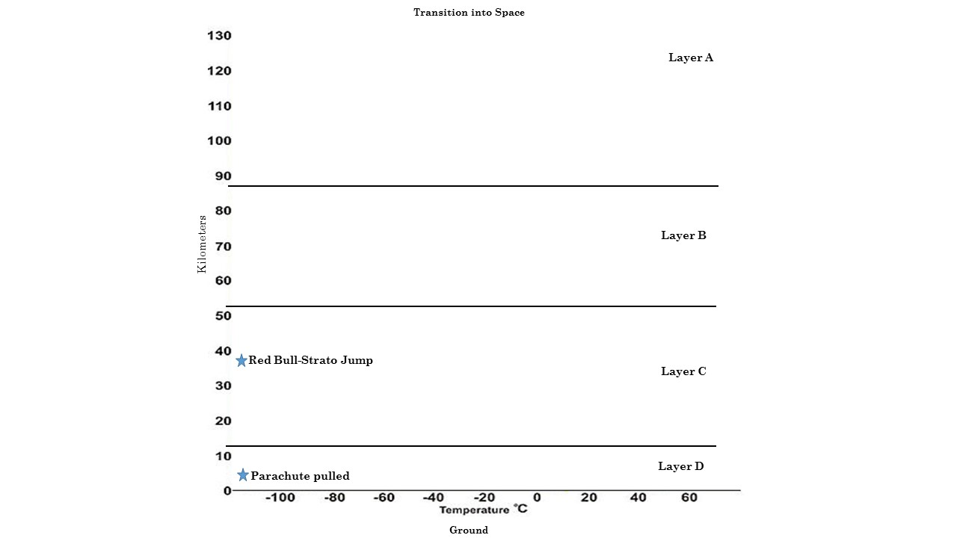

Blackline Masters 3: Description Cards

Thermosphere
The air is very thin and the temperature increases with height. Both the space shuttle and the International Space Station orbit in the middle-to-upper part of this layer. Also, the auroras (northern & southern lights) occurs in this layer. Thickest layer, and our boundary into space.
Mesosphere
This is the coldest layer. Although the air is thin, it’s still thick enough to burn up meteors due to friction which protects life from the impacts of the meteors as well as prevents the dust from shading out the sun and causing major adjustments to the weather and climate of Earth. Second thickest layer and temperature decreases with height.
Stratosphere
Contains the ozone layer which protects life on Earth by absorbing harmful ultraviolet (UV) radiation. The stratosphere also acts like a blanket keeping the Earth warm and habitable. Some weather balloons can reach the lower part of this layer. Temperature increases with height.
Troposphere
This is the layer closest to Earth, where all living things are found. This is where the water cycle occurs bringing water to all life on Earth, as well as where the gases we breathe reside. It is also the layer where all weather occurs and jets fly. As you increase in height the air pressure and temperature decreases.

Blackline Masters 4: Atmospheric Layers Check for Understanding and Answer Key
Atmospheric Layers Check for Understanding

1. Satellite communication is an important aspect of daily life that allows us to receive radio signals that transmit to our phones, computers, and TVs. Where is the satellite communication taking place in our atmosphere? (SC.6.E.7.9)
- Mesosphere
- Stratosphere
- Thermosphere
- Troposphere
2. The stratosphere contains the Earth’s ozone layer. The ozone blocks some solar radiation. What would happen if the ozone layer was removed from the atmosphere? (SC.6.E.7.9)
a. The removal of the ozone layer would cause higher temperatures.
b. The removal of the ozone layer would cause an extinction of all life.
c. The removal of the ozone layer would cause a higher rate of skin cancer.
d. The removal of the ozone layer would cause the depletion of natural resources.
3. Referencing the diagram above, how does layer C of the atmosphere protect Earth’s surface? (SC.6.E.7.9)
a. The mesosphere’s thickness helps break down meteors.
b. The stratosphere’s thickness helps break down meteors.
c. The mesosphere contains the ozone layer which helps absorb the suns radiation.
d. The stratosphere contains the ozone layer which helps absorb the suns radiation.

4. Referencing the diagram above, how does layer A support life on Earth? (SC.6.E.7.9)
- The mesosphere’s thickness helps break down meteors.
- The thermosphere shields us from dangerous radiation from the sun.
- The troposphere contains the gases we breathe and water cycle we depend on.
- The stratosphere contains the ozone layer which helps absorb the suns radiation.
5. Why is a model of the layers of the atmosphere helpful to learning about the atmosphere? (SC.6.N.3.4)
- The model allows us to safely observe the atmosphere.
- The model allows us to see all of the layers and their characteristics at once.
- The model allows us to learn more about the atmosphere than studying it directly.
- The model allows us to increase the size of the atmosphere so that we can view it.
Atmospheric Layers Check for Understanding Answer Key
1. Satellite communication is an important aspect of daily life that allows us to receive radio signals that transmit to our phones, computers, and TVs. Where is the satellite communication taking place in our atmosphere? (SC.6.E.7.9)
- Mesosphere
- Stratosphere
- Thermosphere
- Troposphere

2. The stratosphere contains the Earth’s ozone layer. The ozone blocks some solar radiation. What would happen if the ozone layer was removed from the atmosphere? (SC.6.E.7.9)
a. The removal of the ozone layer would cause higher temperatures.
b. The removal of the ozone layer would cause an extinction of all life.
c. The removal of the ozone layer would cause a higher rate of skin cancer.
d. The removal of the ozone layer would cause the depletion of natural resources.
3. Referencing the diagram above, how does layer C of the atmosphere protect Earth’s surface? (SC.6.E.7.9)
a. The mesosphere’s thickness helps break down meteors.
b. The stratosphere’s thickness helps break down meteors.
c. The mesosphere contains the ozone layer which helps absorb the suns radiation.
d. The stratosphere contains the ozone layer which helps absorb the suns radiation.

4. Referencing the diagram above, how does layer A support life on Earth? (SC.6.E.7.9)
- The mesosphere’s thickness helps break down meteors.
- The thermosphere shields us from dangerous radiation from the sun.
- The troposphere contains the gases we breathe and water cycle we depend on.
- The stratosphere contains the ozone layer which helps absorb the suns radiation.
5. Why is a model of the layers of the atmosphere helpful to learning about the atmosphere? (SC.6.N.3.4)
- The model allows us to safely observe the atmosphere.
- The model allows us to see all of the layers and their characteristics at once.
- The model allows us to learn more about the atmosphere than studying it directly.
- The model allows us to increase the size of the atmosphere so that we can view it.
Blackline Masters 5: Clip Art Pictures

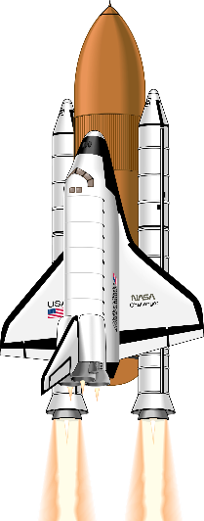 | 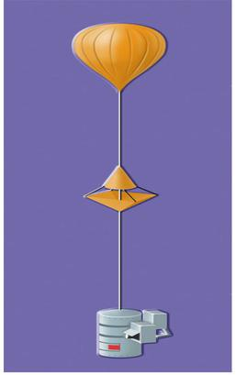 | 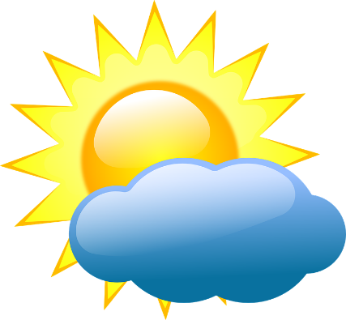
 |  | 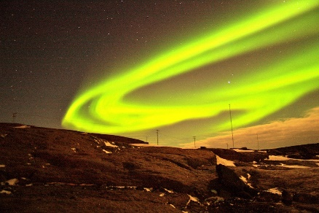
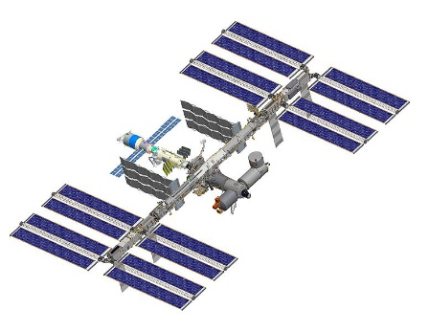 | 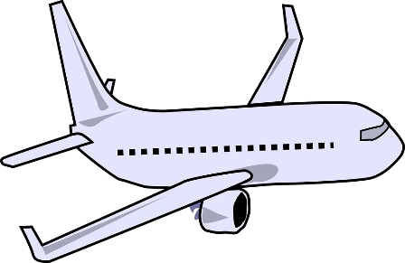 | 