Name _________________________________________ Date ______________ Student No. ___________
Blackline Master #1

Checking for Understanding: Tides

Use the diagram below to answer questions 1 and 2.
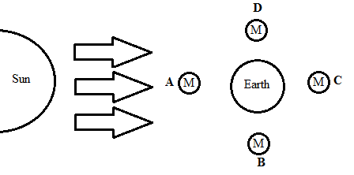
___ 1. Which Moon positions will create the smallest difference between high tide and low tide?
- A or B
- A or C
- B or D
- B or C

___ 2. Spring Tides are the highest high tides and the lowest low tides. Which Moon positions above would create spring tides?
- A or B
- A or C
- B or D
- B or C

___ 3. Why does the Moon have a greater tidal effect than the Sun?
- The Moon has more mass than the Sun
- The Moon rotates faster than the Sun
- The Moon is a solid and the Sun in a gas
- The Moon is closer to the Earth than the Sun

___ 4. Which of the diagrams below most accurately represents the effects of the Moon on the Earth's tides?
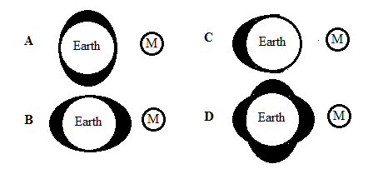

Blackline Master #1 Key
Answer Key:
- c
- b
- d
- b

