  Blackline Master 1  Photo Credit: https://pixabay.com/get/9732887a5bc608483fc8/1441312505/fire-30276_1280.png?direct | 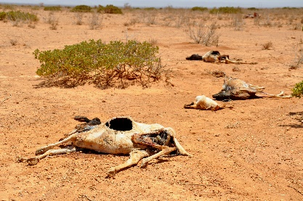  Photo Credit: https://www.flickr.com/photos/oxfameastafrica/5758386784/ | 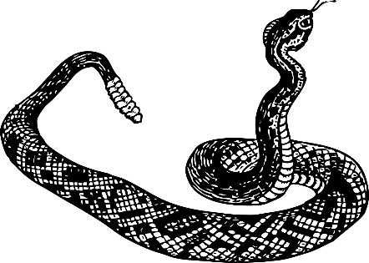  Photo Credit: https://pixabay.com/get/66595badd7fa9a966102/1441312162/rattlesnake-32693_1280.png?direct
A fire has engulfed a large section of the forest. 25 deer have died as a result. | It hasn’t rained in weeks and your ecosystem is suffering a drought. As a result, half of your current population dies. | A new family of rattlesnakes are living in your area and have bitten 5 deer in your population. As a result, all 5 deer have died.
Photo Credit: https://pixabay.com/get/66595badd7fa9a966102/1441312162/rattlesnake-32693_1280.png?direct | 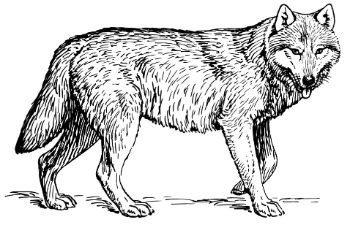  Photo Credit: http://www.freestockphotos.biz/stockphoto/14950 | Photo Credit: http://www.freestockphotos.biz/stockphoto/14950
A new family of rattlesnakes are living in your area and have bitten 5 deer in your population. As a result, all 5 deer have died. | You share your habitat with wolves and they are your predator. 5 deer in your population have died to feed the wolves. | You share your habitat with wolves and they are your predator. 5 deer in your population have died to feed the wolves.
Photo Credit: http://www.freestockphotos.biz/stockphoto/14950 | Photo Credit: http://www.freestockphotos.biz/stockphoto/14950 | 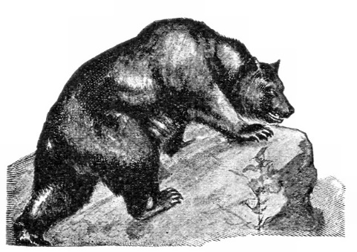  Photo Credit: http://www.freestockphotos.biz/stockphoto/13322
You share your habitat with wolves and they are your predator. 5 deer in your population have died to feed the wolves. | You share your habitat with wolves and they are your predator. 5 deer in your population have died to feed the wolves. | The local bear family can’t find any more fish so they have turned to the deer in your population as a food source. 5 deer in your population have been killed to feed the bears.
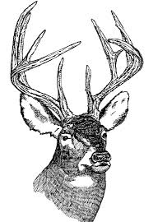  Photo Credit: www.public-domain-image.com%2Ffree-images%2Fart%2Fline-art-illustration-pictures%2Fwhite-tailed-deer-head-illustration%2Fattachment%2Fwhite-tailed-deer-head-illustration&psig=AFQjCNF-0XvP6VQAiiCVaKGn79NibGF_Ig&ust=1441470873659269 | 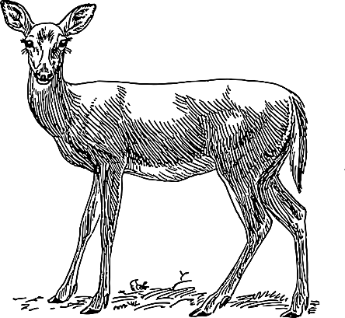  Photo Credit: https://pixabay.com/get/a4b6fbfb70b5a7d10c89/1441384611/female-48231_1280.png?direct | 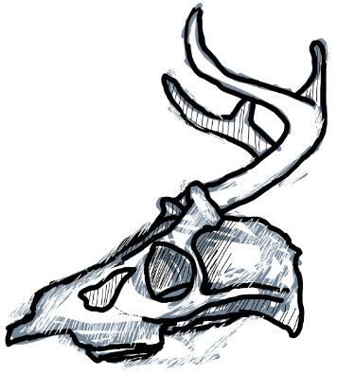  Photo Credit: http://www.sketchport.com/drawing/5684992466223104/ol-alfred
There are too many males in your population and not enough females. Decrease your population by 20 deer. | There are too many females in your population and most are of age to reproduce. Increase your population by 20 deer. | It was a harsh winter and all of your infant and elderly deer die. Decrease your population by 20 deer.
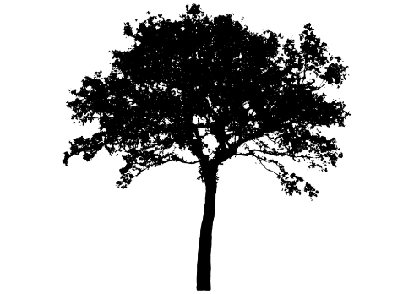  Photo Credit: http://www.freestockphotos.biz/stockphoto/15119 | Photo Credit: http://www.freestockphotos.biz/stockphoto/15119 | Photo Credit: http://www.freestockphotos.biz/stockphoto/15119
You’ve found SHELTER!  Increase your population by 10 deer. | You’ve found SHELTER!  Increase your population by 10 deer. | You’ve found SHELTER!  Increase your population by 10 deer.
Photo Credit: http://www.freestockphotos.biz/stockphoto/15119 | 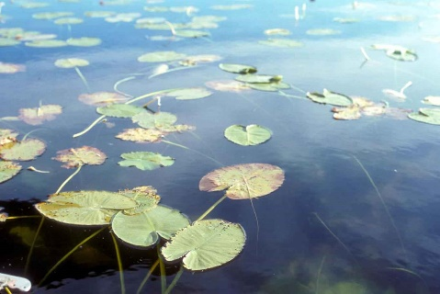  Photo Credit: http://www.public-domain-image.com/free-images/flora-plants/flowers/water-lily-lotus-flower/aquatic-environments-plants-water-lilies-leaves/attachment/aquatic-environments-plants-water-lilies-leaves | Photo Credit: http://www.public-domain-image.com/free-images/flora-plants/flowers/water-lily-lotus-flower/aquatic-environments-plants-water-lilies-leaves/attachment/aquatic-environments-plants-water-lilies-leaves
You’ve found SHELTER!  Increase your population by 10 deer. | You’ve found WATER!  Increase your population by 10 deer. | You’ve found WATER!  Increase your population by 10 deer.
Photo Credit: http://www.freestockphotos.biz/stockphoto/13322 | 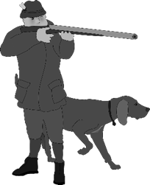  Photo Credit: https://pixabay.com/get/a0a3a77e989458d58353/1441383050/hunter-160297_1280.png?direct | Photo Credit: https://pixabay.com/get/a0a3a77e989458d58353/1441383050/hunter-160297_1280.png?direct
The local bear family can’t find any more fish so they have turned to the deer in your population as a food source. 5 deer in your population have been killed to feed the bears. | There are hunters in your area. 10 deer in your population have been shot and killed. | There are hunters in your area. 10 deer in your population have been shot and killed.
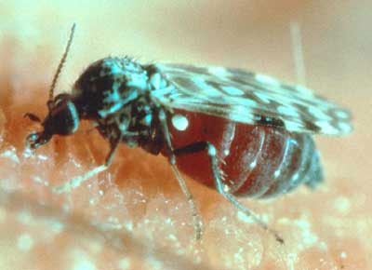  Photo Credit: https://commons.wikimedia.org/wiki/File:Biting_Midge.png | Photo Credit: https://commons.wikimedia.org/wiki/File:Biting_Midge.png | 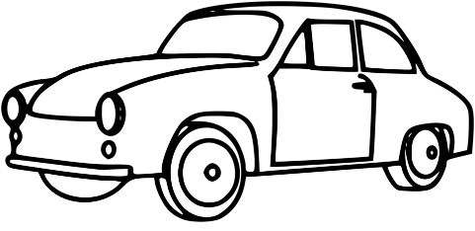  Photo Credit: http://www.freestockphotos.biz/stockphoto/15049
The biting fly population is booming this year! As a result, many of the deer in your population have contracted Hemorrhagic Disease and 5 have died. | The biting fly population is booming this year! As a result, many of the deer in your population have contracted Hemorrhagic Disease and 5 have died. | There is a highway near your habitat that your population often crosses. Many are hit by cars. Decrease your deer population by 10.
Photo Credit: http://www.public-domain-image.com/free-images/flora-plants/flowers/water-lily-lotus-flower/aquatic-environments-plants-water-lilies-leaves/attachment/aquatic-environments-plants-water-lilies-leaves |   Photo Credit: http://www.torange.us/Plants/fruit-and-berries/currants-in-isolation-33142.html | Photo Credit: http://www.freestockphotos.biz/stockphoto/15119
You’ve found WATER!  Increase your population by 10 deer. | You’ve found FOOD!  Increase your population by 10 deer. | You’ve found SHELTER!  Increase your population by 10 deer.
Photo Credit: http://www.public-domain-image.com/free-images/flora-plants/flowers/water-lily-lotus-flower/aquatic-environments-plants-water-lilies-leaves/attachment/aquatic-environments-plants-water-lilies-leaves | Photo Credit: http://www.public-domain-image.com/free-images/flora-plants/flowers/water-lily-lotus-flower/aquatic-environments-plants-water-lilies-leaves/attachment/aquatic-environments-plants-water-lilies-leaves | Photo Credit: http://www.torange.us/Plants/fruit-and-berries/currants-in-isolation-33142.html
You’ve found WATER!  Increase your population by 10 deer. | You’ve found WATER!  Increase your population by 10 deer. | You’ve found FOOD!  Increase your population by 10 deer.
Photo Credit: http://www.torange.us/Plants/fruit-and-berries/currants-in-isolation-33142.html | Photo Credit: http://www.torange.us/Plants/fruit-and-berries/currants-in-isolation-33142.html | Photo Credit: http://www.torange.us/Plants/fruit-and-berries/currants-in-isolation-33142.html
You’ve found FOOD!  Increase your population by 10 deer. | You’ve found FOOD!  Increase your population by 10 deer. | You’ve found FOOD!  Increase your population by 10 deer.
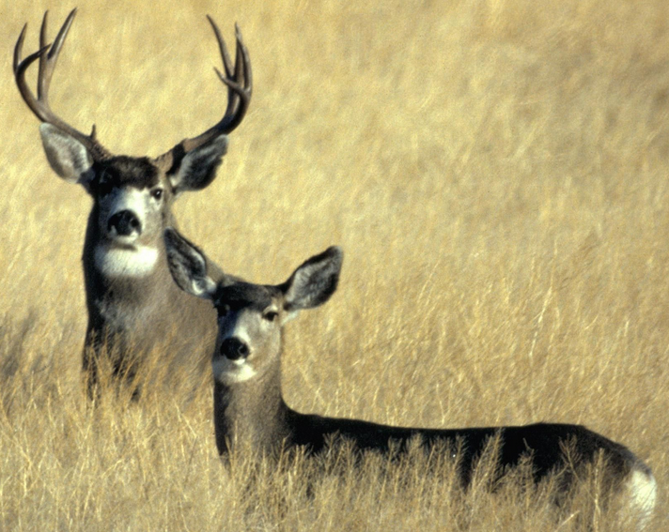  Photo Credit: http://www.public-domain-image.com/free-images/fauna-animals/deers/mule-deer-in-california/attachment/mule-deer-in-california | Photo Credit: http://www.public-domain-image.com/free-images/fauna-animals/deers/mule-deer-in-california/attachment/mule-deer-in-california | 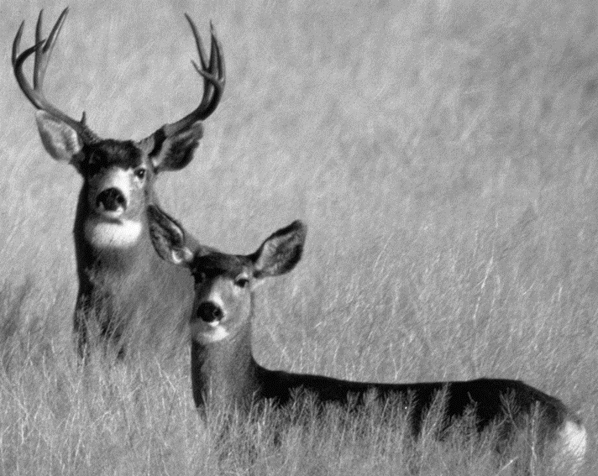  Photo Credit: http://www.public-domain-image.com/free-images/fauna-animals/deers/mule-deer-in-california/attachment/mule-deer-in-california
You’ve found a MATE!  Increase your population by 5 deer. | You’ve found a MATE!  Increase your population by 5 deer. | You’ve found a MATE!  Increase your population by 5 deer.

Blackline Master 2

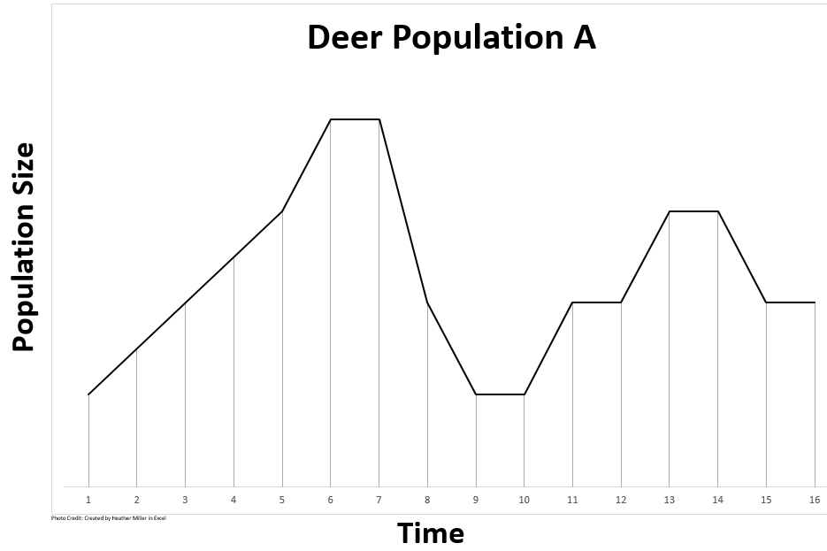
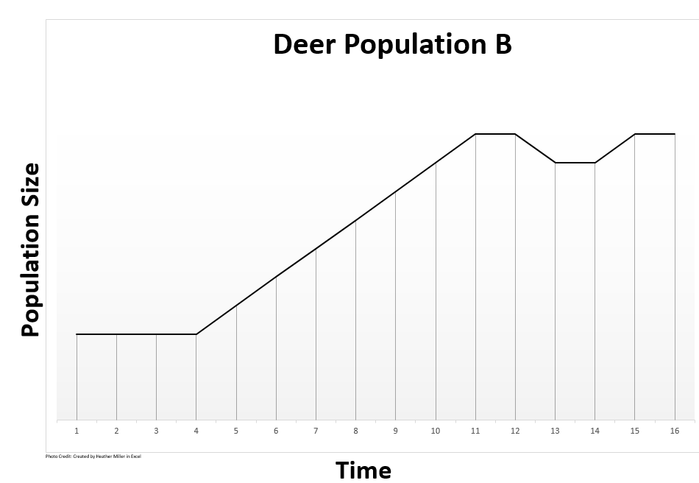
Blackline Master 3

Engage
Problem: How is population size affected by different environmental factors?
Based on the patterns in the graphs, what do you think could account for the differences between the two populations of the deer?

With your face partner, rally robin (share back and forth) one idea each that you wrote for the question above. Continue sharing back and forth until your teacher calls time.

With your shoulder partner, research the following questions (BYOD):
What do deer need to survive?

What interferes with a deer’s survival?

Hypothesis: If a population experiences _______________________ then it will ____________ because

___________________________________________________________________________________.

Explore
You will be conducting your own population study with a population size of 100 deer. You will be exposing your deer to factors that they commonly encounter in their natural ecosystems and will be evaluating how it impacts their population.

Procedure:
- Draw one card out of the envelope at a time.
- Read what the card says and record the results in your data table.
  - For example, if the card says that aliens have invaded and have killed 10 deer, subtract 10 deer from your population, record the new number of deer in your population, and then carry the new number into the row below for the next turn.
Population | Limiting Factor | Effect on Population | New Population
100 | aliens invaded | -10 | 90
90

- DO NOT put the card back in the envelope.
- Draw the next card and continue drawing and recording data until you have drawn 20 cards and completed all 20 trials.
- When you are finished with your trials, put all cards back in the envelope.

Deer Population Data Table
Turn | Population | Limiting Factor | Effect on Population | New Population
 | 100 Deer
(each turn represents population changes over a 3 month period)

Deer Population Graph

Deer Population
Photo Credit: http://www.texample.net/tikz/examples/graph-paper/

Months
(1 turn = 3 months)
Explain
Use your data and your graph to help you answer the following questions.

- Give an overall description of your graph/data. Explain what factors accounted for the major increases or decreases in your population.

- Based on the cards that you chose, and using your data table as a reference, what do you think a “limiting factor” is?

- What were some of the biotic limiting factors in the deer’s ecosystem?

- What were some of the abiotic limiting factors in the deer’s ecosystem?

- Choose two limiting factors that had a positive effect on your population and explain why they had an impact on your population.

- Choose two limiting factors that had a negative effect on your population and explain why they had an impact on your population.

- Carrying capacity is the maximum number of organisms that an ecosystem can support. Looking at your data table and graph, what would you predict is the carrying capacity for your ecosystem? Explain your choice.

- What is the relationship between limiting factors and carrying capacity in an ecosystem?

- Predict what you think would happen to a population that exceeds the carrying capacity for its ecosystem.

- Explain how an immigration (movement INTO an area) of deer would impact the population in terms of numbers, limiting factors, and carrying capacity.

- Explain how an emigration (movement OUT of an area) of deer would impact the population in terms of numbers, limiting factors and carrying capacity.

- Density-dependent factors are limiting factors in an ecosystem that only impact a population when the population becomes too large or too small. Which of the limiting factors that you encountered were density-dependent factors? Explain your rationale.

- Density-independent factors are limiting factors in an ecosystem that impact a population regardless of the population size. Which of the limiting factors that you encountered were density-independent factors? Explain your rationale.

- How is your graph similar or different than the graph of another group?
Expand/Elaborate
Now that you know a little about deer and the limiting factors that affect their population sizes, think about one of your favorite animal or plant species and what might affect their population. You will be creating a simulated population study of your animal based on a little research and your knowledge of limiting factors.

Animal: ___________________________

Biotic Factors
Abiotic Factors
Density-dependent limiting factors:
Density-independent limiting factors:
Factors that will increase the population:
Factors that will decrease the population:

Draw a graph that could represent your animal’s population and its changes over time. Explain your graph in terms of what caused the changes in the population fluctuations (increases, decreases, etc). Assume that you begin with a population of 100 organisms.


Explanation of your graph:
Blackline Master 4
Assessment

1. The carrying capacity of an ecosystem is the maximum number of individuals of a particular species that can be supported on a long-term basis in a given amount of land. For example, the carrying capacity of the Florida Panther may be 50 panthers per 10,000 square kilometers of habitat in the Everglades ecosystem. Which of the following determines the carrying capacity of an ecosystem? (SC.912.L.17.5)
- the availability of resources required for survival
- the average daily temperature of the ecosystem
- the number of predators found in the ecosystem
- the amount of disease affecting organisms in the ecosystem

2. The graph shown represents the population growth curves of two different species of organisms, A and B. What is a valid prediction based on this graph? (SC.912.L.17.5) (PTI 4,4. 5.8)
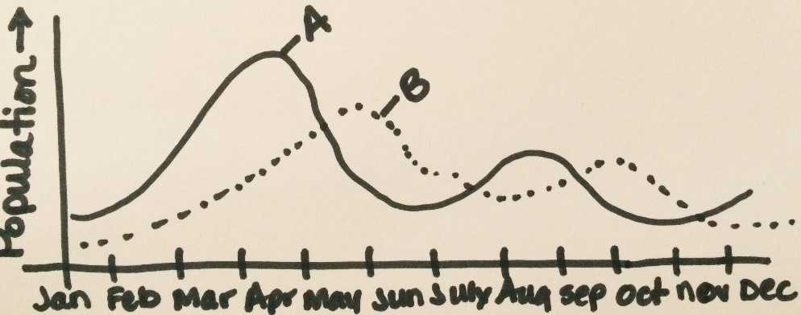
Photo Credit: Drawn by Heather Miller
- Species A will eliminate species B after 1 year.
- Species A will not be present in the winter months.
- Species B will attain maximum population size each autumn due to a decrease in temperature.
- Species B will decrease in population size approximately 2 months after a decrease in the population size of species A.

3. The food web below shows the relationship between different factors in a forest ecosystem. (SC.912.L.17.5) (PTI 5.8)
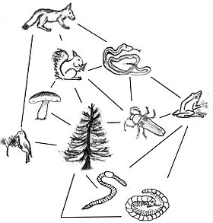
Photo Credit: https://commons.wikimedia.org/wiki/File:TrophicWeb.jpg
Identify an abiotic limiting factor that could inhibit the growth of the snake population.
- disease in the trees
- a decrease in air and soil quality
- an increase in the fox population
- a decrease in the number of frogs
4. Goatfish are fish that move in schools and feed on plankton and plant matter. Natural predators of the goatfish include sea trout, sharks, pelicans and dolphins. The graph below shows how the number of goatfish in an area has changed over time. (SC.912.L.17.5) (PTI 4.4, 5.8)
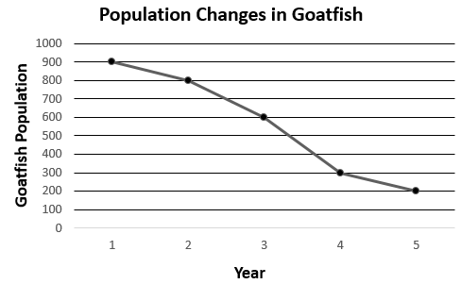
Photo Credit: Created by Heather Miller in Excel
Based on the data, one student concludes that a new predator was introduced into the area during this time period. Which of the following is a likely alternate explanation for the change in the goatfish population?
- the temperature of the area increased
- the amount of goatfish prey increased in the area
- the amount of aquatic plants in the area decreased
- the amount of goatfish parasites decreased in the area

5. The graph below shows changes in the sizes of four animal populations over a 16-year period.
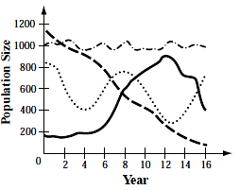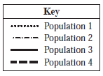
Photo Credit: https://stangbio.wikispaces.com/Ecology
In which population was birthrate most likely greater than death rate from year 8 to year 12? (SC.912.L.17.5) (PTI 4.4, 5.8)
- population 1
- population 2
- population 3
- population 4

OPTIONAL (not assessed on EOC).
6. Which of the following is NOT an example of a density-dependent limiting factor?
- Diseases
- Natural disasters
- Parasites
- Predators
Engage:
Blackline Master 5: Answer Keys
- Based on the patterns in the graphs…Student responses will vary.
- What do deer need to survive? Student responses will vary but could include food, water, shelter, space, and mates.
- What interferes with a deer’s survival? Student responses will vary but could include disease, hunters, lack of food, water, shelter, space, and mates.
- Hypothesis: If a population experiences (a hardship, lack of food, lack of water, too many predators, an abundance of food, a stable ecosystem, etc) then it will (increase, decrease, stay the same, etc) because (organisms need food to survive, organisms need to mate to carry on the population, etc.)

Explore:
- Student data & graphs will vary.

Explain:
- Give an overall description of your graph/data. Explain what factors accounted for the major increases or decreases in your population. Student responses will vary based on their graphs. Students should be able to identify what caused the increases and decreases in their population of deer.
- Based on the cards that you chose, and using your data table as a reference, what do you think a “limiting factor” is? Student response should indicate that a limiting factor is anything in an organisms’ environment that can have a positive or negative impact on their population size.
- What were some of the biotic limiting factors in the deer’s ecosystem? Food, hunters, bears, wolves, mates, biting flies, disease (if not viral), shelter (if trees and brush), snakes, and bears. Students may have additional responses that are correct as long as they are LIVING things.
- What were some of the abiotic limiting factors in the deer’s ecosystem? Water, air, cars, fire, drought, guns, and seasons. Students may have additional responses that are correct as long as they are NON-LIVING things.
- Choose two limiting factors that had a positive effect on your population and explain why they had an impact on your population. Food, water, shelter, mates, too many females all had a positive impact on the population. These allowed the deer to be healthy and reproduce which increased their numbers.
- Choose two limiting factors that had a negative effect on your population and explain why they had an impact on your population. Drought, fire, snake bites, predators, disease, too many males, hunters, bad weather, and car traffic all had a negative impact on the population. These factors caused death or heightened competition which led to a decrease in numbers.
- Carrying capacity is the maximum number of organisms that an ecosystem can support. Looking at your data table and graph, what would you predict is the carrying capacity for your ecosystem? Explain your choice. Student responses will vary depending on their graphs and data. The carrying capacity should be represented somewhere around their maximum population. Once deer reach a certain population size, the resources in their ecosystem become stretched too thin amongst the deer and deer begin dying or are not born.

- What is the relationship between limiting factors and carrying capacity in an ecosystem? Student responses may vary but should indicate something similar to: The amount of limiting factors in an ecosystem determine the carrying capacity for each organism. For example, there may be enough food for 100 deer, but if there are too many predators, then the population of deer may only reach 50.
- Predict what you think would happen to a population that exceeds the carrying capacity for its ecosystem. When a population exceeds its carrying capacity, natural factors (disease, food shortage, water shortage, competition over mates, etc) will cause deer to die or not be able to reproduce. This will decrease the deer numbers back to below the carrying capacity.
- Explain how an immigration (movement INTO an area) of deer would impact the population in terms of numbers, limiting factors, and carrying capacity. Immigration into a community would cause the deer population to rise, there would be a strain on the limiting factors in the environment (like food shortage, water shortage, etc), the population would climb toward its carrying capacity, deer would begin to struggle for survival and would die off until the numbers fell back below the carrying capacity.
- Explain how an emigration (movement OUT of an area) of deer would impact the population in terms of numbers, limiting factors and carrying capacity. . Emigration out of a community would cause the deer population to fall, there would be an abundance on the limiting factors in the environment (like food, water, shelter, etc), the population would climb toward its carrying capacity, deer would begin to struggle for survival and would die off until the numbers fell back below the carrying capacity.
- Density-dependent factors are limiting factors in an ecosystem that only impact a population when the population becomes too large or too small. Which of the limiting factors that you encountered were density-dependent factors? Explain your rationale. Competition for food, water, shelter, predation by bears and wolves, and mates would all increase if the population is large and dense. The spread of disease within the population would also increase as the density of the population increases. With these factors, the more deer you have, the more likely they are to affect the population.
- Density-independent factors are limiting factors in an ecosystem that impact a population regardless of the population size. Which of the limiting factors that you encountered were density-independent factors? Explain your rationale. Fire, drought, hunters, snakes, harsh weather, and car traffic are all factors that are not affected by how many deer there are. Whether there are 5 deer or 500 deer, these factors will impact the population size.
- How is your graph similar or different than the graph of another group? Student responses will vary depending on their graph and the graph they choose for comparison.

Extend/Elaborate:
Student animals, biotic factors, abiotic factors, density dependent & independent factors, graphs, and explanations will vary.

Evaluate:
1. A 2. D 3. B 4. C 5. C 6. B

