Blackline Master #1
What is in the test tubes?
Test Tube 1 | Test Tube 2 | Test Tube 3

Your Predictions:
What will happen when hydrogen peroxide is added to the chicken liver?

What will happen when we introduce FIRE into each test tube?
 | Test Tube 1 | Test Tube 2 | Test Tube 3
What will happen?
Why will that happen?

Your group’s ideas:

Your observations & explanations:
 | Test Tube 1 | Test Tube 2 | Test Tube 3
What happened?
Why did that happen?

Enzymes Puzzle
Blackline Master #2
Cut out the pieces along the heavy black lines. Credit: Hand drawn. Heather Miller

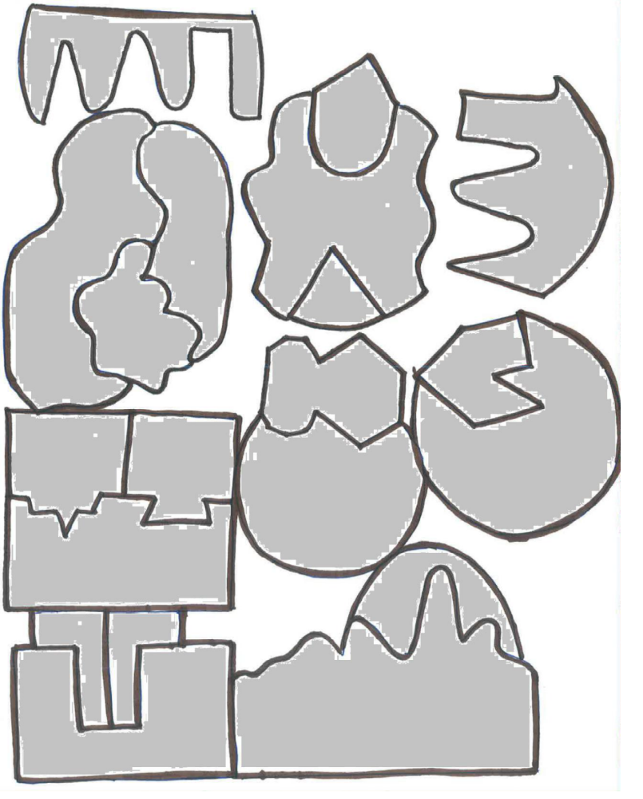
Blackline Master #3

- In the puzzle, the large piece of the puzzle represents the “enzyme,” the area where the enzyme and the pieces meet is called the “Active site” and the little pieces that connect to the active site are called “substrates.” Draw a labeled diagram that shows how the enzyme and substrate interact.
- Were you able to fit multiple different substrates into multiple different active sites? Why or why not?
- Based on your response to question 2, what conclusion can be drawn about the relationship between enzymes and substrates?
- How might this puzzle activity be related to the demonstration you saw with the liver and hydrogen peroxide?
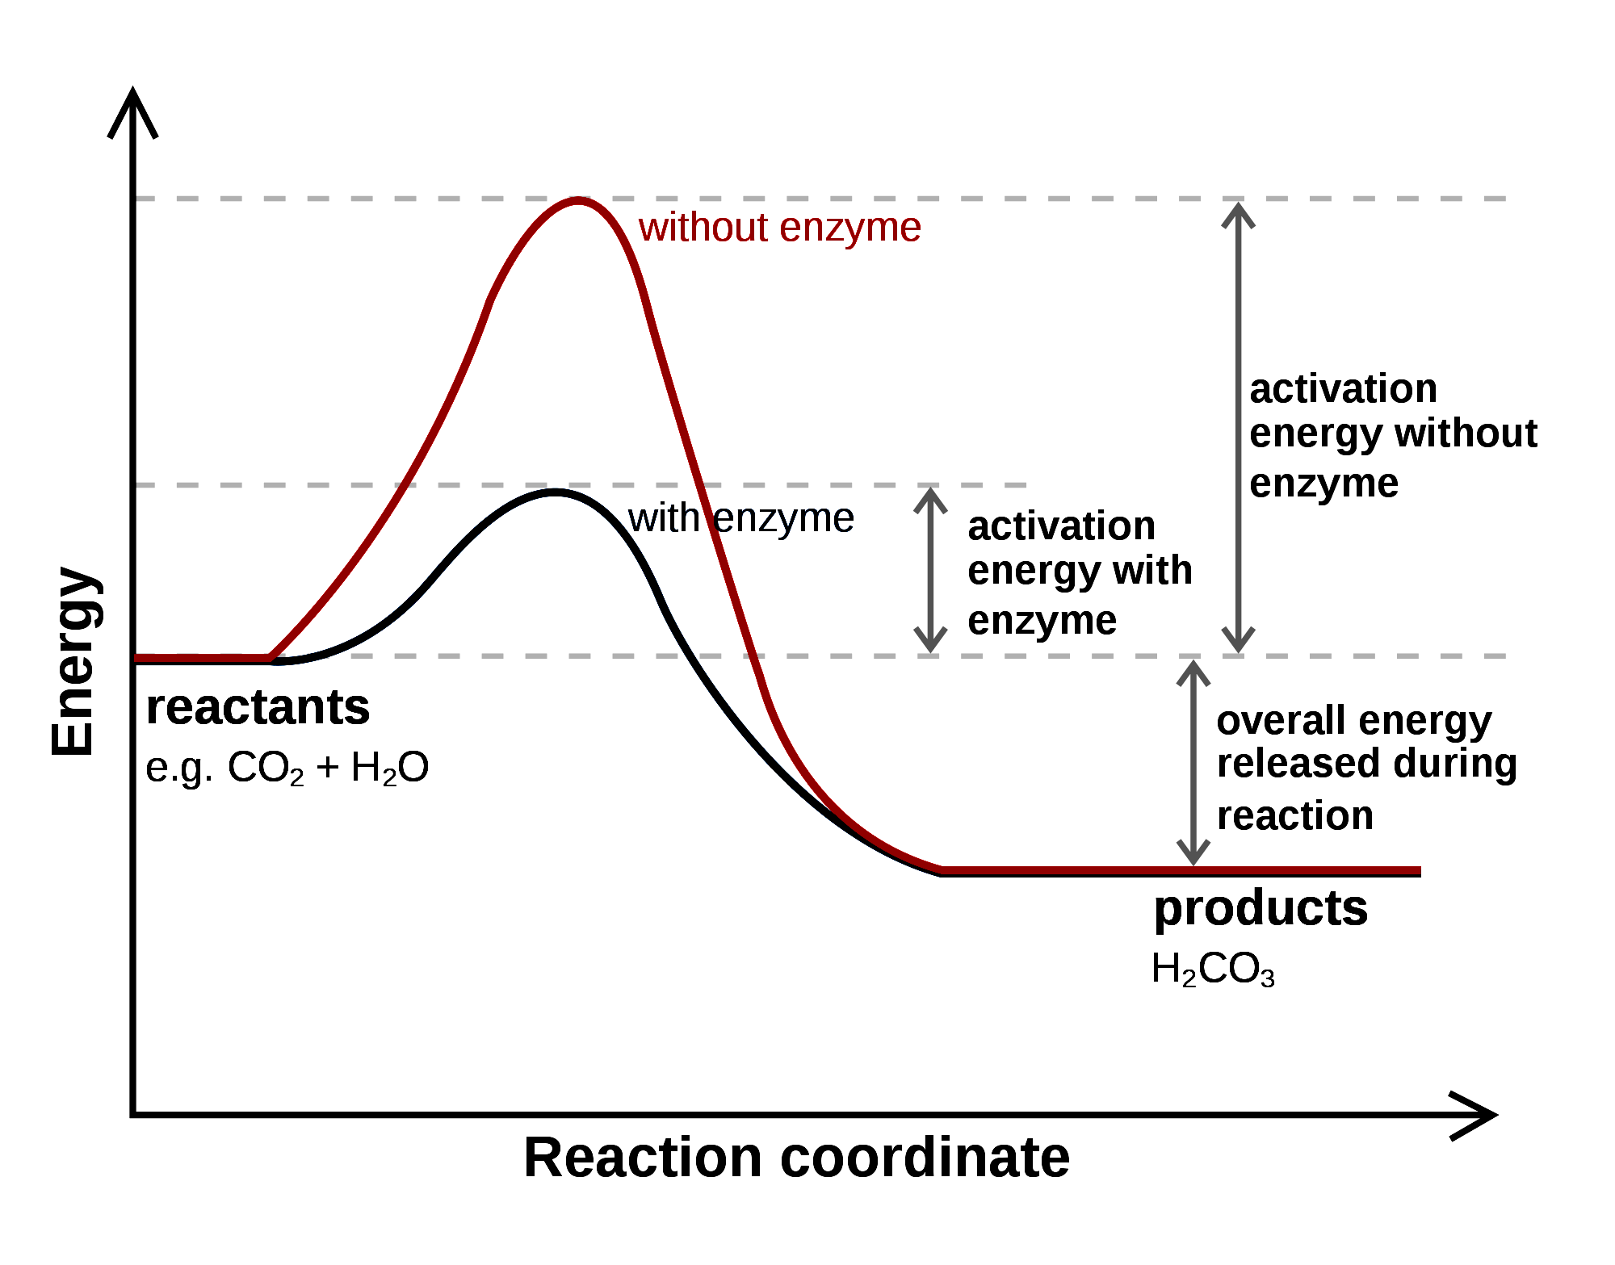
- “Denaturing” of an enzyme occurs when the shape of the enzyme is altered due to extreme temperatures or changes in pH. How could you alter your puzzle pieces to show the denaturing of an enzyme?
Photo Credit: https://commons.wikimedia.org/wiki/File:Carbonic_anhydrase_reaction_in_tissue.svg

- The graph on the right shows the energy required to carry out a biological reaction with and without an enzyme present. Write an analysis of how the presence of the enzyme affects the energy requirements of the reaction.

- When you connect the substrate to the enzyme, this represents an “enzymatic reaction.” What do you hypothesize might speed up or slow down an enzymatic reaction?
Blackline Master #4
Introduction:
Catalase is an enzyme that speeds up the breakdown of hydrogen peroxide (H₂O₂) into water (H₂O) and oxygen gas (O₂). Hydrogen peroxide is a poisonous by-product of cell metabolism. Without catalase, the cells would be damaged by the hydrogen peroxide they produce. In this activity, you will use the catalase in potato cells to see how various factors such as concentration, temperature, and pH level affect enzyme activity.

Materials:

Test tube rack
3 test tubes
3% Hydrogen peroxide
Potato cubes
Mortar and pestle
Hot water bath
Ice water bath
Test tube holder
Graduated cylinders
Test tube cleaners
Waste container
Purified Water
Hydrochloric acid (HCl)
Sodium hydroxide (NaOH)

Estimating the Reaction: For each test, allow the reaction to fully occur for ALL test tubes, and then describe the pattern of reaction and rank the test tubes in order of reactivity.

0 = no reaction (no foam or bubbling)
1 = minor reaction (very few bubbles or very slow to bubble, delayed reaction)
2 = moderate reaction (medium amount of bubbles, medium speed, delayed reaction)
3 = major reaction (a lot of bubbles, bubbles quickly and immediately)

Procedures:

Test 1: Enzyme Concentration (High, Medium, & Low Concentration)
- Set up a test tube rack with 3 test tubes.
- Place an unground piece of potato (low enzyme concentration) in tube 1.
- Cut a second piece of potato into 4 pieces (medium enzyme concentration) and add the pieces into tube 2.
- Grind one pea-sized piece of potato in a mortar and pestle. (Grinding releases the enzyme from the cells, which will increase the concentration of the enzyme.) Add the ground potato to tube 3.
- Pour 10ml of hydrogen peroxide into tubes 1, 2, and 3.
- Estimate the rate of reaction (based on the scale) and record your results in the data table.
- Clean the test tubes and move on to the next section.

Test 2: Temperature (Freezing 0ºC, Room 25ºC, Boiling 100ºC)
- To tube 1, 2, and 3, add one piece of potato.
- Place tube 3 in a hot water bath for 5 minutes.
  - Caution: Follow instructions exactly as demonstrated when using the hot water bath!
  - Use a test tube holder to remove the tube from the hot water.
- At the same time, place tube 1 in an ice water bath for 5 minutes.
- Test tube 2 will remain at room temperature in the test tube rack.
- After the five minutes have passed, put test tubes 1 and 3 in the test tube rack and add 10ml of hydrogen peroxide to all 3 test tubes.
- Estimate the rate of reaction (based on the scale) and record your results in the data table.
- Clean test tubes and move to the next section.

Test 3: pH level (Neutral pH, acidic pH, or basic pH)

Test Tube #1
- Add 5 ml of hydrochloric acid to test tube 1.
- Add 5 ml of hydrogen peroxide to test tube 1.
- Using the pH indicator paper, measure the pH of the solution in the test tube.
Test Tube #2
- Add 5 ml of water to test tube 2.
- Add 5 ml of hydrogen peroxide to test tube 2.
- Using the pH indicator paper, measure the pH of the solution in the test tube
Test Tube #3
- Add 5 ml of sodium hydroxide to test tube 3.
- Add 5 ml of hydrogen peroxide to test tube 3.
- Using the pH indicator paper, measure the pH of the solution in the test tube.
All Three Test Tubes
- Add one piece of potato to each test tube.
- Estimate and compare the rate of reaction (based on the scale) and record your results in the data table.
- Thoroughly clean all test tubes, mortars and pestles, and table area. Return all equipment to its assigned location.

Blackline Master #5
Question: How does a change in temperature, concentration, or pH affect enzyme activity?

Hypotheses:
Make a hypothesis in which you predict under which condition the enzyme will work best.
Follow the example shown.

- Concentration (High, Moderate, Low concentration)
Example Hypothesis: If the enzyme catalase concentration is LOW, then it will react faster/better than if the concentration was high.

Your Hypothesis:

- Temperature (Freezing 0ºC, Room 25ºC, Boiling 100ºC)
Your Hypothesis:

- pH level (Neutral pH (7), acidic pH (0-6.9), or a basic pH (7.1-14))
Your Hypothesis:

Data Table:

Test 1: Concentration
Contents & Observations |  | Reaction rate
Test tube 1
Test tube 2
Test tube 3

Test 2: Temperature
Contents & Observations |  | Reaction rate
Test tube 1
Test tube 2
Test Tube 3

Test 3: pH
Contents & Observations |  | Reaction rate
Test tube 1
Test tube 2
Test tube 3

Data Analysis:
Graph the results of your three tests: concentration, temperature, and pH vs reaction rate. Don’t forget your axis labels for each graph.

CONCENTRATION TEMPERATURE pH
Conclusions:
- How did reaction rate change with the change in concentration? Explain why you think this happened. Cite your data in your explanation.
- How did reaction rate change with the change in temperature? Explain why you think this happened. Cite your data in your explanation.
- How did reaction rate change with the change in pH? Explain why you think this happened. Cite your data in your explanation.

- Where might we see changes in pH, temperature, OR concentration in nature and how could these changes affect living organisms?
- How might the reactions you observed be different if enzymes were not present?
- Based on your data, predict what the “optimum” pH, temperature, and concentration is for the catalase enzyme reactions that you observed.
- How and why might the “optimum” temperature for the enzymes in liver be different that the “optimum” temperature for the enzymes in potatoes?
- Based on your data, at what pH and temperature do you predict that denaturing would occur in the catalase enzyme?

WAIT TO COMPLETE THIS QUESTION. We will do this after we rearrange our groups.
- How was your data, your analysis, and your conclusions similar or different than your collaborative group?
Blackline Master #5
Enzymes Check for Understanding
1. Researchers know that the reaction rate of an enzyme is affected by temperature and pH level. Some of these effects are shown on the graphs below.
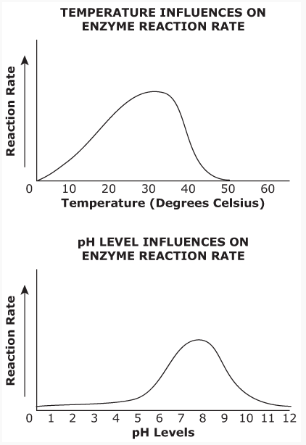
Images created using Excel: Heather MIller

If the enzyme was placed in an environment where the temperature is 50ºC with a pH 5.0, what would be expected to happen to the rate of reaction?
A. There would be an increased rate of reaction.
B. There would be no change to the rate of reaction.
C. There would be a reduced rate of reaction and possible denaturing of the enzyme.
D. There would first be an increased rate of reaction and then a decreased rate of reaction.

2. Enzymes are catalysts that are able to speed up the rate of chemical reactions. How are enzymes able to do this?
A. Enzymes make the particles interacts more frequently.
B. Enzymes are able to increase the temperature of the reaction.
C. Enzymes lower the activation energy needed to carry out the reaction.
D. Enzymes increase the activation energy needed to carry out the reaction.

3. Which of the following best explains why enzymes are necessary for many cellular reactions?
A. Enzymes supply the oxygen necessary for the reactions.
B. Enzymes change reactants from solid to liquids during the reactions.
C. The reactions take up too much space in the cell if the enzymes are missing.
D. The reactions are too slow to meet the needs of the cell if enzymes are missing.

- The picture below shows the lock-and-key model of enzyme function.
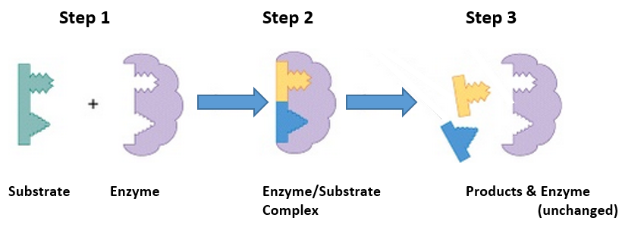
Picture created and edited in Word: Heather Miller
What is taking place in the second step of this process?
A. The catalyzed reaction is releasing a product.
B. The active sites are restructuring the enzyme.
C. The substrates are beginning to alter the enzyme.
D. The enzyme is causing bonds to break within the substrate.

5. A certain enzyme will react with protein but not fats. Which statement best explains this observation?
A. Proteins act as a coenzyme for reactions.
B. Fat molecules are too large to be reacted with.
C. Enzyme molecules are specific in their actions.
D. Fats are composed of lipids which cannot be reacted.
Blackline Master #6: ANSWER KEYS

What is in the test tubes?
Test Tube 1 | Test Tube 2 | Test Tube 3
Chicken Liver | Hydrogen Peroxide | Chicken Liver & Hydrogen Peroxide

Your Predictions:
What will happen when hydrogen peroxide is added to the chicken liver?
Student responses will vary as this is a prediction.

What will happen when we introduce FIRE into each test tube?
 | Test Tube 1 | Test Tube 2 | Test Tube 3
What will happen? | Student responses will vary as this is a prediction. | Student responses will vary as this is a prediction. | Student responses will vary as this is a prediction.
Why will that happen? | Student responses will vary as this is a prediction. | Student responses will vary as this is a prediction. | Student responses will vary as this is a prediction.

Your group’s ideas:
Student responses will vary as this is a prediction.

Your observations & explanations:
 | Test Tube 1 | Test Tube 2 | Test Tube 3
What happened? | Nothing happened | Nothing happened | There was a loud “POP” and then the wooden stick lit on fire.
Why did that happen? | There was no oxygen present | There was no oxygen present | There was oxygen present and oxygen is flammable so it lit on fire causing the wood to catch on fire.

1. In the puzzle, the large piece of the puzzle represents the “enzyme,” the area where the enzyme and the pieces meet is called the “Active site” and the little pieces that connect to the active site are called “substrates.” Draw a labeled diagram that shows how the enzyme and substrate interact.
Students’ diagrams should look something like this:
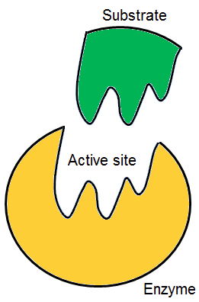
Photo credit: https://commons.wikimedia.org/wiki/File:Lock_and_key.png
2. Were you able to fit multiple different substrates into multiple different active sites? Why or why not?
Student responses will vary but should reflect that they were only able to make one specific substrate fit into the active site of one specific enzyme.
3. Based on your response to question 2, what conclusion can be drawn about the relationship between enzymes and substrates?
Student responses may vary but should include something explaining that there is only one substrate that each enzyme is responsible for reacting with and that the enzyme-substrate relationship is very specific like a “lock & key” system.

4. How might this puzzle activity be related to the demonstration you saw with the liver and hydrogen peroxide?
Student responses may vary but should indicate that there are enzymes in the liver (catalase) that connect with the hydrogen peroxide (the substrate) to break it down into water and oxygen. The puzzle pieces could be the enzyme (catalase) from the liver and the substrate (hydrogen peroxide).

5. “Denaturing” of an enzyme occurs when the shape of the enzyme is altered due to extreme temperatures or changes in pH. How could you alter your puzzle pieces to show the denaturing of an enzyme?
Students responses may vary but could include that they could change the shape of one of their puzzle pieces by cutting it or ripping off a piece so that it no longer fits with its substrate puzzle piece.
Photo Credit: https://commons.wikimedia.org/wiki/File:Carbonic_anhydrase_reaction_in_tissue.svg
6. The graph on the right shows the energy required to carry out a biological reaction with and without an enzyme present. Write an analysis of how the presence of the enzyme affects the energy requirements of the reaction.
The students should be able to interpret from the graph that enzymes lower the activation energy needed to carry out a reaction.

7. When you connect the substrate to the enzyme, this represents an “enzymatic reaction.” What do you hypothesize might speed up or slow down an enzymatic reaction?
Students could hypothesize that increasing temperature, concentration, or surface area could result in a speed up of the reaction because they have learned this is true of chemical reactions. They could further hypothesize that the opposite would be true to slow down the reaction.

Question: How does a change in temperature, concentration, or pH affect enzyme activity?

Hypotheses:
Make a hypothesis in which you predict under which condition the enzyme will work best.
Follow the example shown.

- Concentration (High, Moderate, Low concentration)
Example Hypothesis: If the enzyme catalase concentration is LOW, then it will react faster/better than if the concentration was high.

Your Hypothesis: Students responses may vary

- Temperature (Freezing 0ºC, Room 25ºC, Boiling 100ºC)
Your Hypothesis: Students responses may vary

- pH level (Neutral pH (7), acidic pH (0-6.9), or a basic pH (7.1-14))
Your Hypothesis: Students responses may vary

Data Table:

Test 1: Concentration
Contents & Observations |  | Reaction rate
Test tube 1 | whole potato  a small amount of bubbles and foam | 1
Test tube 2 | quartered potato  a medium amount of bubbles and foam | 2
Test tube 3 | ground up potato  a lot of bubbles and foam  potato could be hard to distinguish from foam | 3

Test 2: Temperature
Contents & Observations |  | Reaction rate
Test tube 1 | cold water, potato may sink,  longer reaction, slow to start, delayed reaction, small amount of bubbles | 1-2
Test tube 2 | room temperature water, potato may float, fast reaction then slows down, a lot of bubbling | 2-3
Test Tube 3 | hot water, potato may sink,  slow to start, delayed reaction, very few bubbles | 0-1

Test 3: pH
Contents & Observations |  | Reaction rate
Test tube 1 | hydrochloric acid, pH 1, little to no reaction, very few if any bubbles | 1
Test tube 2 | water, pH of 7, bubbled a lot and continuously bubbles | 3
Test tube 3 | sodium hydroxide, pH 12+, moderate bubbling that lasted a long time | 2

Data Analysis:
Graph the results of your three tests: concentration, temperature, and pH vs reaction rate. Don’t forget your axis labels for each graph.
CONCENTRATION TEMPERATURE pH

Conclusions:
- How did reaction rate change with the change in concentration? Explain why you think this happened. Cite your data in your explanation.
As the concentration increases, the reaction rate increases. Student data will vary but should be cited specifically in their response, for example, “With low concentration we had a reaction rate of only 1 but with a high concentration we had a reaction rate of 3.” Possible explanations for this occurrence could include that when there are more enzymes available to react (increased concentration) then the reaction speeds up and produces more oxygen gas as a byproduct (bubbles).
- How did reaction rate change with the change in temperature? Explain why you think this happened. Cite your data in your explanation.
Enzyme reaction should be the low for the cold temperature water and even lower for the high temperature water as the enzymes become denatured. The highest reaction should be for the room temperature water. Student data will vary but should be cited specifically in their response, for example, “With our ice water bath we had a reaction rate of 1-2, with room temperature it was more like a 3, and with hot water is was 0-1.” Possible explanation for this occurrence could include that when the enzymes are cold, it slows their reaction because the kinetic energy of the reaction slows. In hot water, the reaction increases to such a speed that the enzymes become denatured and can no longer react with the substrate. Moderate temperatures may be the temperature of their natural environment.
- How did reaction rate change with the change in pH? Explain why you think this happened. Cite your data in your explanation.
Enzyme reaction should be the lowest for the low pH and low for the high pH with the best reaction occurring when the pH is near neutral. Student data will vary but should be cited specifically in their response, for example, “With the low pH we had a reaction rate of 1, with neutral pH it was more like a 3, and with high pH it is was 1-2.” Possible explanation for this occurrence could include that when the enzymes react best when they are in a neutral pH environment and that this might be the pH of their natural environment.

- Where might we see changes in pH, temperature, OR concentration in nature and how could these changes affect living organisms?
Changes in pH in nature could occur from acid rain, a change in environment where the soil or water has a different pH, or from illness in the organism. Change in temperature could occur from changes in the environment such as climate or weather change, change in location, the cooking process, or illness in the organism. Changes in concentration would occur if medications were taken to provide the body with extra enzymes or reduce enzyme activity. Another reason might be from eating specific foods that need a specific enzyme to be digested or metabolized (example: lactase). Changes in any of these conditions would heighten or diminish an organisms’ ability to carry out these reactions.
- How might the reactions you observed be different if enzymes were not present?
If the enzymes were not present in the reactions observed, the reaction would take much longer and no reaction would likely be observed.

- Based on your data, predict what the “optimum” pH, temperature, and concentration is for the catalase enzyme reactions that you observed.
Student responses will correlate with their data, but should follow the general pattern of optimum pH is around neutral, optimum temperature is around room temperature, and optimum concentration is high.
- How and why might the “optimum” temperature for the enzymes in liver be different that the “optimum” temperature for the enzymes in potatoes?
The optimum temperature for liver from an ANIMAL would likely be higher than the optimum temperature for a PLANT like a potato as the internal temperature of most birds and mammals is somewhere between 98^{O}F and 109^{O}F (37^{O}C to 43^{O}C). The internal temperature of plants depends on their exterior surroundings with most plants growing in the spring and summer where temperatures are between 60^{O}F and 90^{O}F (16^{O}C to 32^{O}C).

- Based on your data, at what pH and temperature do you predict that denaturing would occur in the catalase enzyme?
Students responses will vary based on their data, but denaturing of this enzyme likely occurs in a pH lower than 6 and higher than 8, and a temperature higher than 70-80^{O}F (21^{O}C to 27^{O}C).

WAIT TO COMPLETE THIS QUESTION. We will do this after we rearrange our groups.
- How was your data, your analysis, and your conclusions similar or different than your collaborative group?
Student responses will vary.
Enzymes Check for Understanding
1. Researchers know that the reaction rate of an enzyme is affected by temperature and pH level. Some of these effects are shown on the graphs below.

If the enzyme was placed in an environment where the temperature is 50ºC with a pH 5.0, what would be expected to happen to the rate of reaction?
A. There would be an increased rate of reaction.
B. There would be no change to the rate of reaction.
C. There would be a reduced rate of reaction and possible denaturing of the enzyme.
D. There would first be an increased rate of reaction and then a decreased rate of reaction.

2. Enzymes are catalysts that are able to speed up the rate of chemical reactions. How are enzymes able to do this?
A. Enzymes make the particles interacts more frequently.
B. Enzymes are able to increase the temperature of the reaction.
C. Enzymes lower the activation energy needed to carry out the reaction.
D. Enzymes increase the activation energy needed to carry out the reaction.

3. Which of the following best explains why enzymes are necessary for many cellular reactions?
A. Enzymes supply the oxygen necessary for the reactions.
B. Enzymes change reactants from solid to liquids during the reactions.
C. The reactions take up too much space in the cell if the enzymes are missing.
D. The reactions are too slow to meet the needs of the cell if enzymes are missing.

- The picture below shows the lock-and-key model of enzyme function.
What is taking place in the second step of this process?
A. The catalyzed reaction is releasing a product.
B. The active sites are restructuring the enzyme.
C. The substrates are beginning to alter the enzyme.
D. The enzyme is causing bonds to break within the substrate.

5. A certain enzyme will react with protein but not fats. Which statement best explains this observation?
A. Proteins act as a coenzyme for reactions.
B. Fat molecules are too large to be reacted with.
C. Enzyme molecules are specific in their actions.
D. Fats are composed of lipids which cannot be reacted.

