Trick or Science: Challenge Activity Directions
Blackline Master #1
Challenge #1  a. Divide into 2 groups.  b. Each group gets a mirror and stands at opposite ends of the table.  c. Arrange the mirrors on the table so that when you look into the other group’s mirror you see the other group’s members; not yourself (hint: move mirrors to see the reflection of your group).  d. Draw your final configuration on your challenge sheet. | Challenge #4  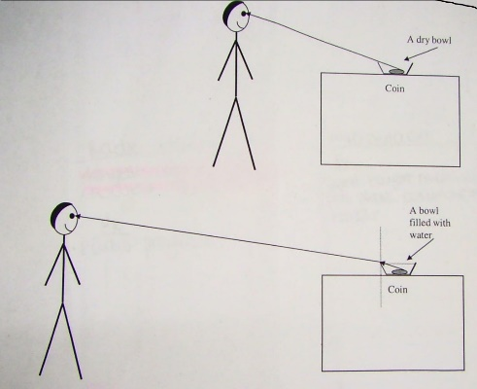  Figure 1  a. Place the penny in the bowl.  b. Have group member #1 walk backwards to where they can no longer see the coin in the bowl. Have group member #2 measure the distance from the group member to the bowl and record this distance as distance #1 on your challenge sheet.  c. Have group member #3 pour water into the bowl until person #1 can see the penny again. Person #1 now walks backward again until they cannot see the penny anymore.  d. Have person #2 or #4 measure the new distance and record it on your challenge sheet as distance #2. Use figure 1 to help you if you need it.
Challenge #2
a. Place the card with the arrows drawn on it upright behind an empty glass beaker 18 centimeters away.
b. Have each group member draw what they observe.
c. Fill the beaker ½ way with water or until 1 arrow is underwater.
d. Have each group member draw what they observe.
e. Add water to the beaker until it is full.
f. Have each group member draw what they observe.
Challenge #3
a. Using a beaker and a straw, place the straw into the beaker. Each group member draws what they are observing.
b. Have a group member fill the beaker half way with water while keeping the straw in the beaker. Each group member draws what they are observing.
c. Have a group member fill the beaker all the way with water while keeping the straw in the beaker. Each group member draws what they are observing.

Trick or Science: Challenge Student Sheet
Blackline Master #2
Challenge #1  Draw your group configuration in this space: |  | Challenge #4  Distance #1:  Distance #2:
Challenge #2  Empty Beaker | Beaker half full |  | Beaker full
Challenge #3  Empty Beaker | Beaker half full |  | Beaker full

Reflecting on the Light Challenges:
Blackline Master #3
Tell whether each challenge is an example of reflection, or refraction. Give evidence from the challenge to support your answers.
Reflection | Refraction
The process of light “bouncing” off of a surface. Light bounces off a surface at the same angle that the light goes in. | The process of light “bending” as it passes from one medium to another. Light bends differently depending on what medium (liquid/gas) it travels through.
Challenge #1
Challenge #2
Challenge #3
Challenge #4
Reflecting on the Light Challenges ANSWER KEY
Tell whether each challenge is an example of reflection, or refraction. Give evidence from the challenge to support your answers.
Reflection | Refraction
The process of light “bouncing” off of a surface. Light bounces off a surface at the same angle that the light goes in. | The process of light “bending” as it passes from one medium to another. Light bends differently depending on what medium (liquid/gas) it travels through.
Challenge #1  In this challenge, light reflects off the mirrors to allow students to see one another. | Refraction does not take place in this challenge.
Challenge #2  Light is reflecting off the card and the arrows to allow students to see the arrows. | Light is refracting from the air to water and back to air to cause the change in direction that students see in the arrows.
Challenge #3  Light is reflecting off the straw and the beaker to allow students to see them. | Light is refracting from the air to water to cause the change in direction (bend) of the straw.
Challenge #4  Light is reflecting off the bowl and the penny to allow students to see them. | Light is refracting from the air to water to cause the change in location (bend) of the penny.

Blackline Master #4
Light Behavior Check for Understanding
- Mario was learning about light behavior in science class, and the teacher showed the class a prism similar to the one in figure 1 below. Which behavior of light explains this observation? SC.7.P.10.2
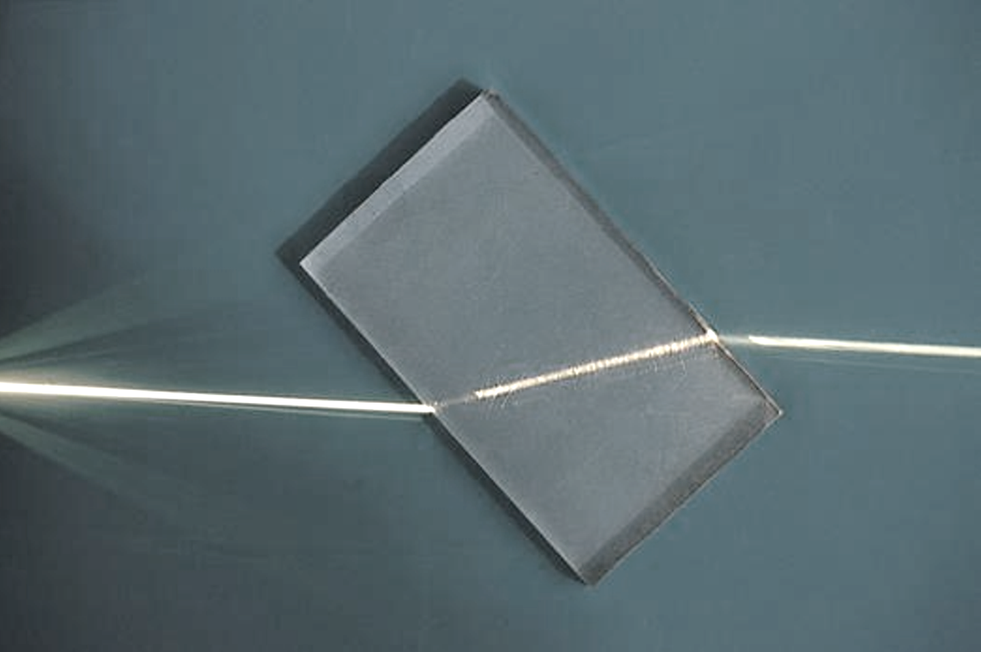
Figure 1
- Reflection c. Diffusion
- Refraction d. Interference

- When a wave hits a surface through which it cannot pass, it bounces back. This interaction with the surface is called: SC.7.P.10.2

  - Interference
  - Diffraction
  - Reflection
  - Refraction

- A beam of light is shining on the surface of a liquid. Which diagram shows what happens when the light is reflected by the liquid? SC.7.P.10.2
a. Light wave c. Light wave
liquid liquid 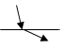
b. Light wave d. Light wave
liquid 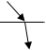 liquid 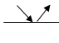

- Rainbows are created when light passes through rain drops and separates into the different colors of light. Rainbows are a great example of light being: SC.7.P.10.2
- Interfered
- Diffracted
- Reflected
- Refracted

- How is working with models of reflection and refraction, such as mirrors and prisms, beneficial to learning about the concepts? SC.7.N.3.2
- Without the model, you cannot see reflection and refraction.
- Without the model, reflection and refraction would be too small to see.
- Without the model, you would not easily be able to experiment with reflection and refraction.
- Without the model, it would be much too dangerous to work with reflection and refraction.

Light Behavior Check for Understanding Answer Key
- Mario was learning about light behavior in science class, and the teacher showed the class a prism similar to the one in figure 1 below. Which behavior of light explains this observation? SC.7.P.10.2
Figure 1
- Reflection c. Diffusion
- Refraction d. Interference

- When a wave hits a surface through which it cannot pass, it bounces back. This interaction with the surface is called: SC.7.P.10.2

  - Interference
  - Diffraction
  - Reflection
  - Refraction

- A beam of light is shining on the surface of a liquid. Which diagram shows what happens when the light is reflected by the liquid? SC.7.P.10.2
a. Light wave c. Light wave
liquid liquid
b. Light wave d. Light wave
liquid liquid

- Rainbows are created when light passes through rain drops and separates into the different colors of light. Rainbows are a great example of light being: SC.7.P.10.2
- Refracted
- Reflected
- Interfered
- Diffracted

- How is working with models of reflection and refraction, such as mirrors and prisms, beneficial to learning about the concepts? SC.7.N.3.2
- Without the model, you cannot see reflection and refraction.
- Without the model, reflection and refraction would be too small to see.
- Without the model, you would not easily be able to experiment with reflection and refraction.
- Without the model, it would be much too dangerous to work with reflection and refraction.

